Copyright
by
Erica Schwartz
2008

The Dissertation Committee for Erica Susanne Schwartz Certifies that this is the approved version of the following dissertation:

Critical role of ROS in capsaicin-induced hyperalgesia

Committee:
Jin Mo Chung, Ph.D.
Kyungsoon Chung, Ph.D.
Giulio Taglialatela, Ph.D.
William D. Willis, M.D., Ph.D.
Eric Klann, Ph.D.

__________________
Dean, Graduate School

HIDDEN TEXT: The top line is for the Supervisor’s signature. There should be as many lines as there are members on the committee. Lines must be solid, not dotted. To delete signature lines, select the line you want to delete, go to the Table menu, select Table Properties, click on the Table tab, and click on the Borders and Shading button, then remove the bottom border of the table. Use the professor's name without titles or degrees
Critical role of ROS in capsaicin-induced hyperalgesia

by
Erica Susanne Schwartz, A.B.

HIDDEN TEXT: Given first name, and previous academic degrees (B.A. or higher) B.A., B.S., etc. Your official name is the name which appears on your UT transcript.

Dissertation
Presented to the Faculty of the Graduate School of
The University of Texas Medical Branch
in Partial Fulfillment
of the Requirements
for the Degree of

Doctor of Philosophy
HIDDEN TEXT: The degree sought must be worded in the form given in the Graduate Catalog, such as Doctor of Philosophy, Doctor of Musical Arts, Doctor of Education.

The University of Texas Medical Branch
May, 2008

Acknowledgements

I want to first acknowledge my parents, David and Michele Schwartz, my brother Joshua, and my sister Julie. They have always believed in me even in those days I did not believe in myself. Their constant support inspires me to do my best so I can make them proud of me. I want to express my most sincere gratitude to my mentor, Dr. Jin Mo Chung, for his valuable guidance and patience. He gave me the chance to participate in this inspiring, interesting, and sometimes challenging research project. Whenever I was in need, he was there. I am so honored to have been one of his students. I also want to acknowledge my committee: Drs. Kyungsoon Chung, William Willis, Giulio Taglialatela, and Eric Klann. Thank you for your time, challenging questions, and willingness to help me with anything I need no matter how big or small. I also want to thank the Neuroscience Graduate Program. I would like to thanks Dr. James E. Blankenship for his guidance during my graduate study and to Cynthia Cheatham for the coordination work she did for me. I want to also acknowledge all the members of the Chung Lab, the past and the present, for being my second family for the past few years. The relationships and friendships I have made is one of the life-lasting treasures that I found in this lab. Finally, I want to thank all of my friends and all of those that have been my constant support.
Critical role of ROS in capsaicin-induced hyperalgesia

Publication No._____________

Erica Susanne Schwartz, PhD
The University of Texas Medical Branch, 2008

Supervisor: Jin Mo Chung

Recent studies indicate that reactive oxygen species (ROS) are critically involved in persistent pain primarily through spinal mechanisms, thus suggesting ROS involvement in central sensitization. To investigate ROS involvement in central sensitization, the effects of ROS scavengers and donors on pain behaviors were examined in mice. The capsaicin-induced hyperalgesia was used as a pain model since it has 2 distinctive pain components, primary and secondary hyperalgesia representing peripheral and central sensitization, respectively. Foot withdrawal frequencies in response to von Frey filament stimuli were measured and used as an indicator of mechanical hyperalgesia. The production of mitochondrial ROS was examined by using a ROS sensitive dye MitoSox-Red. Mice developed primary and secondary mechanical hyperalgesia after capsaicin injection. A systemic or intrathecal ROS scavenger treatment significantly reduced secondary hyperalgesia, but not primary hyperalgesia, in a dose dependent manner. MitoSox positive dorsal horn neuron numbers were increased significantly after capsaicin treatment. This study suggests that ROS mediates the development and maintenance of capsaicin-induced hyperalgesia in mice, mainly through central sensitization and the elevation of spinal ROS is most likely due to increased production of mitochondrial superoxides in dorsal horn neurons.
This study also investigated the role of mitochondrial antioxidant SOD2 in pain. Experiments were done to measure spinal levels of SOD2 protein and activity, inactivated SOD2 protein, and ROS accumulating dorsal horn cells after capsaicin injection to mouse foot with or without ROS scavengers. The capsaicin-induced hyperalgesia was determined in mice after manipulating SOD levels. Results showed that following capsaicin treatment, spinal levels of SOD2 activity were decreased, inactivated SOD2 proteins were increased, but total SOD2 proteins were unchanged. These changes were reversed with ROS scavengers. Mice showed enhanced or reduced hyperalgesia with decreased or increased SOD2 levels, respectively. The number of ROS accumulating cells was increased in SOD2KO mice but decreased in SOD2Tg mice. The data suggest that SOD2 activity levels determine the ROS accumulation, which in turn determines the levels of central sensitization and capsaicin-induced secondary hyperalgesia. Therefore, this study suggests a therapeutic potential of targeting SOD2 in persistent pain conditions.

Table of Contents
LIST OF FIGURES xi
ABBREVIATIONS xiv
CHAPTER 1: INTRODUCTION AND BACKGROUND 1
Significance of the Project 2
The Nociceptive pathway and Perception of Pain 4
Persistent Pain and Hyperalgesia 5
Peripheral sensitization 7
Central Sensitization 9
Capsaicin-induced pain 12
Reactive Oxygen Species (ROS) 14
Mitochondrial Oxidative Stress 18
Superoxide Dismutase (SOD) 19
CHAPTER 2: GENERAL METHODS 22
Experimental Animals 22
Capsaicin Injection 23
Behavioral Testing for assessment of foot withdrawal responses 23
Systemic Injection of ROS Scavengers and SOD Mimetic 25
ROS Scavengers 25
SOD mimetic,Mn (III) tetrakis(4-benzoic acid)porphyrin(MnTBAP) 26
Direct transcutaneous intrathecal injection of ROS Scavengers, SOD Inhibitor, and ROS Donor 26
ROS Scavengers 27
SOD inhibitor, Diethylthiocarbamate, (DETC) 27
ROS donor, tert-butylhydroperoxide (t-BOOH) 28
Animal Perfusion 28
In vivo detection of mitochondrial superoxides using MitoSOX-Red
(MS-R) 29
Western Blot Analysis of SOD2 30
Immunoprecipitation and Western Blot Analysis of N-SOD2 32
SOD2 activity measurement and analysis 32
Statistical Analysis 34
Behavioral Experiments 34
Western Blot and SOD2 Activity Experiments 35
Cell Counts 35
CHAPTER 3: OXIDATIVE STRESS IN THE SPINAL CORD IS AN IMPORTANT CONTRIBUTOR IN CAPSAICIN-INDUCED SECONDARY MECHANICAL HYPERALGESIA 36
Introduction 36
Results 38
Capsaicin induces long lasting primary and secondary hyperalgesia in mice 38
Post-treatment with ROS scavengers reduces capsaicin-induced secondary hyeralgesia, but not primary hyperalgesia, in a dose-dependent manner 39
The main action site of ROS is the spinal cord 40
Intrathecal administration of a ROS donor, t-BOOH, produced transient pain behaviors in normal mice in a dose-dependent manner 42
Pretreatment with ROS scavengers significantly reduced the development of secondary hyperalgesia 42
Discussion 43
CHAPTER 4: INTRADERMAL INJECTION OF CAPSAICIN CAUSES INCREASED PRODUCTION OF MITOCHONDRIAL SUPEROXIDE IN SPINAL DORSAL HORN NEURONS 63
Introduction 63
Results 66
Intradermal capsaicin induces increased mitochondrial superoxide production in the dorsal horn 66
ROS producing cells 67
Discussion 68
CHAPTER 5: THE LEVELS OF MITOCHONDRIAL SUPEROXIDE DISMUTASE PLAY AN IMPORTANT ROLE IN CAPSAICIN-INDUCED SECONDARY HYPERALGESIA 77
Introduction 77
Results 79
SOD is involved in capsaicin-induced secondary hyperalgesia 79
Spinal levels of SOD2 proteins were unchanged but activities were decreased after capsaicin treatment 81
Capsaicin-induced hyperalgesia is correlated with endogenous SOD2 activity levels 84
Mitochondrial superoxide accumulation in response to capsaicin treatment is correlated to the levels of SOD2 activity 87
Discussion 88
CHAPTER 6: GENERAL DISCUSSION 108
REFERENCES 114

LIST OF FIGURES
Figure 1: Sites of capsaicin injection and behavioral testing in the mouse hind foot 48

Figure 2: Time course of primary and secondary hyperalgesia after intradermal (i.d.) capsaicin injection (5μl, 0.5%) in the mouse hind foot 49

Figure 3: Effects of systemic (i.p.) PBN or TEMPOL post-treatment on capsaicin-induced hyperalgesia using vF # 2.48 51

Figure 4: Effects of systemic (i.p.) PBN or TEMPOL post-treatment on capsaicin-induced hyperalgesia using vF # 3.00 53

Figure 5: Effects of intrathecal (i.t.) PBN or TEMPOL treatment on capsaicin-induced hyperalgesia using vF # 2.48 55

Figure 6: Effects of intrathecal (i.t.) PBN or TEMPOL treatment on capsaicin-induced hyperalgesia using vF # 3.00 57

Figure 7: Effects of i.t. t-BOOH on mechanical hyperalgesia 58

Figure 8: Effects of systemic PBN or TEMPOL pre-treatment on capsaicin-induced hyperalgesia using vF # 2.48 60

Figure 9: Effects of systemic PBN or TEMPOL pre-treatment on capsaicin-induced
hyperalgesia using vF # 3.00 62

Figure 10: MitoSOX positive cells in the deep layers of the L4-L5 spinal dorsal horn 72

Figure 11: Density of MitoSOX positive cells 73

Figure 12: MitoSOX positive neurons in the deep layers of the L4-L5 spinal dorsal horn 74

Figure 13: MitoSOX positive astrocytes in the deep layers of the L4-L5 spinal dorsal horn 75

Figure 14: The average proportion of neurons and glia among MitoSOX positive, ROS producing cells 76

Figure 15: Effect of a SOD mimetic, MnTBAP, on capsaicin-induced hyperalgesia 96

Figure 16: Effect of a SOD inhibitor, DETC, on capsaicin-induced hyperalgesia 98

Figure 17: Total SOD2 protein levels in the L4/5 spinal cord 99

Figure 18: Total SOD2 activity levels in the L4/5 spinal cord 100

Figure 19: Nitrated SOD2 (N-SOD2) protein levels in the L4/5 spinal cord 101

Figure 20: Capsaicin-induced primary (A) and secondary (B) hyperalgesia in SOD2 underexpressing SOD2KO+/- mice 102

Figure 21: Capsaicin-induced primary (A) and secondary (B) hyperalgesia in SOD2 overexpressing SOD2Tg+/- mice 103

Figure 22: SOD2 activity levels in the L4/5 spinal cord in SOD2KO+/- and SOD2Tg^{+/-} mice with and without i.d. capsaicin treatment 104

Figure 23: Examples of the MitoSOX labeled L5 spinal dorsal horn (lamina V) sections in various groups of mice 105

Figure 24: The number of MitoSOX positive cells in the superficial (laminae I-II) and deep (laminae III-V) dorsal horn of various groups 106

Figure 25: Proposed role of superoxide in capsaicin-induced hyperalgesia 107

ABBREVIATIONS

ANOVA | Analysis of Variance
ATP | Adenosine triphosphate
Ca²⁺ | Calcium
CAP | Capsaicin
CGRP | Calcitonin gene-related peptide
DETC | Diethyldithiocarbamic acid
DH | Dorsal Horn
EAA | Excitatory amino acids
ETC | Electron transport chain
GABA | γ-aminobutyric acid
GFAP | Glial fibrillary acidic protein
GPCR | G-protein-coupled receptor
GPx | GSH peroxidase
GSH | Glutathione
H₂O₂ | Hydrogen peroxide
i.d. | Intradermal
i.p. | Intraperotineal
i.t. | Intrathecal
LTP | Long term potentiation
MnTBAP | Mn (III) tetrakis (4-benzoic acid) porphyrin
MS-R | MitoSOX-Red
NMDA | N-methyl-D-aspartate
NMDAR | N-methyl-D-aspartate Receptor
NK-1 | Neurokinin-1
NeuN | Neuronal nuclei
NO | Nitric Oxide
NOS | Nitric Oxide Synthase
N-SOD2 | Nitrated mitochondrial SOD2
•O₂‾ | Superoxide anion
•OH | Hydroxyl radical
ONOO‾ | Peroxynitrite
PKA | cAMP-dependent protein kinase
PKC | Ca²⁺ /phospholipids-dependent kinase
SMT | Spinomesencephalic tract
SNL | Spinal nerve ligation
SOD | Superoxide dismutase
SOD2KO^{+/-} | Heterozygous SOD2 knockout mice
SOD2Tg^{+/-} | Heterozygous SOD2 transgenic mice
SP | Substance P
SRT | Spinoreticular tract
STT | Spinothalamic tract
t-BOOH | tert-butylhydroperoxide
TEMPOL | 4-hydroxy-2,2,6,6,-tetramethylpiperidine-1-oxyl
TRPV1 | Transient receptor potential vanilloid 1
VEH | Vehicle
VF | von Frey
WDR | Wide dynamic range
Wt | Wild type
XO | Xanthine oxidase

CHAPTER 1: INTRODUCTION AND BACKGROUND
Pain is one of the most prevalent conditions limiting productivity and diminishing quality of life and therefore is an important medical problem. Over one-third of the world’s population suffers from pain yearly. Pain is defined as “an unpleasant sensory and emotional experience associated with actual or potential tissue damage, or described in terms of such damage” (Merskey and Bogduk, 1994). It is a sensation transmitted from sensory nerves through the spinal cord and to the sensory areas of the cerebrum, where sensation is perceived. As a part of the body’s defense system, pain triggers mental and physical behaviors that seek to end the painful experience while also being a feedback system that promotes learning, making repetition of the painful situation less likely. Pain may be sharp or dull, intermittent or constant, throbbing or steady, and sometimes is very difficult to describe. Pain becomes the primary reason for seeking medical attention when it persists. There are various ways to relieve pain based on the knowledge of pain transmission and modulation in the nervous system at the present time. However, the human population suffering from either acute or persistent pain is still large, due to lack of proper understanding of pain mechanisms and proper treatment paradigms. Thus pain treatment is a severe economic and health problem worldwide. Therefore, there is an urgent need for better understanding of pain mechanisms, especially persistent pain mechanisms, and for the development of proper management paradigms, in our society, scientific community, and among heath care professionals.

Significance of the Project
Acute pain (nociceptive or physiological) is detected by primary afferent nociceptors and the information is transmitted to the brain and sensed as pain (Woolf and Salter, 2000). The mechanisms underlying acute pain show a rather straight-forward information transmission system. However, persistent pain is different in that it is the result of a maintained abnormality in the peripheral and central nervous systems (Woolf and Costigan, 1999; Woolf and Salter, 2000). In persistent pain, peripheral and/or central sensitization develops. In persistent pain, peripheral sensitization contributes to an increase in the sensitivity and excitability of the primary afferent terminal. In the case of central sensitization, sensitized spinal dorsal horn neurons respond more vigorously to peripheral input and receive input from expanded cutaneous receptive fields (Cook et al., 1987; Woolf and Thompson, 1991). The enhanced activation of N-methyl-D-aspartate (NMDA) receptors (NMDAR) by phosphorylation is an important means by which central sensitization is initiated and maintained (Chen and Huang, 1992; Zou et al., 2000). After phosphorylation of the receptor, the NMDA-activated currents are enhanced by increasing the probability of channel openings (Chen and Huang, 1992). This may cause an increase in excitability of sensory processing in the dorsal horn of the spinal cord that results in greater firing of spinal efferent systems in response to given noxious inputs and normally innocuous stimuli (Haley et al., 1990; Woolf and Thompson, 1991; Raymond et al., 1993; Ren and Dubner, 1999; Zou et al., 2000; Guo et al., 2002; Votyakova and Reynolds, 2004). This phenomenon of central sensitization, induced by intradermal capsaicin injection, is considered the underlying mechanism of some persistent pain such as the secondary hyperalgesia (Dougherty and Willis, 1992; Willis, 1994) and is a significant clinical problem.
An emerging concept in the field of persistent pain is that elevated levels of spinal reactive oxygen species (ROS) play a critical role in central sensitization. Studies have shown that ROS are critically involved in cell death in many degenerative neurological conditions, such as Alzheimer disease, Parkinson disease, amyotrophic lateral sclerosis, and other brain dysfunctions ranging from brain injury to aging (Gerlach et al. 1994; Jenner 1994; Hensley et al. 1997; Lewen et al. 2000). We are now extending this concept to the role of ROS in central sensitization and pain. However, little is known about how ROS elevation develops in the spinal cord and why it leads to pain. Therefore, it is important to explore the ROS mechanisms in central sensitization and thus pain, which can then lead to the development of new treatment paradigms. We propose that spinal ROS are important intermediate signaling molecules between high intensity nociceptive inputs and central sensitization and that an antioxidant superoxide dismutase (SOD) plays a critical role in reducing central sensitization. Presently, the most widely used drugs for pain management are morphine, aspirin (NSAIDs), and a variety of non-specific agents (anti-convulsants, antidepressants). While they are somewhat effective in providing analgesia in patients, their usage is limited due to various accompanying unwanted effects, such as habituation, tolerance. ROS involvement in pain is a novel idea and the research proposed here will provide the knowledge needed to develop new pharmacological strategies specifically targeting spinal ROS. Understanding the molecular and cellular mechanisms that underlie the initiation of pain and how spinal ROS mediates the development and maintenance of capsaicin-induced hyperalgesia will undoubtedly reveal novel targets for the discovery of more effective and more specific pain therapies.

The Nociceptive pathway and Perception of Pain
The vast majority of pain signals which are processed by the nervous system are designed to detect the potential source of bodily harm and to trigger responses which can prevent or alleviate the damage (Bonica, 1990; Martin and Eisenach, 2001). The pathways that carry information about noxious stimuli to the brain, as might be expected for such an important and multifaceted system, are complex. Transmission of nociceptive information is carried from the spinal cord through three major ascending pathways: the spinothalamic, spinoreticular, and spinomesencephalic tracts. However, they all share one common characteristic: nociceptive signals are detected in the periphery by free nerve endings of C and Aδ primary afferent fibers (Sherrington, 1906). Thinly myelinated Aδ fibers with medium-sized cell bodies in dorsal root ganglia (DRG) mediate fast pain, which is described as sharp, acute well localized pain. Unmyelinated C fibers with small-sized cell bodies in DRG meditate slow pain, which is reported as dull, throbbing longer-lasting pain (Julius and Basbaum, 2001). Besides conduction velocity, there are also other differences between the two fibers such as their response specificity to different modalities of stimuli. Aδ fibers are mainly activated by noxious intensities of mechanical and thermal stimulation; whereas, C fibers often respond to noxious mechanical, thermal, or chemical stimuli (Bessou and Perl, 1969).
In the spinal cord, the spinothalamic tract is the most prominent and well studied ascending nociceptive pathway. It is comprised of the axons of nociceptive-specific and wide-dynamic range (WDR) neurons in laminae I and IV-VI of the dorsal horn. These axons project to the contralateral side of the spinal cord and ascend in the anterolateral white matter, terminating in the thalamus. It is thus nerve impulses in the spinothalamic tract that result in pain perception. When peripheral stimulation occurs, nociceptive DRG neurons are first-order neurons in the pain pathway and they receive input from peripheral tissues. DRG neurons then transmit the signal into the central nervous system by forming synapses with second-order neurons, spinothalamic tract (STT) cells, in both the superficial and deep layers of the dorsal horn. STT cells are largely responsible for the signal being relayed to the thalamus and then continuing on to the somatosensory cortex upon which the perception of pain is ultimately formed. In addition, other ascending pathways, including the spinoreticular tract (SRT) and spinomesencephalic tract (SMT) also play a role in conveying pain information from the periphery to the thalamus. However, these signals are delivered to brain structures which are responsible for triggering the emotional aspect of pain. In addition, besides forward neural pathways, feedback control by a descending modulatory system from higher centers also is an important feature of pain mechanisms (Willis, 1982; Willis, 1988).

Persistent Pain and Hyperalgesia
Pain can be classified as acute or persistent based on the nature of the pain itself, as cutaneous or visceral based on the source of pain, and as peripheral or central based on the origin. Acute pain is viewed as the intiation phase of an extensive, nociceptive, and behavioral cascade triggered by tissue injury and is detected by primary afferent nociceptors, and the information is transmitted to the brain and sensed as pain (Woolf and Salter, 2000). Persistent pain is defined as being associated with maintained abnormalities of the peripheral and/or central nervous system following tissue inflammation or nerve injury (Woolf and Costigan, 1999; Woolf and Salter, 2000). The one consistent fact of persistent pain is that as a disorder, it cannot be understood in the same terms as acute pain. The mechanisms underlying acute pain show a rather well defined information transmission system; however, there is still a lack of proper understanding of mechanisms underlying persistent pain which is of particular interest for this project. As mentioned, one of the most common causes for persistent pain is peripheral tissue inflammation or nerve injury which leads to maintained abnormalities in the central nervous system (Dray, 1995; Garry et al., 1999; Woolf and Salter, 2000; Kim et al., 2006). It has been shown that in persistent pain, central sensitization develops, resulting in sensitized spinal dorsal horn neurons that respond more vigorously to peripheral input and receive input from expanded cutaneous receptive fields (Cook et al., 1987; Woolf and Thompson, 1991).
Persistent pain can be subdivided into two broad classes, nociceptive and neuropathic (Kandel et al., 2000). Nociceptive pain results from the direct activation of nociceptors in the skin in response to tissue injury and usually arises due to inflammation. Neuropathic pain is a complex, persistent pain state that usually is accompanied by tissue injury in the nervous system and may persist after healing of the primary event. With neuropathic pain, the nerve fibers themselves might be damaged, dysfunctional, or injured (Woolf and Salter, 2000) causing a change in nerve function both at the site of injury and areas around the injury resulting in multiple changes within the central nervous system that perpetuate the pain experience (Costigan and Woolf, 2000). Some symptoms of persistent pain are allodynia, hyperalgesia, paresthesia, or dysesthesia. Paresthesia and dysesthesia are two types of pain associated with an abnormal sensation, whether spontaneous or evoked and allodynia designates pain experienced in response to an innocuous stimulus. Hyperalgesia is defined as the enhancement of pain perception to noxious stimuli, and is the primary focus for this project (Hardy, 1956; Willis and Coggeshall, 1991; Willis, 2001). Hyperalgesia can be further divided into two types: primary and secondary. Primary hyperalgesia is explained by peripheral nociceptor sensitization (Simone et al., 1989; Baumann et al., 1991; Koul et al., 1992; Steen et al., 1992) and can be evoked in response to either thermal or mechanical stimuli. Secondary hyperalgesia, which is known to be due to central sensitization of spinal dorsal horn neurons (Willis, 2001), involves an increased sensitivity only to mechanical and not thermal stimuli (Dougherty et al., 1998; Sluka et al., 1997)

Peripheral sensitization
Inflammation of peripheral tissue causes pain, redness, and swelling in the area that was affected. It results in the release of inflammatory mediators at the affected area, such as bradykinins, prostaglandins, substance P, calcitonin gene-related peptide (CGRP) and others (Nanayama et al., 1989; Sun and Larson, 1991; Bileviciute et al., 1993; Supowit et al., 1995). These chemicals act on G-protein-coupled receptors (GPCR), such as NKI receptors and metabotropic glutamate receptors, activating intracellular signaling pathways such as protein kinase C, that by phosphorylating receptors and ion channels in the nociceptor terminal change their threshold and kinetics (Dougherty et al., 1994; Ren et al., 1996; Mark and Herlitze, 2000; Willis, 2001). GPCRs regulate the function of ion channels, which play an essential role in the function of neurons, by mediating electrical currents and regulation of selective ion concentrations across the cell membrane. All of this contributes to an increase in the sensitivity and excitability of the primary nociceptor terminal, a phenomenon referred to as peripheral sensitization (Hardy, 1953; Hardy, 1956; Hargreaves et al., 1988; Kress et al., 1997; Willis, 2001). Peripheral sensitization produces an increase in pain sensitivity that is restricted to the site of inflammation. Sensitized primary afferent nociceptors are believed to be the mechanism underlying primary hyperalgesia (Meyer and Campbell, 1981; Willis, 1994).
The most well studied molecular basis of peripheral sensitization is the activation of ion channels on the surface membranes of nociceptors, such as transient receptor potential vanilloid 1 (TRPV1) receptors. TRPV1 receptors are found on many polymodal C and mechano-heat Aδ fibers and are activated by capsaicin, other vanilliod chemicals, protons, and noxious heat stimulation (Bevan and Szolcsanyi, 1990; Caterina et al., 1997; Caterina et al., 2000). Sodium and calcium influx through the channel is initiated following ligand binding, which leads to excitation and sensitization of the nociceptive neurons (Marsh et al., 1987; Chen et al., 1998). For example, studies have shown that both prostaglandin E₂ (PGE₂) and bradykinin cause changes in the TRPV1 via activation of cAMP-dependent protein kinase (PKA) and Ca²⁺/phospholipid-dependent kinase (PKC) (Chuang et al., 2001). Futhermore, studies have shown that these inflammatory mediators cause changes in the sensory-neuron-specific voltage-gated Na⁺ channel Na_{v}1.8, altering its activation kinetics and, hence, terminal-membrane excitability (Khasar et al., 1998).

Central Sensitization
After the excitation of nociceptors during peripheral inflammation, the neurotransmission between the primary afferents and dorsal horn neurons is facilitated, which leads to increased activity and prolonged hyperexcitability of dorsal horn neurons in response to innocuous and noxious stimuli applied to the inflamed and even adjacent normal tissue (Baumann et al., 1991; LaMotte et al., 1991; Torebjörk et al., 1992). It is thus the plastic changes in dorsal horn neurons of the central nervous system that contribute to this phenomenon referred to as “central sensitization,” which is of particular interest for this project. Central sensitization of dorsal horn neurons is the mechanism underlying the behavioral hyperexcitability of secondary hyperalgesia. Central sensitization occurs after prolonged C-nociceptor input and is dependent on the activation of wide dynamic range (WDR) neurons in the dorsal horn of the spinal cord (Willis and Coggeshall, 1991; Willis, 2001; Dubner and Ruda, 1992). It is characterized by enhanced spontaneous and evoked activity, expanded receptive fields, and increased efficacy of nociceptive neurotransmission of spinal dorsal horn neurons ( Cook et al., 1987; Coderre and Melzack, 1991; Coderre and Melzack, 1992; Coderre et al., 2004) and is referred to as a facilitated state of nociceptive processing following a persistent noxious input (Ji et al., 2003). These neuroplastic changes are accompanied by other electrophysiological manifestations that cause neurons to fire with increased frequency or even spontaneously (Waxman et al., 1999). In addition, spinal processing is further affected by descending inhibitory and facilitory pathways that provide additional modulation of spinal γ-aminobutyric acid (GABA) interneurons (Lin et al., 1996; Vanderah et al., 2001). The spinal mechanisms responsible for central sensitization, and the associated behavioral hypersensitivity, involve alterations in synaptic efficacy (Willis and Coggeshall, 1991; Dubner and Ruda, 1992; Owens et al., 1992; ; Willis, 2001; Ji et al., 2003) proposed to be due to receptor trafficking and altered receptor/ ion channel activity (Woolf and Salter, 2000). It is thus central plastic changes that can be recorded from nociceptive dorsal horns in response to a strong noxious stimulus. It is important to mention that this phenomenon is present in other neural systems. A central sensitization-like phenomenon can also be generated in neurons in other parts of the pain system, such as the rostralventral medulla, anterior cingulate cortex, and amygdala (Wei and Zhuo, 2001; Burgess et al., 2002; Neugebauer and Li, 2003). If fact, central sensitization can be regarded as a type of LTP (Willis, 2002; Ji et al., 2003). In addition, several symptomatic features of headache reflect central sensitization produced in trigeminal nuclei within the brainstem (Hu et al., 1992; Malick et al., 2000).
The early phase of central sensitization reflects changes in synaptic connections within the spinal cord, after a signal has been received from primary afferent nociceptors. The central terminals of the nociceptor release a host of extracellular signaling neurotransmitters and modulators, including substance P, CGRP, and excitatory amino acids (EAA) from both small myelinated and unmyelinated fibers into the dorsal horn of the spinal cord (Carlton et al., 1987; Carlton et al., 1985; Dougherty and Willis, 1991; Sorkin and McAdoo, 1993; Dougherty et al., 1993; Galeazza et al., 1995; Seybold et al., 1995). Unmyelinated C-fiber nociceptor afferents coexpress glutamate and neuropeptide neurotransmitters substance P (SP) and CGRP (Battaglia and Rustioni, 1988). These transmitters/modulators act on specific receptors on the spinal cord neurons, activating intracellular signaling pathways that lead to the phosphorylation of membrane receptors and channels, particularly the NMDA and AMPA receptors for the glutamate neurotransmitter. Studies have shown that both glutamate and SP are colocalized in the terminals of primary afferent fibers in the superficial dorsal horn (De and Rustioni, 1988). It has been shown that SP not only excites dorsal horn neurons but potentiates the excitatory effects of NMDA and therefore, is involved in the mechanisms underlying hyperalgesia ; Willis, 2001). In the DRG it was found that CGRP and glutamate are also colocalized; suggesting that CGRP and glutamate are released from the same axon terminals in the spinal cord (Miller et al., 1993). Due to the abundance of glutamate in the superficial layers of the dorsal horn of the spinal cord, it is colocalized with either SP, CGRP, or both (Merighi et al., 1991). Receptors, such as NMDA, AMPA, kainate receptors, and NK1, are activated and second messenger systems are triggered (Dougherty and Willis, 1992; Palecek et al., 1992; Dougherty et al., 1994; Willis, 2001). These post-translational changes lower the threshold and opening characteristics of these channels, thereby increasing the excitability of the neurons.

Capsaicin-induced pain

The behavioral consequences of central sensitization can be readily detected using the capsaicin-induced pain model. The capsaicin-induced pain model has well defined peripheral and central components, making it a good model for studying central vs. peripheral mechanisms underlying persistent pain. Furthermore, intradermal injection of capsaicin is a useful and reversible experimental model for the study of mechanisms underlying persistent pain (Simone et al., 1989; LaMotte et al., 1992). Capsaicin is the pungent ingredient found in chili peppers that activates the TRPV1 receptor. As mentioned previously, TRPV1 receptors are located predominantly on nociceptive afferent fibers, and are also responsive to noxious heat (Sluka et al., 1997). It is thus activation of these nociceptors that induces central sensitization of nociceptive dorsal horn neurons (Simone et al., 1991). Capsaicin can excite and desensitize unmyelinated afferent nerve fibers resulting in acute and restricted cutaneous neurogenic inflammation. This type of inflammation is characterized by a local increase in blood flow and the development of edema (Lin et al., 1999). Capsaicin also causes a variety of endogenous inflammatory substances to be released from either primary afferent terminals or inflammatory cells, such as neurotransmitters (glutamate, peptides), prostaglandins, bradykinin, SP, CGRP, histamine, 5-hydroxytryptamine (5-HT) and adenosine 5’-triphosphate (Hardy, 1956; Wood et al., 1988; Willis and Coggeshall, 1991; Kress and Zeilhofer, 1999; Willis, 2001). Side effects that occur from these substances include vasolidilation, redness, warmth, swelling, and pain.
Intradermal capsaicin injection has been shown to cause changes in behavioral responses of rats and to increase responses of nociceptive projection neurons in the dorsal horn of the spinal cord at a cellular level (Willis, 2001; Lee et al., 2007). Activation of C-polymodal nociceptors and C-chemosensitive fibers, by intradermal injection of capsaicin, occurs and produces mechanical allodynia, primary hyperalgesia to thermal and mechanical stimuli, and secondary mechanical allodynia and hyperalgesia (Baumann et al., 1991; LaMotte et al., 1992; Torebjörk et al., 1992; LaMotte et al., 1992; Willis, 2001). An analgesic area of the skin, at the injection site is mainly due to desensitization or destruction of primary afferent nociceptor terminals. This area is surrounded by an area of primary hyperalgesia. After tissue damage occurs, a number of chemical substances that trigger sensitization are released by the damaged cells. These chemical agents (i.e. prostaglandins, bradykinin, and SP) then activate and sensitize unmyelinated C fibers; this is most likely a possible mechanism underlying primary hyperalgesia in this model (Willis and Coggeshall, 1991; Dray, 1995; Lawand et al., 1997; Schepelmann et al., 1992; Schuligoi et al., 1994; Coggeshall and Carlton, 1997; Carlton et al., 1998). Secondary hyperalgesia develops in the neighboring area of skin adjacent to the injection site (Baumann et al., 1991; LaMotte et al., 1992; Torebjörk et al., 1992; Dougherty et al., 1998; Willis, 2001; Simone et al., 1989; Simone et al., 1991). In the capsaicin-induced hyperalgesia model, it occurs by neuronal activity that originates in the area of injection/injury and is carried by chemosensitive afferent fibers (Ren and Dubner, 1999). A lot of evidence has shown that intradermal injection of capsaicin induces both increased sensitivity of nociceptive dorsal root ganglion neurons and primary hyperalgesia in response to mechanical and thermal stimuli, as well as secondary mechanical hyperalgesia (Gamse et al., 1980; Jansco and Kiraly, 1981; Dougherty et al., 1994; Sluka et al., 1997; Sun et al., 2004). Studies have been conducted in rodent (Hylden et al. 1998; Lee et al., 2007), cat (Schaible et al. 1991), primates (Dougherty and Willis, 1991) and human subjects (LaMotte et al., 1983; Simone et al., 1989; LaMotte et al., 1991) following intradermal injection of capsaicin, which makes capsaicin an important tool for the study of mechanisms underlying persistent pain.
In this project, capsaicin injection is used in animal experiments to investigate the mechanisms underlying persistent pain, namely central sensitization. Therefore, secondary hyperalgesia induced by intradermal capsaicin injection is an attractive model to study reactive oxygen species (ROS) action on central sensitization in the spinal cord.

Reactive Oxygen Species (ROS)
By definition a free radical is any atom (e.g. oxygen) with at least one unpaired electron in the outermost shell, that is capable of independent existence. A free radical is easily formed when a covalent bond between entities is broken and one electron remains with each newly formed atom and therefore the atoms become highly reactive due to the presence of unpaired electron(s). Any free radical involving oxygen or nitrogen can be referred to as reactive oxygen species (ROS) or reactive nitrogen species (RNS). The majority of free radicals in biological systems are ROS. Oxygen centered free radicals contain one or more unpaired electrons in the outer shell. When free radicals steal an electron from a surrounding compound or molecule, a new free radical is formed in its place. In turn the newly formed radical wants to return to its ground state by stealing electrons with antiparallel spins from cellular structures or molecules.
Biologically relevant ROS include oxygen ions, free radicals, and peroxides both inorganic and organic (Maher and Schubert, 2000). They are generally very small molecules and are highly reactive to the presence of unpaired valence shell electrons. One form of ROS readily converts to another in vivo and reactivity varies widely from one ROS to the next (Afonso et al., 2007). The most abundant ROS representative in the living cell is superoxide [•O₂‾]. Other free radicals include hydrogen peroxide [H₂O₂], singlet oxygen [O₂], and the hydroxyl anion radical [•OH]. The special feature of these agents is their high oxidative reactivity, creating a significant threat for redox-sensitive cellular components, primarily for proteins, lipids, and nucleic acids (Maher and Schubert, 2000). The expedient destructive function of ROS is tightly linked to the function of another radical, nitric oxide [NO•]. Beside nitric oxide, the RNS group contains diverse nitrogen derivatives (peroxynitrite [ONOO‾], nitrogen dioxide [NO₂•], dinitrogen trioxide [N₂O₃], and others) that also all possess a strong oxidative capacity. Cross talk between ROS and RNS allows both forms to be referred to as a general group of small signaling molecules. For the sake of convenience, therefore, we will use the term "ROS" to represent both ROS and "RNS" in this text.
ROS are natural byproducts of the normal metabolism of oxygen and have important roles ranging from cell signaling to cell death. Superoxide, the most abundant ROS in the mitochondria, can easily be converted to other more aggressive ROS. Although it is believed that superoxide may not directly react with lipids, proteins, sugars or nucleotides, it can be easily transformed into the hydroxyl radical when it interacts with metal ions (Fenton reaction) (Afonso et al., 2007). It can also react with nitric oxide to quench physiological activities such as vascular relaxation (Liu et al., 1999). At the same time, it has been shown that superoxide can form peroxinitrite in the presence of nitric oxide, thereby modifying the bioavailability of nitric oxide (Afonso et al., 2007; Demicheli et al., 2007). The life spans of the hydroxyl radicals and superoxides are extremly short and hydroxyl radicals are highly reactive with various cellular molecules. These ions are normally present in tiny amounts in healthy individuals, as they are sequestered by specialized proteins such as ferritin, thus causing hydroxyl radical formation to be limited. Other highly reactive ROS, such as peroxyl radicals [ROO.] and hydroxyl radical, can modify/damage the structures of cellular molecules through fragmenting DNA, peroxidizing lipid structures and matrix components, and oxidizing proteins, thus leading to increased vulnerability to proteases (Davies et al., 1987). Other ROS, such as hydrogen peroxide, can diffuse into the cytoplasm since they can easily cross cell membranes and once in the cytoplasm can affect various cellular functions. ROS may also act as mediators that regulate cell functions such as prolifertation and apoptosis, by influencing intracellular signaling pathways via effects on gene expression such as nuclear factor-κB (NF-κB) and hypoxia-inducible factor-1α (HIF-1α) (Haddad, 2002).
ROS are products of many metabolic processes including: superoxide generation from mitochondrial oxidative phosphorylation; activation of phospholipase A2 leading to an arachidonate cascade; activation of proteases leading to conversion of xanthine dehydrogenase to xanthine oxidase; and nitric oxide production by activation of nitric oxide synthase (NOS) (Coyle and Puttfarcken, 1993; Han et al., 2000). Among those, mitochondria have been recognized as the major source of intracellular ROS (Halliwell and Gutteridge, 1989; Schapira and Cooper, 1992;) in neurons during excitotoxicity (Han et al., 2000) and long term potentiation (LTP) in hippocampal CA1 neurons (Reynolds and Hastings, 1995; Bindokas et al., 1996; Klann, 1998).
ROS concentrations are governed by the balance between the production of ROS and their elimination by antioxidants. An antioxidant is a molecule capable of slowing or preventing the oxidation of other molecules. Oxidation is a chemical reaction that transfers electrons from a substance to an oxidizing agent. Oxidation reactions can produce free radicals, which start chain reactions that damage cells. Antioxidants terminate these chain reactions by removing free radical intermediates, and inhibit other oxidation reactions by being oxidized themselves. Antioxidant mechanisms are strategically localized in the tissues, cells, and subcellular organelles, where ROS are generated and are ubiquitously distributed. Antioxidant enzymes include the superoxide dismutases (SODs), glutathione peroxidase (GPx), and catalase. In addition, hydrosoluble antioxidants (glutathione [GSH], vitamin C, and uric acid) and liposoluble antioxidants (vitamin E, carotenoids, and bilirubin) are particularly important for protecting cell membranes and plasma lipoproteins (Maher and Schubert, 2000). Physiological concentrations of cellular ROS are quite beneficial; however, in some pathological conditions cellular ROS levels may rise beyond the normal physiological ranges, thus leading to oxidative stress (Jenner, 1994; Contestabile, 2001). This can result from either increased ROS production or decreased antioxidant capacity. However in certain conditions, levels of ROS rise to a point that may endanger the functional and structural integrity of cells, sometimes leading to irreversible damage (Jenner, 1994; Contestabile, 2001; Valko et al., 2007). This imbalance between the production of reactive oxygen and a biological system's ability to readily detoxify the reactive intermediates or easily repair the resulting damage results in oxidative stress.

Mitochondrial Oxidative Stress
Free radicals are produced inside cytoplasmic organelles, such as the mitochondria, peroxisomes, and microsomes. In this project I will focus on mitochondrial ROS generation, since the major source of intracellular ROS in neurons is leakage from the mitochondria. Studies have shown that the mitochondria significantly contribute to the basal levels of intracellular ROS and are themselves a sensor for ROS. However, besides their own production of ROS, the mitochondria regulate ROS generation of other cellular compartments, through the regulation of the oxygen content in these compartments. Therefore, the mitochondria are known to be the main oxygen consumers. Mitochondria convert energy for the cell into a usable form, adenosine triphosphate (ATP). The process in which ATP is produced, called oxidative phosphorylation, involves the transport of protons (hydrogen ions) across the inner mitochondrial membrane by means of the electron transport chain to generate proton motive force (pmf). At complex V, ATP is synthesized from ADP and inorganice phosphate, as driven by pmf. In the electron transport chain, electrons are passed through series of proteins via oxidation-reduction reactions, with each acceptor protein along the chain having a greater reduction potential than the previous one. The last destination for an electron along this chain is an oxygen molecule. Normally the oxygen is reduced to water; however, about 1-2% of oxygen consumed is converted into superoxides (Melov, 2000).

Superoxide Dismutase (SOD)
Since superoxide is one of the main reactive oxygen species in the cell and is potentially damaging, the cell has evolved defenses against superoxides, namely superoxide dismutases. Superoxide dismutases (SODs) are the first and most crucial part of the antioxidant enzyme defense systems against superoxides. SODs are abundant endogenous enzymes in nervous tissue and they neutralize superoxide by transforming it into hydrogen peroxide. Hydrogen peroxide, however, can be readily degraded to the very reactive hydroxyl radical (Maher, 2000). For this reason, SOD is referred to as a double-edged sword. Futhermore, hydrogen peroxide is metabolized to molecular oxygen and water by either catalase or glutathione peroxidase (Fridovich, 1995). The less reactive, reasonably stable thus long lasting, hydrogen peroxide can diffuse out of the mitochondria and either be converted to water by cytosolic catalase or modify cellular signal transduction pathways. Alternatively, if the hydrogen peroxide is confined within the mitochondria it is converted to water by mitochondrial glutathione peroxidase (Melov, 2000). Presently, the biochemistry and molecular structure of three SOD isoforms found in different compartments have been characterized. These SOD isozymes catalyze the same chemical reaction but display different enzymatic properties and distinct cellular localizations. Cu/ZnSOD (SOD1) is found mainly in the cytoplasm, Mn-SOD (SOD2) is localized primarily in the mitochondrial matrix, and finally EC-SOD (SOD3) is localized in the extracellular space. The physiological importance of SODs is illustrated by the severe pathologies evident in mice genetically engineered to lack these enzymes. Mice lacking SOD1 develop a wide range of pathologies, including hepatocellular carcinoma, an acceleration of age-related muscle mass loss, an earlier incidence of cataracts and a reduced lifespan. Mice lacking SOD3 do not show any obvious defects and exhibit a normal lifespan (Reaume et al., 1996; Folz et al., 1999). In marked contrast, inactivation of SOD2 results in a neonatal lethal phenotype characterized by a dilated cardiomyopathy and fibrosis, neurodegeneration, metabolic acidosis, hepatic fat accumulation, DNA oxidative damage, tissue-specific mitochondrial respiratory chain abnormalities, and abnormalities in TCA cycle enzymes (Lebovitz et al., 1996; Melov et al., 1998; Melov et al., 1999) and the mice die several days after birth. This emphasizes the importance of mitochondrial SOD (SOD2) and mitochondrial generated ROS and the potential for heterogenous pathologies due to mitochondrial oxidative stress. In this project, we will focus primarily on SOD2 since it has been proposed that mitochondrially generated ROS are a major source of degenerative diseases (Jenner, 1994).
Whereas much of the research has been directed toward the role of ROS in cell death, ROS is also involved in inducing cell proliferation and differentiation through activation of signaling pathways (Kamata and Hirata, 1999). Therefore, it is important to understand the ROS mechanisms underlying capsaicin-induced pain, which then can lead to the development of new treatment paradigms. The present study proposes that a sudden surge of intracellular Ca²⁺ following intense NMDA receptor activation overloads mitochondrial Ca²⁺ uptake. This destabilizes mitochondrial membrane potentials and speeds up the mitochondrial electron transport system. This will result in increased mitochondrial ROS generation, which in turn inactivates mitochondrial antioxidant SOD2 thus causing more ROS accumulation. These findings begin to show for the first time that elevated spinal levels of ROS, specifically superoxide, are critical for capsaicin-induced secondary hyperalgesia. It also suggests that SOD2 is a critical enzyme and most likely the mechanism that maintains the elevated superoxide levels in the spinal cord after capsaicin treatment. Futhermore, this study suggests the possible therapeutic potential for targeting SOD2 in persistent pain conditions.

CHAPTER 2: GENERAL METHODS

Experimental Animals

Young adult male mice, 4-5 weeks old (20-25g body weight), and of various strains were used for this study. Wild type mice of the FVB/NJ and C57BL/6 strains and SOD2KO^{+/-} mice [B6.129S7-Sod2^{tm1Leb}/J] of the C57BL/6 strain were purchased from the Jackson Laboratory (Bar Harbor, Maine) and SOD2Tg^{+/-} mice of theC57BL/6 strain (originally produced by Dr. Ho) were generously provided by Dr. Eric Klann. The construction of SOD2 transgenic mice has been previously described by Dr. Ho et al. (1998). For all experiments, heterozygous mice (SOD2KO^{+/-} and SOD2Tg^{+/-}) were compared with wild-type mice from the same litter. All animals were housed in groups of four to five in plastic cages with soft bedding, with free access to food and water, and under a 12/12 hour light-dark cycle. Animals were acclimated for 1 week for any experimental procedures. All experimental protocols were approved by the Animal Care and Use Committee at the University of Texas Medical Branch and are in accordance with the National Institute of Health’s Guide for the Care and Use of Laboratory Animals. The UTMB Animal Care Center is led by several Doctors of Veterinary Medicine and includes an experienced veterinarian expert in laboratory animal care, medicine, and diagnostic pathology and surgery.

Capsaicin Injection
For injection of capsaicin, each mouse was anesthetized with isoflurane (2.0% for induction and 1.5 % for maintenance) in a flow of O₂ and placed in a prone position. For behavioral experiments, 25 µg of capsaicin (0.5% final concentration, Sigma, St. Louis, MO) was dissolved in 5 μl of vehicle containing 20% alcohol, 7% Tween 80, in saline and was injected intradermally (i.d.) using a 30 gauge needle attached to a Hamilton Syringe. The needle was inserted into a site, marked X in Figure 1, near the heel of the left hind paw and advanced to the middle of the plantar surface. A successful injection was noted by the formation of a “bleb” about 1 mm in diameter. The insertion site was pressed for 1 min to prevent leakage of the solution after removal of the needle. Anesthesia was discontinued and the mice were aroused within 5 min and then returned to their cages. For SOD protein and activity analysis and ROS imaging, 25 μl of 0.5% capsaicin was injected into both the plantar (15 μl) and dorsal (10 μl) surface of the left hind paw. This volume is 5 times larger than the volume used for the behavioral testing in order to increase the number of activated capsaicin responsive afferents and thus to maximize the number of affected neurons in the spinal cord.

Behavioral Testing for assessment of foot withdrawal responses
Foot withdrawal frequencies in response to von Frey stimuli were measured and used as an indicator of mechanical hypersensitivity. Tests were conducted blindly and foot withdrawal responses were assessed before and 1, 2, 3, 5, 8, and 24 hr (or sometimes 48 hr) after i.d. injection of capsaicin. For each test, the animal was placed in a plastic chamber on top of a mesh screen platform and was habituated for at least 10 min. Mechanical stimuli were applied from underneath to the plantar surface of the left hind foot. Mechanical sensitivity of the foot was determined by the amount of positive foot withdrawal responses using von Frey monofilaments 2.48, 3.00, or 3.61 (vF#2.48, #3.0, and #3.61), which are equivalent to 0.03, 0.10, or 0.41 g force, respectively and the first stimulus was always administered using the lower filament. For wild type mice of the FVB/NJ strain von Frey monofilaments 2.48 and 3.00 were used; whereas, for wild type, SOD2KO^{+/-}, SOD2Tg^{+/-} of the C57BL/6 strain 3.00 and 3.61 von Frey monofilaments were used due to differences in the basal pain thresholds between the two strains. To assess primary hyperalgesia a von Frey monofilament was applied to site P in Figure 1, which is 3 mm distal from the injection site (site I). For secondary hyperalgesia, a von Frey monofilament was applied at the base and/or proximal part of the third and fourth toes (site S). This area is an adequate distance from the capsaicin injection site, and should not be directly affected by capsaicin, but becomes extremely sensitive and is thus identified as a site of secondary hyperalgesia. For mechanical stimulation, a von Frey filament was applied perpendicular to the stimulation site with sufficient force to bend the filament for 2-3 sec and then removed. An abrupt withdrawal with or without licking of the foot, during stimulation or immediately after stimulus removal, was considered a positive response. Mechanical sensitivity was also tested on the contralateral (non-injected) side in all experimental mice. Each test was composed of 10 stimuli for each area. The number of positive responses was converted into a percentage with 10 positive responses corresponding to 100%.

Systemic Injection of ROS Scavengers and SOD Mimetic

ROS Scavengers
To determine the effects of ROS scavengers on capsaicin-induced hyperalgesia, two different ROS scavengers were tested: phenyl N-tert-butylnitrone (PBN; Sigma, St Louis, MO) and 4-hydroxy-2,2,6,6-tetramethylpiperidine 1-oxyl (TEMPOL; Sigma). Both scavengers were dissolved in saline. For injection of ROS scavengers, each mouse was anesthetized with isoflurane (2.0% for induction and 1.5% for maintenance) in a flow of O₂ and placed in a prone position. For PBN experiments, 20 mg of PBN was dissolved in 1 ml of saline, and 100 μl of this solution was injected intraperitoneally (i.p) per 20 g of body weight (100 mg per kg of body weight). The same volume of saline was used as a control. To determine the role of ROS in the induction or maintenance of capsaicin-induced hyperalgesia, PBN treatment was administered either 0.5 hours before (pre-treatment) or 1.5 hours after (post-treatment) capsaicin injection. .
For TEMPOL experiments, 60 mg of TEMPOL was dissolved in 1 ml of saline, and 100 μl of this solution was injected per 20 g of body weight intraperitoneally (300 mg per kg of body weight). The same volume of saline was used as a control. To determine the role of ROS in the induction or maintenance of capsaicin-induced hyperalgesia, TEMPOL also was administered either 0.5 hours before (pre-treatment) or 1.5 hour after (post-treatment) capsaicin treatment. To examine the dose response of PBN, one of three doses of PBN (20 mg, 50 mg , or 100 mg/kg of body weight) or saline was injected i.p., 1.5 hours (post-treatment) after intradermal injection of capsaicin. For TEMPOL, either 200 mg/kg, 300 mg/kg, or saline was injected i.p., 1.5 hours (post-treatment) after intradermal injection of capsaicin.

SOD mimetic, Mn (III) tetrakis(4-benzoic acid) porphyrin (MnTBAP)
For injection of MnTBAP (Calbiochem, San Diego, CA), each mouse was anesthetized with isoflurane (2.0% for induction and 1.5% for maintenance) in a flow of O₂ and placed in a prone position. 25 mg of MnTBAP was dissolved in 2.5 ml of saline, and 100 μl of this solution was injected intraperitoneally (i.p) per 20 g of body weight (10 mg per kg of body weight). The same volume of saline was used as a control. To determine the role of SOD in capsaicin-induced hyperalgesia, MnTBAP was administered either 0.5 hours before capsaicin treatment (pre-treatment) or 1.5 hours after (post-treatment).
To examine the dose response, one of three doses of MnTBAP (2 mg, 5 mg, or 10 mg/kg of body weight) or saline was injected i.p., 1.5 hours (post-treatment) after intradermal injection of capsaicin.

Direct transcutaneous intrathecal injection of ROS Scavengers, SOD Inhibitor, and ROS Donor
For intrathecal injection, a modified method (Lee et al., 2006) of direct transcutaneous intrathecal injection developed by Hylden and Wilcox (1980) was used. Mice were anesthetized (2.0% for induction and 1.5 % for maintenance) with isoflurane in a flow of O₂, placed in a prone position, and the hair on their backs was clipped. The caudal paralumbar region, just cranial to the iliac crests, was securely held by the thumb and middle finger of the left hand and the index finger was placed on the tip of sixth lumbar (L6) spinous process, the highest point of the vertebral column. A 30 gauge 1½ inch needle connected to a Hamilton syringe was positioned underneath the index finger with the beveled side facing upward in a forward direction. The needle was inserted into the tissue at a 45˚ angle. The angle of the needle was maintained until the needle went through the L5-L6 intervertebral space and “slipped in” causing a sudden lateral movement of the tail. Solution was injected at a rate of 1 μl/sec. The needle was held in position for 10 seconds and removed slowly to avoid any outflow of the solution. Anesthesia was discontinued and the mice were aroused within 5 min and then returned to their cages.

ROS Scavengers
Either 200 μg of PBN in 5 μl of saline or 500 μg of TEMPOL in 5 μl of saline was injected intrathecally (i.t.) 1.5 hrs following capsaicin injection. To examine the dose response of PBN, one of three doses of PBN: 50 μg, 100 μg, 200 μg, or saline was injected i.t., 1.5 hours (post-treatment) after intradermal injection of capsaicin. For TEMPOL, either 100 μg, 300 μg, 500 μg, or saline was injected i.t., 1.5 hours (post-treatment) after intradermal injection of capsaicin.

SOD inhibitor, Diethylthiocarbamate, (DETC)
Two mg of DETC (Sigma) was dissolved in 4 ml of saline, and 5 μl of this solution was injected i.t. The same volume of saline was used as a control. To determine the role of SOD in capsaicin-induced hyperalgesia, DETC was administered either 0.5 hours before capsaicin treatment (pre-treatment) or 1.5 hours after (post-treatment).
To examine the dose response, one of three doses of DETC (0.01 mg, 0.02 mg, 0.05 mg) or saline was injected i.p., 1.5 hours (post-treatment) after intradermal injection of capsaicin.

ROS donor, tert-butylhydroperoxide (t-BOOH)
A bolus of tert-butylhydroperoxide (t-BOOH; Sigma) was injected intrathecally (i.t.) using the direct transcutaneous intrathecal injection method. Three different doses of t-BOOH (0.05, 0.10, 0.25 mg) in 5 μl saline and the same volume of saline (control) were tested. Ten minutes later, the mechanical hypersensitivity of various spots on the plantar surface of the left hind paw were tested and the most sensitive area was used to measure mechanical hyperalgesia. Mechanical sensitivity of the paw was measured every 15 min for 2 hrs following i.t. injection of t-BOOH.

Animal Perfusion
Mice were deeply anesthesized with sodium pentobarbital (Nembutal, 75 mg/kg). When anesthesia was deep, the chest was opened, a perfusion needle was inserted through the left ventricle and up to the aorta, and blood was quickly washed out by perfusion solution. The perfusion solution was either saline for tissues used for western blot analysis or 0.5 M phosphate buffer, pH 7.4, for SOD activity measurement. For western blot and activity experiments, the desired tissue was frozen immediately and stored at -80 ºC until use. For histology experiments, the saline perfusion was followed by a fixative containing 4% paraformaldehyde in 0.1 M phosphate buffer, pH 7.2. The desired tissue was taken out and stored in fixative overnight and then placed in 30% sucrose until equilibration.

In vivo detection of mitochondrial superoxides using MitoSOX (MS-R)

MitoSox Red (Molecular Probes, Eugene, OR) was dissolved in a 1:1 mixture of dimethylsulfoxide (DMSO, Sigma) and saline to a final concentration of 33 μM. Under isoflurane anesthesia, 5 μl of MitoSox was injected intrathecally (i.t.) by using the direct transcutaneous intrathecal injection method described previously. Approximately 23 hrs after MitoSox injection, mice received an i.d. injection of either capsaicin (0.5%, 25 μl) or the same volume of vehicle on both the plantar and dorsal surface of the left hind paw. A larger volume (25 μl) of capsaicin (as compared to behavioral testing) was injected to increase receptive fields, including the dorsal surface of the foot, in order to expose a large number of afferents to capsaicin, which would maximize the number of affected neurons in the spinal cord. Mice remained under 1.5 % isoflurane anesthesia for 30 min to suppress any side effects induced by capsaicin. One hr after capsaicin injection, mice were then perfused through the aorta with saline followed by fixative containing 4% paraformaldehyde and the L4-L5 spinal cord segments were removed. The cord was postfixed 4-15 hr in the perfusion fixative, equilibrated in 30% sucrose, cryosectioned at 30 μm, and mounted on gelatin coated slides. The sections were examined under a fluorescence microscope with a rhodamine filter. Two different regions of the dorsal horn were photographed from 10 randomly selected sections from each animal: the lateral part of laminae I -II and laminae III-V. Photographs were taken with a Q-Imaging Retiga 2000R digital camera attached to an Olympus BX50 microscope using a 63x oil objective lens and saved as digital image files. The number of MitoSOX positive cellular profiles with distinctive nuclei (dark oval shaped space surrounded by red granules) was counted from these pictures.
Some spinal cord sections from each treatment group were also immunostained for neurons, astrocytes, and microglia. The primary antibodies used were for a neuronal nuclei marker (NeuN) (Chemicon, Temecula, CA; 1:1000 dilution), astrocytic marker glial fibrillary acidic protein (GFAP) (Chemicon, 1:500 dilution) and a microglia marker (OX-42); (AbD Serotec, Raleigh, NC 1:200 dilution) and Alexa fluor 488 conjugated goat-anti-mouse IgG (Molecular Probes, 1:200 dilution) as secondary antibodies. The sections were washed with distilled water, mounted on slides, air dried, and then coverslipped. The sections were examined under a fluorescent microscope with rhodamine and FITC filters. Photographs of the same regions were taken with appropriate filters and saved as digital image files. The number of single and double labeled, MitoSox only and MitoSox and NeuN, GFAP, or OX-42 cellular profiles were determined.

Western Blot Analysis of SOD2
At the time of tissue sampling, mice were anesthetized deeply with sodium pentobarbital (Nembutal, 75 mg/kg) and perfused with cold saline for approximately 1 min through the aorta. The L4-5 spinal cord segments were removed after laminectomy and divided into right (contralateral) and left (ipsilateral to capsaicin injection) halves and frozen immediately on dry ice. The spinal cord segments were homogenized, using a mini bead-beater (BioSpec Products, Inc. Bartlesville, OK), in 100 ul of Lysis Buffer (20 mM Tris-Base, 150 mM NaCL, 10% glycerol, 0.1% Triton X-100, 1% Chaps, 2 mM EGTA, 1% protease inhibitor cocktail; Sigma). Lysates were centrifuged at 12,500 g for 30 min at 4º C. The supernatants were collected and protein concentration was determined using the bicinchoninic acid protein assay (BCA; Pierce; Rockford, IL). 40 μg of protein was resuspended in 40 μl of Laemmli sample buffer (Bio-Rad Laboratories; Hercules, CA) and 5% 2-mercaptoethanol (Bio-Rad Laboratories) and heated for 10 min. The samples were loaded in 15 % SDS polyacrylamide gels (Bio-Rad Laboratories). After separation by SDS-PAGE, proteins were transferred electrophoretically to Polyvinylidene Fluoride (PVDF, Bio-Rad Laboratories) membranes and blocked. For detection of SOD2, blots were incubated with rabbit polyclonal anti-SOD2 (1:5000 dilution; Upstate Cell Signaling, Billerica, MA) and incubated with anti-rabbit horseradish peroxidase-conjugated secondary antibody (Amersham, Piscataway, NJ; 1:3000 dilution). The specific complex was detected by an enhanced chemiluminescence detection system. SOD2 levels were quantified by densitometry using MetaMorph software (Molecular Devices, Downingtown, PA). Equal protein loading was determined using β-Actin (1:5000 dilution; Sigma) expression as a control.

Immunoprecipitation and Western Blot Analysis of N-SOD2
The L4-5 spinal cord segments were sampled after cold saline perfusion as described in the previous section. The spinal cord segment was homogenized, using a mini bead-beater, in 100 μl of lysis buffer. After homogenization, solubilized extracts were sonicated and centrifuged at 12,500 g. The supernatants were collected and stored at -80º C immediately. Protein concentration was determined by the BCA method as above. Forty micrograms of solubilized proteins were incubated with 10 μg of agarose-conjugated anti-nitrotyrosine antibody (Upstate Cell Signaling) overnight at 4º C. Agarose beads were collected by centrifugation at 12,500 g, washed in PBS three times, and collected. The mixture of the beads-antibody and binding proteins complex was resuspended in 50 μl of Laemmli sample buffer and 5% 2-mercaptoethanol and heated for 10 min at 95º C. Mouse brain treated with peroxynitrite (Upstate Cell Signaling) for 10 min was used as a positive control. The samples were then loaded into 15 % SDS-PAGE minigels. After separation by SDS-PAGE, proteins were transferred electrophoretically to PVDF membranes and western blots for SOD2 were performed as above. Equal protein loading was determined using β-Actin expression as a control.

SOD2 activity measurement and analysis
Tissue samples were homogenized, using a mini bead-beater, in 100 μl of 50 mM sodium phosphate buffer, ph 7.4, two times for 20 sec each. The homogenates were centrifuged for 20 min at 12,000 g and supernatants were collected and stored on ice. Protein concentration was determined using the BCA method as above. SOD activity was tested using a microtiter plate assay for SOD using a water soluble tetrazolium (WST-1) salt. This assay uses a superoxide generating system which produces a water-soluble formazan dye upon reduction with a superoxide anion. The rate of WST-1 reduction by xanthine oxidase-derived superoxide anion is linear and is inhibited by SOD. The reagent mixture for detection consists of: Assay buffer: 1 mM diethylenetriamine-pentaacetic acid (DTPA; Sigma), 1mM Hypoxanthine (Sigma), 50 mM phosphate buffer (pH 8.0), Catalase: 2 mg/ml (Sigma), WST-1: 50 uM (Dojindo Laboratories; Gaithersburg, MD), and Xanthine Oxidase: 4.5 mU/ml (Sigma). The reagent mixture was prepared immediately before use. Xanthine oxidase was added to the reaction mixture just before starting the assay. After preparation, SOD standards were made. Bovine Cu/Zn SOD (Sigma) was used as a standard and final SOD concentrations of 0, 1, 3, 10, 30, 100 ng/ well was used. In a flat bottomed 96 well plate, 10 μl of standard was pipeted in triplicate form into wells, as well as a blank (-SOD, - xanthine oxidase), positive blank (-SOD, + xanthine oxidase) and each sample. SOD1 activity was inhibited by performing the assay in the presence of 2mM NaCN (Sigma) after pre-incubation of samples for 30 min. Inhibition of samples with NaCN allowed measurement only of SOD2. Samples then were diluted 1:10 and each sample was pipeted in triplicates, as well as standards. 200 ul of reagent mixture per well was pipeted quickly, being careful not to make bubbles. Absorbance was read at 450 nM at 0 min and then every 10 min for 1 hr. Absorbance data were printed, stored using Excel, and graphs of the standard solutions and samples were made using a 1st order equation using linear line of absorbance curve. A time point was chosen based on this R² value and a standard curve for SOD was made at the time point chosen. The y-axis was percent inhibition of absorbance whereas the x-axis was the log scale of the SOD standard. The absorbance of the sample between the maximum value and minimum value of the SOD standard was selected and the SOD activity of sample was calculated based on the standard curve.

Statistical Analysis
Data are presented as mean ± standard error of the mean (SEM) and were analyzed using the statistical program SigmaStat (Version 3.1, Systat Software, CA). Statistical analyses for differences in changes over time in multiple groups were performed using two-way analysis of variance (ANOVA) with one repeated factor (time), followed by Duncan’s post hoc test. Differences of values in different groups were tested using the t-test (when comparing 2 groups) or the one-way ANOVA (when comparing more than 2 groups) followed by post-hoc pair-wise multiple comparisons. All statistical tests were evaluated at a p level of significance of 0.05.

Behavioral Experiments
Behavioral experiments compare foot withdrawal frequencies. Changes following administration of capsaicin, ROS scavengers and donor, and SOD inhibitors and mimetics, were determined to be statistically significant by using a two-way repeated measures analysis of variance. All values are given as mean ± SEM.

Western Blot and SOD2 Activity Experiments
Comparison of data between two treatment groups will be made by a non-paired t-test, using the same criteria as described above for repeated measures analysis of variance. These experiments compare relative density of gel band (or absorbency of light at a specific spectrum) of chemicals of interest (e.g. SOD2) to that of β-Actin. All values are given as mean ± SEM. Comparison of data between more than two treatment groups will be made using a one-way analysis of variance.

Cell Counts
Experiments with MitoSOX and immunohistochemistry require comparing cell counts. Comparison of data between treatment groups will be made by a non-paired t-test, using the same criteria as described above for repeated measures analysis of variance. All average values are given as mean ± SEM.

CHAPTER 3: OXIDATIVE STRESS IN THE SPINAL CORD IS AN IMPORTANT CONTRIBUTOR IN CAPSAICIN-INDUCED SECONDARY MECHANICAL HYPERALGESIA

Introduction
Oxidative stress, cytotoxic effects of reactive oxygen species (ROS), is considered a prominent factor in many degenerative neurological conditions, such as Alzheimer disease, Parkinson disease, amyotrophic lateral sclerosis, and other brain dysfunctions ranging from brain injury to aging (Jenner, 1994; Gerlach et al., 1994; Hensley et al., 1997; Lewen et al., 2000). ROS are oxygen containing chemicals, free radicals and nonradicals, and are byproducts of normal cellular functions, such as oxidative phosphorylation and various enzyme reactions such as monoamine oxidase reaction (Hensley et al., 1997). Physiological concentrations of cellular ROS are tightly controlled by an endogenous antioxidant system which includes various enzymes and non-enzymatic molecules (Jenner, 1994; Contestabile, 2001). In some pathological conditions, however, cellular ROS levels may rise beyond the normal physiological ranges and thus lead to oxidative stress. This can result from either increased ROS production or decreased antioxidant capacity. The consequences of oxidative stress varies from modification of cellular signaling pathways to irreversible structural and/or functional damages (Jenner, 1994; Contestabile, 2001). The mechanisms of persistent pain are not clearly understood, but ROS have been proposed to contribute to persistent pain (Khalil et al., 1999; Kim et al., 2004; Wang et al., 2004). For instance, mechanical allodynia developed after a peripheral nerve injury in the rat was temporarily but almost completely relieved by a systemic injection of free radical scavengers, phenyl-N-tert-butyl-nitrone (PBN) and 5,5-dimetyl-pyrroline-N-oxide (DMPO) (Kim et al., 2004). The hyperalgesia induced by an injection of formalin into the rat paw was significantly attenuated by a treatment with antioxidants, either systemically or intrathecally (Hacimuftuoglu et al., 2006). Furthermore, the number of neurons showing mitochondrial ROS production was significantly increased in the lumbar spinal dorsal horn in spinal nerve ligated neuropathic rats (Park et al., 2006). These studies thus suggest that increased levels of ROS in the spinal cord and/or in the peripheral tissue play an important role in persistent pain after peripheral nerve injury or tissue inflammation.
While different studies suggest that ROS are important for central or peripheral sensitization in pain states, the exact site of ROS action has not been clearly identified. Pain induced by intradermal capsaicin has well defined peripheral and central components (Willis, 2001). Primary hyperalgesia, occurring at the capsaicin-injected site, is explained by peripheral nociceptor sensitization (Simone et al., 1989; Baumann et al., 1991; Baumann et al., 1991; Steen et al., 1992). On the other hand, secondary hyperalgesia, which is observed in the intact neighboring region of the injection site, is known to be due to central sensitization in the spinal dorsal horn (Willis, 2001). Thus the capsaicin induced pain model is useful to study the role of ROS in these two different components of hypersensitivity. Using this well established model, the present study investigates the differential role of ROS in primary and secondary hyperalgesia. The data indicate that spinal ROS are critical for secondary hyperalgesia and thus central sensitization.

Results

Capsaicin induces long lasting primary and secondary hyperalgesia in mice
Mechanical sensitivity of the foot was determined by the amount of positive foot withdrawals in response to von Frey stimuli applied 10 times. An abrupt withdrawal with or without licking of the foot, during stimulation or immediately after stimulus removal, was considered a positive response. However, animals did not exhibit any spontaneous licking or shaking of the paw after intradermal capsaicin injection in the absence of von Frey stimulation. To assess primary hyperalgesia, a von Frey monofilament was applied to site P in Figure 1, which is 3 mm distal from the injection site (site I). For secondary hyperalgesia, a von Frey monofilament was applied at the base and/or the proximal part of the third and fourth toes (site S).
In normal mice, the average % of foot withdrawal frequencies was 2.1 ± 1.8 % (mean ± SEM, n=6) and 3.2 ± 2.3 % (n=6) in response to mechanical stimuli with vF filaments # 2.48 (0.03 g force) and # 3.00 (0.10 g force), respectively. One hour after i.d. capsaicin injection, foot withdrawal frequencies increased to 36.3 ± 2.3 % (vF #2.48, n=6) and 45.1 ± 2.3 % (vF #3.0, n=6) in the area where inflammation developed due to capsaicin injection (site P in Fig. 1) compared to 2.1 ± 1.3 % (vF #2.48, n=6) and 3.3 ± 2.7 % (vF #3.00, n=6) in the vehicle treated mice (Fig. 2). The data indicate that primary hyperalgesia developed at the capsaicin injection site. Foot withdrawal responses were also significantly increased in the neighboring non-inflamed region (site S in Fig. 1) to 40.4 ± 4.6 % (vF # 2.48, n=6) and 50.2 ± 3.7 % (vF #3.00, n=6) with capsaicin treatment compared to 1.5 ± 1.1 % (vF #2.48, n=6) and 4.2 ± 1.7 % (vF #3.00, n=6) with vehicle treatment, indicating the development of secondary hyperalgesia. The peak responses, ranging from 64 to 82 %, were observed 2 hrs after capsaicin injection for both primary and secondary hyperalgesia, and then started to decline gradually afterward. Significant hyperalgesia was observed up to 5-8 hrs (Fig. 2) after capsaicin injection. Data suggest that i.d. capsaicin induces both primary and secondary hyperalgesia that last approximately 5-8 hrs. The foot withdrawal responses to mechanical stimuli recovered to the pretreatment levels by 24 hrs after capsaicin injection for both primary and secondary hyperalgesia.

Post-treatment with ROS scavengers reduces capsaicin-induced secondary hyeralgesia, but not primary hyperalgesia, in a dose-dependent manner

To test whether ROS are involved in the maintenance of capsaicin-induced hyperalgesia, the effects of ROS scavengers on pain were examined and the data are shown in Figures 3 and 4. Systemic PBN treatment (100 mg/kg, i.p.), 1.5 hours after capsaicin injection, had no effect on the primary hyperalgesia. The same treatment, however, produced a significant reduction in secondary hyperalgesia, which lasted approximately 6 hours in a dose-dependent manner. Foot withdrawal frequencies in response to vF stimuli were 67.2 ± 4.4 % (vF #2.48, n=6) and 72.2 ± 5.2 % (vF #3.00, n=6) 0.5 hrs after systemic saline treatment at the secondary hyperalgesia site. With PBN treatment, these values were 32.1 ± 3.4 % (vF #2.48, n=6; Figs. 3B & C) and 35.3 ± 4.1 % (vF #3.00, n=6; Figs. 4B & C) 0.5 hrs after PBN treatment. In the dose-response study, both 50 and 100 mg/kg of PBN (n=6 for each dose) resulted in graded antihyperalgesic responses, whereas, 20 mg/kg of PBN did not cause any significant reduction in secondary hyperalgesia as compared to the saline treated group (Fig. 3B&C and Figs 4B & C). A systemic TEMPOL treatment (200 and 300 mg/kg, i.p. n=6) also had a similar antihyperalgesic effect only on the secondary hyperalgesia. The foot withdrawal frequencies at the secondary hyperalgesia site decreased to 35.6 ± 3.4 % (vF #2.48, n=6; Figs. 3E&F) and 40.5 ± 4.2 % (vF #3.00, n=6; Figs 4E & F), while they stayed at the levels of 55.2 ± 4.7 % (vF #2.48, n=6) and 60.3 ± 3.7 % (vF #3.00, n=6) with saline treatment. The results show that ROS scavengers are effective in producing antihyperalgesia only on the capsaicin-induced secondary hyperalgesia, thus suggesting that ROS are mainly involved in central sensitization.

The main action site of ROS is the spinal cord
To check whether ROS are acting mainly by a spinal mechanism, the effects of intrathecally injected PBN and TEMPOL on capsaicin-induced secondary hyperalgesia were examined. After confirming the development of the primary and secondary hyperalgesia 1 hr after i.d. capsaicin treatment, a bolus of either PBN (200 μg) or TEMPOL (500 μg) was injected intrathecally 1.5 hr after capsaicin treatment. The foot withdrawal frequencies were then measured on both primary and secondary hyperalgesia sites at various times after i.t. PBN or TEMPOL injection. The time course of behaviors and the averaged values of the foot withdrawal frequencies at 2 hr after capsaicin, representing 0.5 hr after PBN or TEMPOL treatment, are shown in Figure 5 (vF 2.48) and Figure 6 (vF 3.0). As shown in both figures, intrathecal injection of either PBN or TEMPOL produced significant analgesic effects on the secondary hyperalgesia. Vehicle treatment did not have any effect on the secondary hyperalgesia. In the dose-response study, all three doses of PBN: 50, 100, or 200 μg (n=6 for each dose) produced graded antihyperalgesic responses. However, 50 μg of PBN did not cause a significant reduction in secondary hyperalgesia as compared to the saline treated group. We also tested the effects of i.t. ROS scavengers on the contralateral paw but there was no change in foot withdrawal frequencies compared to the pre-drug values, which show no response.
In the dose-response study of TEMPOL, all three doses used for intrathecal treatment, 100, 200, and 500 μg (n=6) in 5 μl saline, also resulted in a graded antihyperalgesic response only on secondary hyperalgesia. The foot withdrawal frequencies at the secondary hyperalgesia site, 0.5 hr after TEMPOL injection (500 μg), were significantly decreased to 35.6 ± 3.4 % (vF #2.48, n=6; Figs. 5E &F) and 40.5 ± 4.2 % (vF #3.00, n=6; Figs. 6E & F) compared to 55.2 ± 4.7 % (vF #2.48, n=6) and 60.3 ± 3.7 % (vF #3.00, n=6) with saline treatment. The results show that ROS scavengers are effective in producing antihyperalgesia only on secondary hyperalgesia, thus suggesting that ROS are mainly involved in central sensitization.
These results show that the antihyperalgesic effects of intrathecal PBN or TEMPOL are almost identical to those of systemic injection. This antihyperalgesic effect of intrathecal PBN or TEMPOL on secondary hyperalgesia lasted approximately 3.5 hours. The result that intrathecal PBN or TEMPOL is effective in producing antihyperalgesia only on secondary hyperalgesia suggests that ROS may be important for central sensitization in the spinal cord.

Intrathecal administration of a ROS donor, t-BOOH, produced transient pain behaviors in normal mice in a dose-dependent manner
To test whether an artificial increase of spinal ROS will induce pain behaviors, a ROS donor t-BOOH was injected intrathecally and mechanical sensitivity of the paw was measured. The most sensitive area of the paw to vF stimuli was identified at the base or proximal parts of the 3rd and 4th digits in each animal and then mechanical sensitivity was measured at this sensitive site. Three different doses of t-BOOH, 0.05, 0.10, or 0.25 mg in 5 µl saline, were tested by using the transcutaneous intrathecal injection method. As shown in Figure 7, the foot withdrawal frequencies started to increase approximately 15 minutes after t-BOOH in all three doses and reached the maximum responses by 45 min and then returned to near baseline levels 90 minutes later. The hyperalgesic effect after 0.25 mg of t-BOOH showed the highest increases of 75.2 ± 4.7 % (vF #2.48, n=10) and 95.4 ± 3.3 % (vF #3.00, n=10) compared to the saline treated group of 1.7 ± 1.3 % (vF #2.48, n=10) and 2.9 ± 1.4 % (vF #3.00, n=10). All three tested doses of t-BOOH produced transient but statistically significant mechanical hyperalgesia as compared to the saline treated group in a dose-dependent manner. The vehicle (saline) treated mice did not produce mechanical hyperalgesia.

Pretreatment with ROS scavengers significantly reduced the development of secondary hyperalgesia
To test whether ROS are involved in the development of pain, the effects of pretreatment with a ROS scavenger on mechanical hyperalgesia were examined in i.d. capsaicin treated mice. A ROS scavenger, PBN (100 mg/kg) or TEMPOL (300 mg/kg), was injected intraperitoneally 0.5 hr prior to capsaicin treatment and then mechanical hyperalgesia were measured as described before. PBN or TEMPOL pretreatment had no affect on the development of capsaicin-induced primary hyperalgesia. On the other hand, these substances significantly reduced capsaicin-induced secondary hyperalgesia. The foot withdrawal frequencies at 1 hr after capsaicin injection were 30.5 ± 3.7 % (vF #2.48, n=6; Figs 8B & C) and 38.2 ± 4.1 % (vF #3.00, n=6; Figs. 9B & C) with PBN pretreatment compared to 55.6 ± 4.7 % (vF #2.48, n=6) and 60.4 ± 3.7 % (vF #3.00, n=6) with saline pretreatment. TEMPOL (300 mg/kg, i.p.) pretreatment also decreased foot withdrawal frequencies significantly to 25.00 ± 3.67 (vF #2.48, n=6) and 30.00 ± 4.12 (vF #3.00, n=6) compared to 55.00 ± 4.69 (vF #2.48, n=6; Figs. 8E & F) and 60.00 ± 3.74 (vF #3.00, n=6; Figs. 9E & F) with saline pretreatment at 1 hr after capsaicin treatment. From this point on mechanical hyperalgesia started to decrease without any further increase. The results showed that with ROS scavenger pretreatment, capsaicin-induced hyperalgesia lasted only 2 hours rather than 5-8 hours with capsaicin only. Therefore, pretreatment with ROS scavengers reduces the magnitude and duration of capsaicin-induced secondary hyperalgesia in mice.

Discussion
The present study shows that both PBN and TEMPOL, which are ROS scavengers, produce a significant antihyperalgesic effect on capsaicin-induced secondary hyperalgesia, but not primary hyperalgesia, indicating that ROS are involved in secondary but not primary hyperalgesia. The significant antihyperalgesic effect of intrathecal ROS scavengers and the induction of hyperalgesia with an intrathecal ROS generator further indicate that ROS act primarily through a spinal mechanism to induce pain.
Evidence showing ROS involvement in pain is limited. There are a few reports that various ROS scavengers and antioxidants reduce hyperalgesic behaviors in rat models of persistent pain (Khalil et al., 1999; Wang et al., 2004; Kim et al., 2006; Kim et al., 2004). In addition, the increased production of mitochondrial superoxides in spinal dorsal horn neurons (Park et al., 2006) and increased levels of extracellular hydrogen peroxides in the spinal trigeminal nucleus (Viggiano et al., 2005) are observed in animal models of neuropathic and inflammatory pain, respectively. Showing that ROS scavengers reduce secondary hyperalgesia and ROS levels are increased in the dorsal horn neurons in capsaicin treated mice, further support that the main action site of ROS is in the spinal cord. However, it has been shown that an intracerebroventricular injection of ROS scavengers also produces a small but significant antihyperalgesic effect in capsaicin-induced secondary hyperalgesia in rats (Lee et al., 2007). Thus, the supraspinal involvement of ROS can not be completely ruled out because it is possible that intrathecally injected ROS scavengers might have spread and acted on supraspinal structures. On the other hand, several other studies have shown that peripheral ROS are important for persistent pain. In a rat model of chronic constriction injury, significantly increased free radical activity is detected in the injured sciatic nerve (Khalil et al., 1999; Khalil and Khodr, 2001). A neuropathic-like pain is produced in rats following prolonged hind paw ischemia and reperfusion, a condition known to induce free radical generation (Coderre et al., 2004). The present study, however, suggests that peripheral ROS production may not contribute significantly to capsaicin-induced primary mechanical hyperalgesia, since ROS scavengers do not affect primary mechanical hyperalgesia. In addition, a significant reduction in intensity and duration of secondary hyperalgesia after PBN or TEMPOL pretreatments indicates that ROS are critically involved not only in the maintenance but also in the development of secondary hyperalgesia in capsaicin-induced hyperalgesia. Detailed mechanisms of how ROS affect the development and maintenance of secondary hyperalgesia need to be explored for a better understanding of roles of ROS in capsaicin-induced hyperalgesia.
It is well known that too much ROS produces tissue damage (Jenner, 1994; Contestabile, 2001). Thus it is possible that increased spinal ROS either after i.d. capsaicin or i.t. t-BOOH might have induced spinal cord damage. The common consequence of oxidative damage in the nervous system is lipid peroxidation due to the presence of large amounts of polyunsaturated fatty acids, compromising cell integrity (Abe and Saito, 1998). Thus it is possible that the hyperalgesic effect of i.d. capsaicin or i.t. t-BOOH might have been the result of oxidative damage of the spinal cord. However, the hyperalgesia induced by i.t. t-BOOH only lasts 80 minutes and then paw sensitivity returns to the normal levels. Furthermore, the hyperalgesia induced by i.d. capsaicin can be reversed by ROS scavengers within 30 minutes. The reversible nature of the antihyperalgesic effect of ROS scavengers and the hyperalgesic effect of a ROS donor suggest that the role of ROS in pain transmission is unlikely due to permanent cellular damage. In support of this, one study showed that lipid peroxidation, a sign of tissue damage, in the spinal cord does not increase in the animal model of neuropathic pain with sciatic nerve transection (Guedes et al., 2006). Thus we propose that the neurons that are less severely stressed by moderately elevated levels of ROS survive but become dysfunctional, and that their function is restored by removal of ROS as shown in the present study.
The spinal cord is a region where nociceptive processing occurs and a nerve injury can cause various neurochemical adaptations, including up- or down-regulation of neurotransmitters, neuromodulators, and various signaling molecules (Zimmermann, 2001). Several recent studies suggest that ROS may modulate the functions of crucial proteins that are involved in persistent pain (O'Dell et al., 1994; Chan and Sucher, 2001). It has been shown that ROS can affect the activities of cellular signaling molecules, such as by activating protein kinase A, protein kinase C and CaMKII and by inactivating protein phosphatases (Servitja et al., 2000; Zhang et al., 2003; Zhang et al., 2005). Studies also report the involvement of hydrogen peroxide in enhancing protein tyrosine phosphorylation by inactivating protein tyrosine phosphatases and activating protein tyrosine kinases (Rhee et al., 2000) and its involvement in the functioning of neurotransmitter receptors by altering ligand-receptor interactions (Sah and Faber, 2002). Based on these ideas, we speculate that increased ROS in the spinal dorsal horn after an i.d. capsaicin injection may be involved in the modification of cellular signal transduction pathways. We propose that elevated ROS modify redox sensitive signaling enzymes, such as protein kinases and protein phosphatases, and thus gates cellular mechanisms toward central sensitization. The ROS induced signal transduction pathway changes in persistent pain need to be explored in future studies.
In conclusion, this study demonstrates that ROS contribute to the development and maintenance of capsaicin-induced secondary hyperalgesia in mice, mainly through central sensitization.

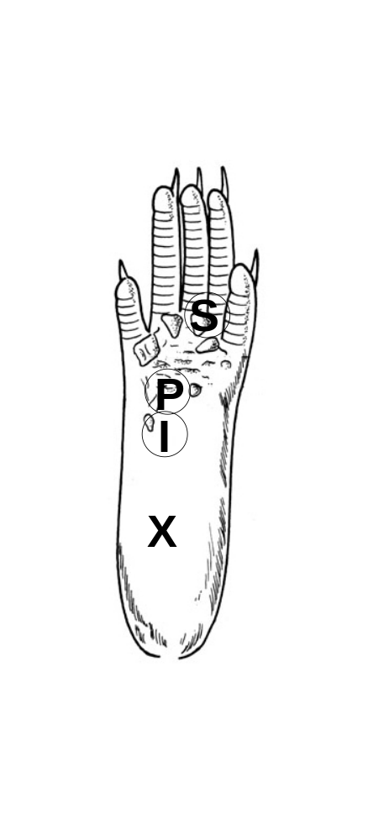
Figure 1: Sites of capsaicin injection and behavioral testing in the mouse hind foot

For capsaicin injection, a 30-gauge needle was inserted at the heel of the foot (X) and advanced to the injection site (I), and capsaicin (25 µg in 5 μl of vehicle) was injected intradermally (i.d.). Foot withdrawal frequencies in response to von Frey stimuli were measured at site P for primary hyperalgesia and at site S for secondary hyperalgesia.

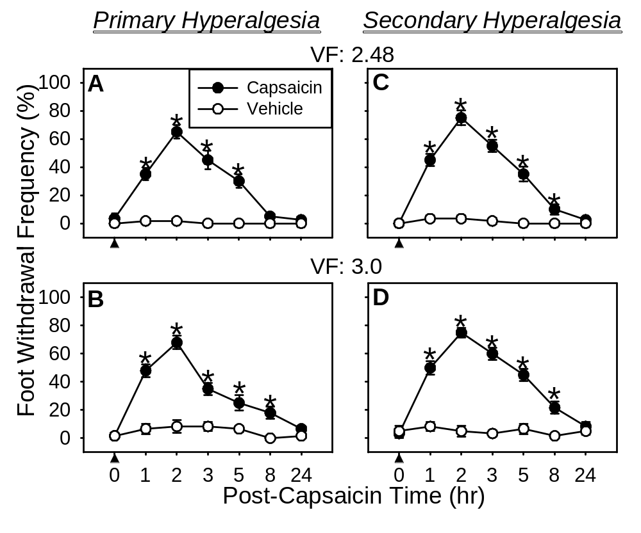
Figure 2: Time course of primary and secondary hyperalgesia after intradermal (i.d.) capsaicin injection (5μl, 0.5%) in the mouse hind foot

Asterisks (*), p≤0.05 (n=6), indicate values significantly different from corresponding values in the vehicle treated group according to Duncan’s post hoc test after two-way repeated ANOVA. Arrowheads indicate time of capsaicin (or vehicle) injection.
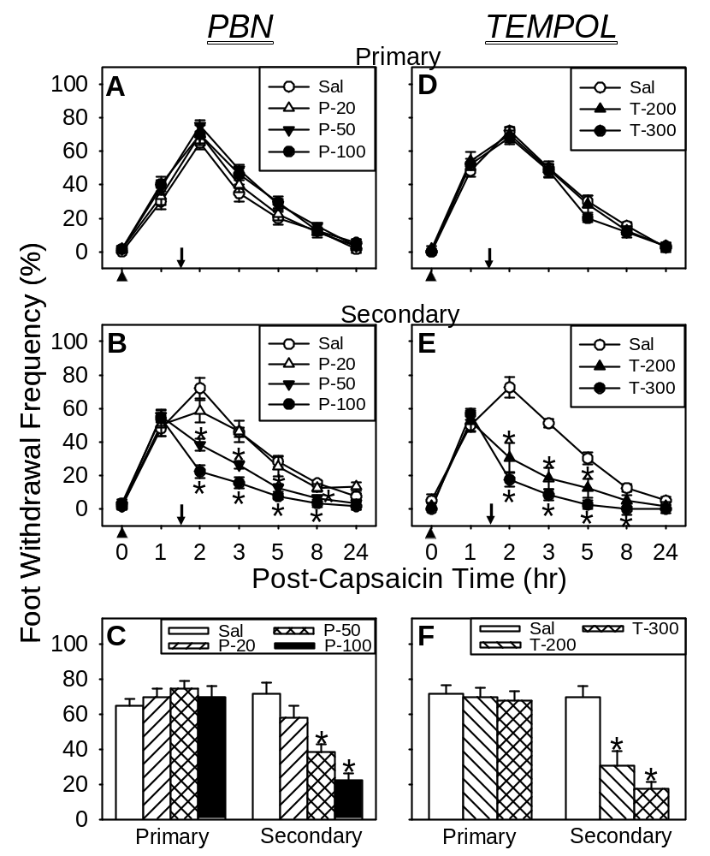

Figure 3: Effects of systemic (i.p.) PBN or TEMPOL post-treatment on capsaicin-induced hyperalgesia using vF # 2.48

A,D Time course of PBN or TEMPOL effects on primary hyperalgesia. B,E Time course of PBN or TEMPOL effects on secondary hyperalgesia. C,F The dose response of PBN or TEMPOL on secondary hyperalgesia 2 hr after i.d. capsaicin injection and 30 min post ROS scavenger. Asterisks (*), p ≤ 0.05 (n=6), indicate values significantly different from corresponding values in the vehicle treated group according to Duncan’s post hoc test after two-way repeated ANOVA. Arrowheads indicate time of capsaicin injection. Downward arrows indicate time of tested compound (PBN, TEMPOL, or saline) injection. PBN(P) doses: 20, 50, or 100 mg/kg body weight. TEMPOL(T) doses: 200 or 300 mg/kg body weight.

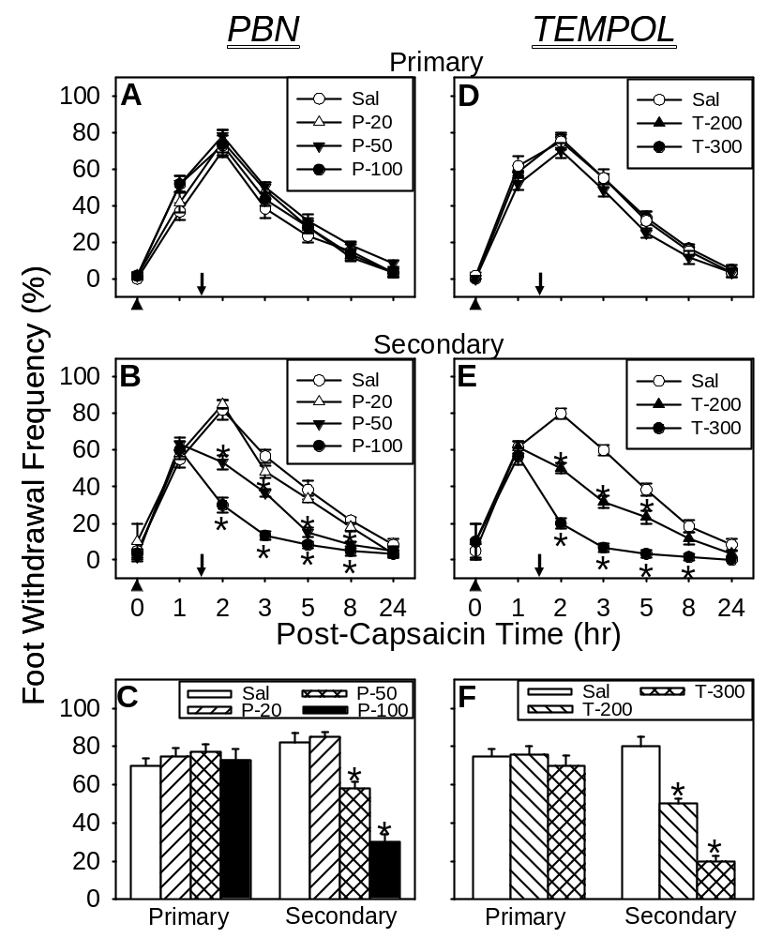

Figure 4: Effects of systemic (i.p.) PBN or TEMPOL post-treatment on capsaicin-induced hyperalgesia using vF # 3.00

A,D Time course of PBN or TEMPOL effects on primary hyperalgesia. B,E Time course of PBN or TEMPOL effects on secondary hyperalgesia. C,F The dose response of PBN or TEMPOL on secondary hyperalgesia 2 hr after i.d. capsaicin injection and 30 min post ROS scavenger. Asterisks (*), p ≤ 0.05 (n=6), indicate values significantly different from corresponding values in the vehicle treated group according to Duncan’s post hoc test after two-way repeated ANOVA. Arrowheads indicate time of capsaicin injection. Downward arrows indicate time of tested compound (PBN, TEMPOL, or saline) injection. PBN(P) doses: 20, 50, or 100 mg/kg body weight. TEMPOL(T) doses: 200 or 300 mg/kg body weight.
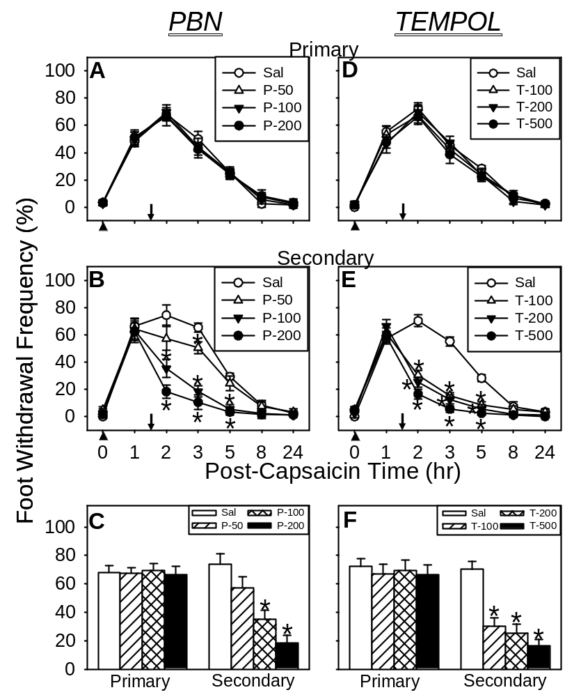

Figure 5: Effects of intrathecal (i.t.) PBN or TEMPOL treatment on capsaicin-induced hyperalgesia using vF # 2.48

A,D Time course of PBN or TEMPOL effects on primary hyperalgesia. B,E Time course of PBN or TEMPOL effects on secondary hyperalgesia. C,F The effect of PBN or TEMPOL on secondary hyperalgesia 2 hr after i.d. capsaicin injection and 30 min after either PBN, TEMPOL, or Saline treatment. Asterisks (*), p ≤ 0.05 (n=6), indicate values significantly different from corresponding values in the vehicle treated group according to Duncan’s post hoc test after two-way repeated ANOVA. Arrowheads indicate time of capsaicin injection. Downward arrows indicate time of tested compound (PBN, TEMPOL, or saline) injection. PBN(P) doses: 20, 50, or 100 μg in 5 μl. TEMPOL(T) doses: 100, 200, or 500 μg in 5 μl saline.

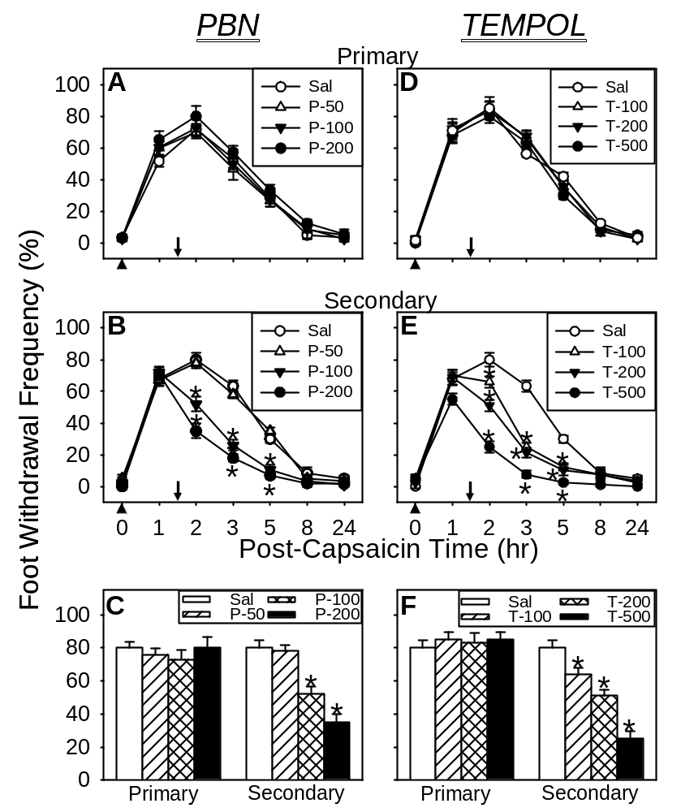

Figure 6: Effects of intrathecal (i.t.) PBN or TEMPOL treatment on capsaicin-induced hyperalgesia using vF # 3.00

A,D Time course of PBN or TEMPOL effects on primary hyperalgesia. B,E Time course of PBN or TEMPOL effects on secondary hyperalgesia. C,F The effect of PBN or TEMPOL on secondary hyperalgesia 2 hr after i.d. capsaicin injection and 30 min after either PBN, TEMPOL, or Saline treatment. Asterisks (*), p ≤ 0.05 (n=6), indicate values significantly different from corresponding values in the vehicle treated group according to Duncan’s post hoc test after two-way repeated ANOVA. Arrowheads indicate time of capsaicin injection. Downward arrows indicate time of tested compound (PBN, TEMPOL, or saline) injection. PBN(P) doses: 20, 50, or 100 μg in 5 μl. TEMPOL(T) doses: 100, 200, or 500 μg in 5 μl saline.
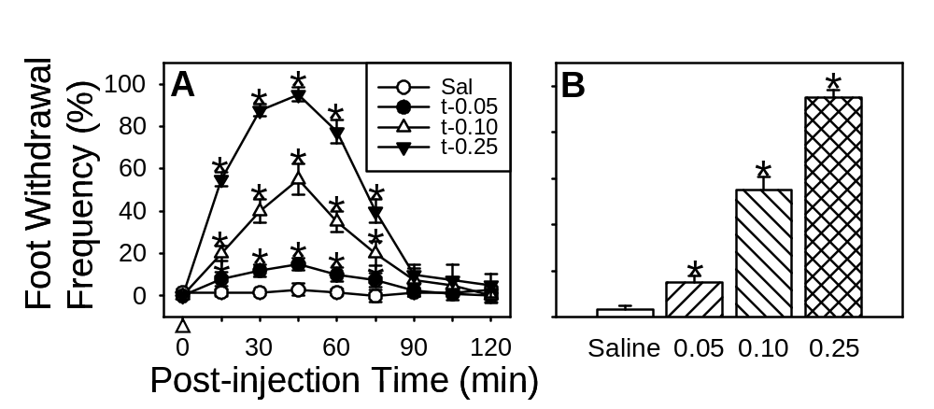

Figure 7: Effects of i.t. t-BOOH on mechanical hyperalgesia

A: i.t. t-BOOH transiently induced mechanical hyperalgesia in normal mice in a dose-dependent manner. Saline did not produc any changes in mechanical sensitivity. B: The bar graph shows the effect of t-BOOH on mechanical hyperalgesia 45 min after t-BOOH injection. Asterisks (*), p ≤ 0.05 (n=10). The open arrowhead indicates time of t-BOOH (or saline) injection. t-BOOH doses: 0.05, 0.10, or 0.25 mg in 5 μl saline.
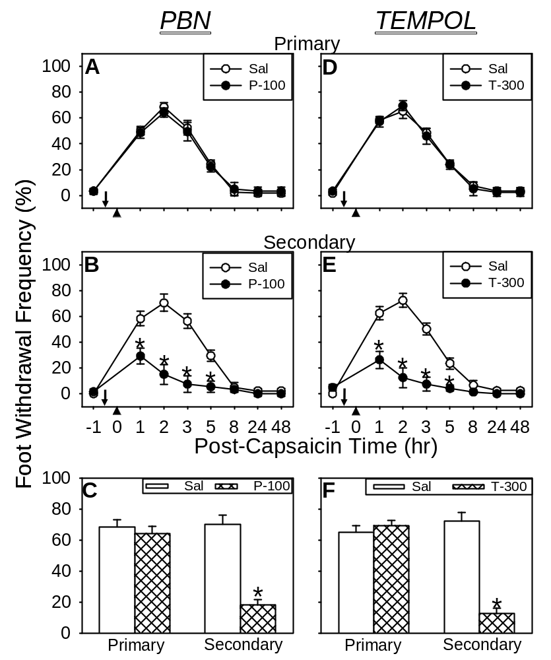

Figure 8: Effects of systemic PBN or TEMPOL pre-treatment on capsaicin-induced hyperalgesia using vF # 2.48
A,D Time course of PBN or TEMPOL effects on primary hyperalgesia. B,E Time course of PBN or TEMPOL effects on secondary hyperalgesia. C,F The effect of PBN or TEMPOL on secondary hyperalgesia 2 hr after i.d. capsaicin injection and 2.5 hrs after either PBN, TEMPOL, or Saline treatment. Asterisks (*), p ≤ 0.05, indicate values significantly different from corresponding values in the vehicle treated group according to Duncan’s post hoc test after two-way repeated ANOVA. Arrowheads indicate time of capsaicin (or saline) injection. Downward arrows indicate time of tested compound (PBN, TEMPOL, or saline) injection. PBN dose: 100 mg/kg body weight. TEMPOL dose: 300 mg/kg body weight.

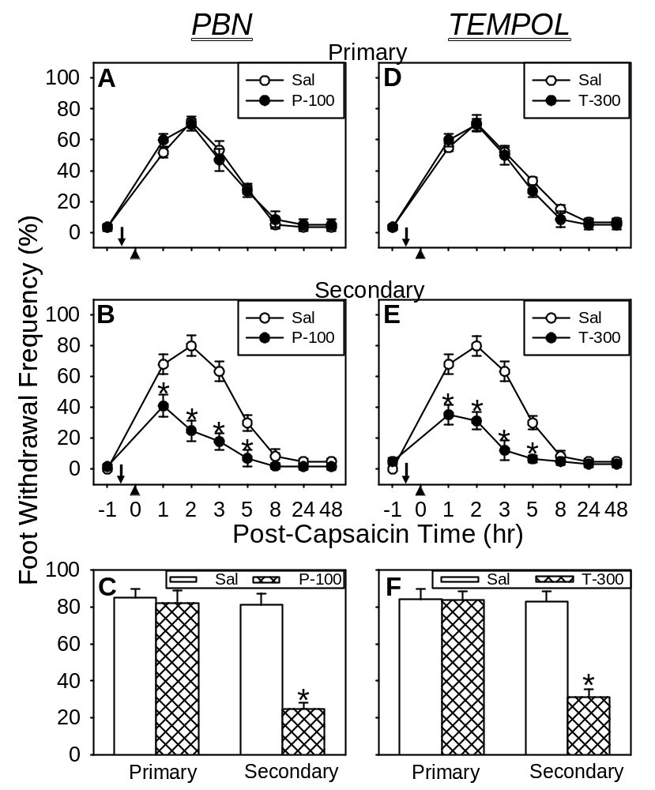

Figure 9: Effects of systemic PBN or TEMPOL pre-treatment on capsaicin-induced
hyperalgesia using vF # 3.00

A,D Time course of PBN or TEMPOL effects on primary hyperalgesia. B,E Time course of PBN or TEMPOL effects on secondary hyperalgesia. C,F The effect of PBN or TEMPOL on secondary hyperalgesia 2 hr after i.d. capsaicin injection and 2.5 hrs after either PBN, TEMPOL, or Saline treatment. Asterisks (*), p ≤ 0.05, indicate values significantly different from corresponding values in the vehicle treated group according to Duncan’s post hoc test after two-way repeated ANOVA. Arrowheads indicate time of capsaicin (or saline) injection. Downward arrows indicate time of tested compound (PBN, TEMPOL, or saline) injection. PBN dose: 100 mg/kg body weight. TEMPOL dose: 300 mg/kg body weight.

CHAPTER 4: INTRADERMAL INJECTION OF CAPSAICIN CAUSES INCREASED PRODUCTION OF MITOCHONDRIAL SUPEROXIDE IN SPINAL DORSAL HORN NEURONS

Introduction
Increased levels of ROS within mitochondria may, at least in part, lead to mitochondrial dysfunction, or alternatively, may be a result of mitochondrial dysfunction (dam-Vizi, 2005). A growing amount of evidence suggests that oxidative damage of mitochondria as a result of increased ROS levels may play a primary role in several neurodegenerative diseases such as aging, cancer, and diabetes (Shigenaga et al., 1994; Green et al., 2004). Oxidative damage to mitochondrial electron transport complexes and DNA can lead to mitochondrial DNA mutations, aberrant electron transport, disruption of calcium homeostasis, and activation of apoptosis (James and Murphy, 2002). Mitochondria consume 85-95% of the oxygen inspired during respiration, most of which is reduced to water, but a small portion (estimated from <0.1% to as high as 4%) of electrons leak from the respiratory chain to reduce oxygen to superoxide(O₂^{.-}) (Lenaz et al., 2002; Fridovich 2004). Studies have shown that both mitochondrial membrane potential and reduction state of respiratory chain carriers can affect superoxide production.
ROS can damage various intracellular macromolecules and has been shown to activate a variety of signaling pathways (Kamata and Hirata, 1999; Maher and Schubert, 2000). As mentioned, ROS are natural byproducts of activity of the mitochondrial electron transfer chain and the rate of superoxide formation is proportional to mitochondrial oxygen utilization. That means that as cell activity increases the demand for energy increases thus enhancing the activity of mitochondrial oxidative phosphorylation, leading to an increase in ROS production. When superoxides are produced during oxidative phosphorylation they are neutralized rapidly by the antioxidant system. This type of “check system” allows the redox state of the mitochondria to remain in balance. However, this balance can be disrupted, causing a change in the oxidative state to occur, thus causing superoxide levels to increase. The fates and consequences of superoxides produced in the mitochondria are multiple: some will oxidize mitochondrial protein, lipids, and nucleic acids; some will be dismutased into hydrogen peroxides by SOD2; and some will react with nitric oxide and produce peroxinitrites. Furthermore, increased production of superoxide can cause endothelial cell damage and increased microvascular permeability (Droy-Lefaix et al., 1991), release of cytokines (Salvemini et al., 1999; Matata and Galinanes, 2002), recruitment of neutrophils at sites of inflammation (Boughton-Smith et al., 1993; Salvemini et al., 1999), single-strand DNA damage (Dix et al., 1996), and poly-ADP-ribose-polymerase (PARP) activation (Inoue and Kawanishi, 1995).
Since behavioral studies have demonstrated that free radical scavengers administered in the spinal cord produce a powerful analgesic effect, we hypothesize that elevated spinal ROS after capsaicin injection to the foot id causing hyperalgesia. Furthermore, we hypothesize that the main source of elevated spinal ROS is dorsal horn neurons. This increase in ROS production occurs because capsaicin will produce intense activation of nociceptors initially and subsequently cause sensitization of them. This sensitization will lead to prolonged nociceptive afferent inputs to the spinal cord. This prolongation will cause hyperalgesia to occur and we hypothesize that this hyperalgesia results from a persistent state of peripheral afferent sensitization. This persistent state subsequently initiates spinal cord central sensitization through the release of the excitatory amino acid glutamate and studies have shown that application of glutamate induces a marked increase in intracellular ROS in cultured forebrain neurons (Bindokas, Jord n et al. 1996; Kahlert and Reiser 2004; Coyle and Puttfarcken 1993), suggesting glutamate mediated ROS production in neurons. Even though ROS production in glia has been reported in culture systems, and astrocytes have been seen to function as modulators of neuronal sensitivity to glutamate and/or in an antioxidant capacity, we hypothesize that neurons, due to the production of free radicals during glutamate toxicity, are the major source of ROS in the spinal cord in capsaicin-induced hyperalgesia. Furthermore, the number of neurons showing mitochondrial ROS production was significantly increased in the lumbar spinal dorsal horn in spinal nerve ligated neuropathic rats (Park et al. 2006).
Based on the reasoning stated above, mitochondria in the dorsal horn neurons are speculated to be the major source of superoxides in response to intraderamal capsaicin. Thus, the production of mitochondrial superoxides was determined by a histological method using a mitochondrial superoxide specific redox sensitive dye, MitoSOX (MS-R), in combination with immunostaining for neurons and glia. When injected intrathecally, MitoSOX diffuses in the spinal cord and is sequestered in mitochondria. Although this marker does not fluoresce in its original form, it fluoresces red when oxidized by mitochondrial superoxide produced. This study shows that many more dorsal horn neurons are labeled by MitoSOX after capsaicin treatment as compared to vehicle treated mice. The majority of MitoSOX positive cells are also identified as neurons. Based on this data, we hypothesize that neuronal production of mitochondrial superoxides is an important factor in capsaicin-induced hyperalgesia.

Results

Intradermal capsaicin induces increased mitochondrial superoxide production in the dorsal horn
To determine whether intradermal injection of capsaicin causes increased ROS production in the spinal cord, the number of cells showing oxidized MitoSOX was counted in the spinal dorsal horn. The reduced form of MitoSOX, a cell-permeant mitochondrial superoxide indicator, has no color and is sequestered in the mitochondria when absorbed by cells. It fluoresces red when oxidized by ROS that are produced by mitochondria. MitoSOX was injected intrathecally and capsaicin was injected into the paw 23 hr later. One hour after capsaicin injection, the spinal cord was removed after perfusion fixation, cryosectioned and examined under a fluorescent microscope. MitoSOX positive cellular profiles, containing red fluorescent granules in the cytoplasm (Fig. 10A & B), were counted in two different regions of the spinal dorsal horn: superficial (laminae I-II) and deep (laminae III-V) layers. Only the cellular profiles that contained red fluorescent granules in the cytoplasm, which surrounds a round to oval shaped dark nucleus, were counted in each sampled picture. After measuring the sampled area of each section, the density of MitoSOX positive cells (average # of cells per 10,000 μm² of sample area ± SEM) was calculated and the data are presented in Figure 11. In vehicle treated (VEH; n=7) mice, the average density of MitoSOX positive cells was 3.73 ± 0.55 and 5.13 ± 0.28 in the superficial and deep layers, respectively. The result indicates that there is a small number of cells that produce a sufficient amount of mitochondrial superoxide to oxidize sequestered MitoSOX in vehicle treated mice. In capsaicin-treated (CAP; n=7) mice, the density of MitoSOX positive cell profiles increased to 4.55 ± 0.59 for laminae I-II and 10.95 ± 0.44 for laminae III-V. These increases are significant on both regions but much greater in the deep layers. The results show that mitochondrial superoxide generation is increased significantly in both the superficial and deeper layers of the dorsal horn in capsaicin-treated mice.

ROS producing cells

To identify the type of cells producing ROS, tissues were immunostained for NeuN, GFAP, and OX-42 in combination with MitoSOX labeling. Examples of MitoSOX positive and NeuN immunoreactive dorsal horn cells are shown in Figure 12 and examples of GFAP immunoreactive astrocytes are shown in Figure 13. In these double labeled sections, MitoSOX labeling was identified as red fluorescent granules in the cytoplasm while NeuN immunostaining was observed as green fluorescence in the nucleus. When these two images were merged, 523 out of 608 MitoSOX positive cells enclosed green nuclei, thus indicating that greater than 85% of ROS producing cells are neurons (Figure 14). In astrocyte immunostained sections, GFAP immunostaining was observed as green fluorescence in the cytoplasm. Colocalization of GFAP was observed only in 31 cells out of 516 MitoSOX positive cells, thus indicating that less than 5% of ROS producing cells are astrocytes. In OX-42 immunostained tissue, microglial staining was almost absent as was colocalization with MitoSOX. The data show that increased mitochondrial superoxide production occurs mainly in neurons in the dorsal horn of the spinal cord after capsaicin treatment. The big increase in the number of MitoSOX positive dorsal horn neurons in capsaicin-treated mice provides strong evidence that increased mitochondrial superoxide production contributes to elevated spinal ROS levels and thus central sensitization in the persistent pain condition.
As a positive control, we examined OX-42 immunoreactivity and MitoSOX labeling in the spinal cord 3 days after L5 spinal nerve ligation, a peripheral neuropathy model, in mice. In these mice, we detected many OX-42 immunoreactive profiles that also contain MitoSOX labeling in the L5 spinal cord. Thus mitochondrial ROS of glial origin can be detected by MitoSOX with the method we used in this study. Since we did not detect any cellular profiles that were positive for both MitoSOX and OX-42, we hypothesize that mitochondrial superoxide production in activated microglia may not be a significant contributor to ROS elevation in the capsaicin-induced hyperalgesia model at the time point we have chosen to study.

Discussion
The present study shows that the significant increase in the number of MitoSOX positive neurons after i.d. capsaicin suggests that mitochondrial ROS production from the dorsal horn neurons may be the major contributor to the spinal ROS increase.
While behavioral data suggest that elevated spinal ROS is involved in capsaicin-induced central sensitization, the sources and critical types of ROS are not clear. There are multiple sources of ROS in nervous tissue: superoxide generation from mitochondrial oxidative phosphorylation; NO production by activation of NO synthase (Coyle and Puttfarcken, 1993); activation of phospholipase A2 leading to an arachidonate cascade, and production of xanthine oxidase by activation of proteases. Among these, mitochondria have been recognized as the major source of intracellular ROS in neurons during excitotoxicity (Schapira and Cooper, 1992). Since capsaicin-induced hyperalgesia is most likely due to a mild form of excitotoxicity, mitochondrial superoxide production in neurons is speculated as the major source of the enhanced spinal ROS. Furthermore, TEMPOL is known to remove superoxides preferentially (Thiemermann, 2003) and it had a strong analgesic effect on capsaicin-induced secondary hyperalgesia. Thus the data suggest that superoxides produced by mitochondria may be a major culprit. The significant increase of dorsal horn neurons that show staining for MitoSOX, specific mitochondrial superoxides, also supports an increased production of mitochondrial superoxides in the dorsal horn neurons in response to capsaicin. Although ROS production in glia has been well documented in cultured systems, this study shows that mitochondrial superoxide production in glia may not be the major source of spinal ROS in capsaicin induced hyperalgesia. This is based on our result that >85% of MitoSOX positive cells are neurons. Furthermore, less than 5% of MitoSOX positive cells were identified as astrocytes and no MitoSOX positive microglia was detected. Since we have observed that many OX-42 immunoreactive microglia were also labeled with MitoSOX in the spinal cords of neuropathic mice, we believe the absence of MitoSOX-containing microglia in capsaicin treated mice is not due to technical problems. However, additional contribution of glia through other types of ROS production methods, such as NADPH oxidase, could not be ruled out.
While previous studies showed that ROS are involved in central sensitization, it is not known what drives the increased mitochondrial ROS production in capsaicin-induced pain. As mentioned previously, studies have shown that application of glutamate induces an increase in intracellular ROS in cultured forebrain neurons (Bindokas et al., 1996; Kahlert et al., 2005), thus implicating glutamate mediated ROS production in neurons. Thus one possible cause of enhanced neuronal ROS production is increased glutamate receptor activation. Intradermal capsaicin injection will induce intense activation of small myelinated and unmyelinated afferent fibers and thus release excitatory amino acids from their central terminals in the spinal dorsal horn (Dougherty et al., 1993; Seybold et al., 1995). Glutamate will activate both ionotrophic and metabotrophic glutamate receptors, including NMDA receptors, which will lead to massive Ca²⁺ influx, thus increasing intracellular Ca²⁺ levels. High levels of intracellular Ca²⁺ will overload mitochondria, destabilize mitochondrial membrane potentials and accelerate the mitochondrial electron transport chain resulting in increased mitochondrial ROS generation (Coyle and Puttfarcken, 1993; Han et al., 2000). This increased ROS, in turn, can shift redox sensitive signaling pathways towards sensitization of dorsal horn neurons (Maher and Schubert, 2000). Thus we propose that peripheral capsaicin treatment causes excessive release of glutamate in the spinal cord and excessive glutamate receptor activation leads to increased production of ROS in neurons. We propose that spinal ROS are a small class of molecules that are produced as a result of calcium influx and act as cellular messengers in central sensitization. In conclusion, the present study demonstrates that the elevation of spinal ROS is most likely due to increased production of mitochondrial superoxides in dorsal horn neurons.

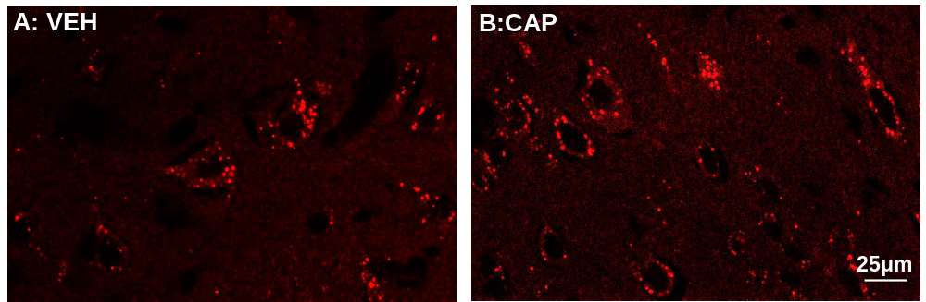

Figure 10: MitoSOX positive cells in the deep layers of the L4-L5 spinal dorsal horn

A&B: MitoSOX labeled cells: vehicle (VEH) and capsaicin (CAP) treated mice.

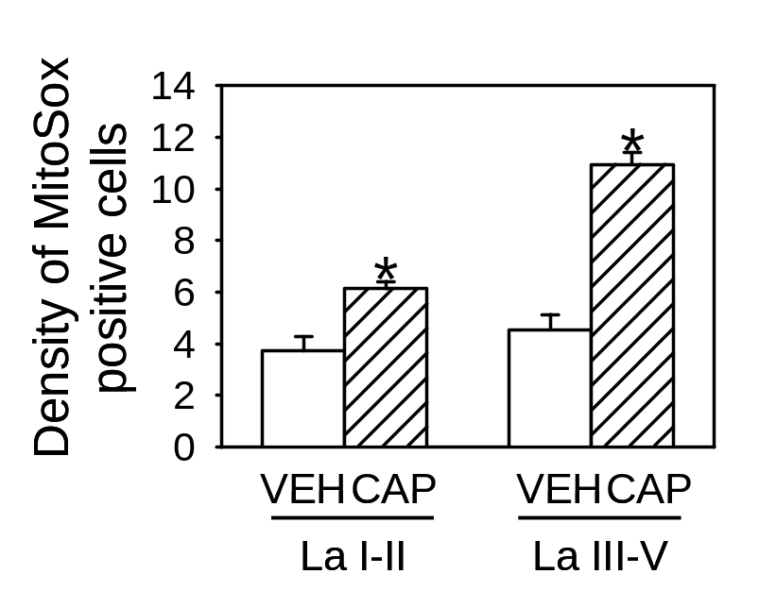
Figure 11: Density of MitoSOX positive cells

The average # of cells per 10,000 μm2 of sample area ± SEM in superficial (La I/II) and deep (La III/V) layers of the dorsal horn after vehicle (VEH; n=7) and capsaicin (CAP; n=7) treatment. Asterisks (*), p ≤ 0.05.

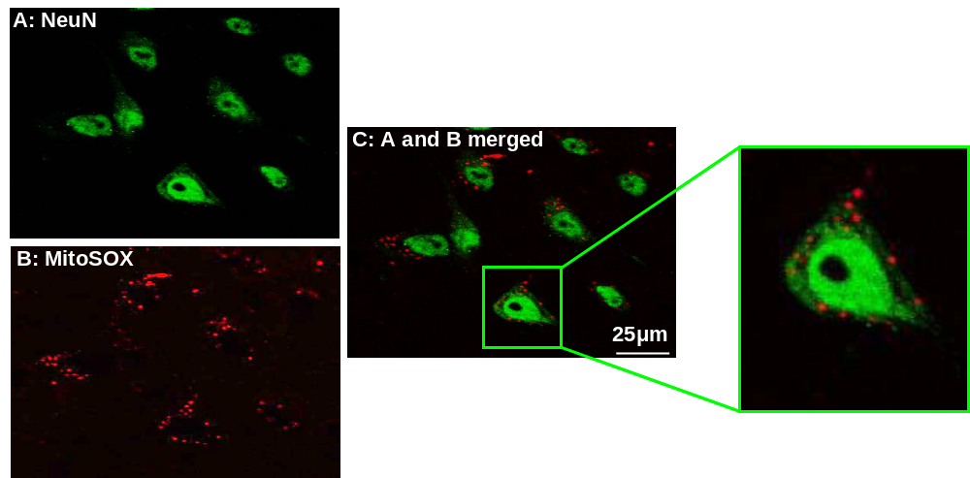

Figure 12: MitoSOX positive neurons in the deep layers of the L4-L5 spinal dorsal horn

A spinal cord section doubled-labeled for ROS with MitoSOX (B) and immunostained for neurons with antibodies to NeuN (A). When combined (C), the majority of MitoSOX labeled cells also contain NeuN-immunoreactive nuclei, thus indicating that they are neurons.

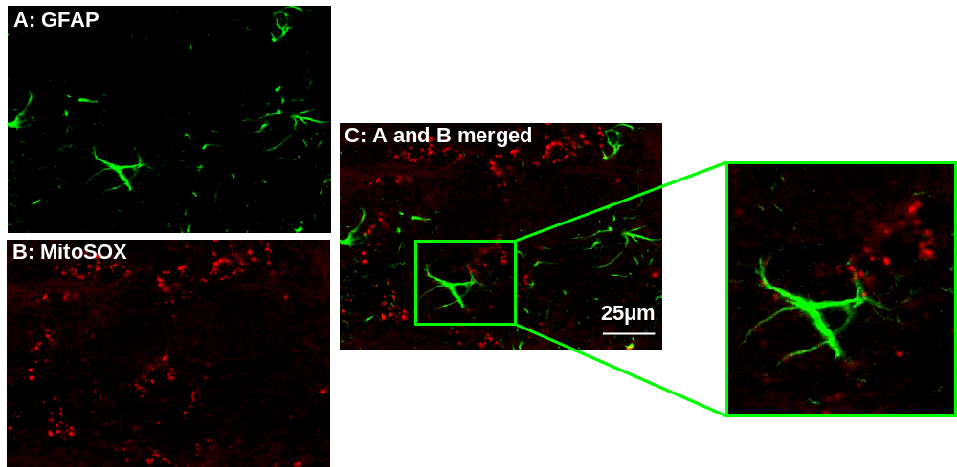

Figure 13: MitoSOX positive astrocytes in the deep layers of the L4-L5 spinal dorsal horn

A spinal cord section doubled-labeled for ROS with MitoSOX (B) and immunostained for astrocytes with antibodies to GFAP (A). When combined (C), the majority of MitoSOX labeled cells do not contain GFAP-immunoreactive cytoplasm, thus indicating astrocytes are not responsible for much of the increased superoxide production.
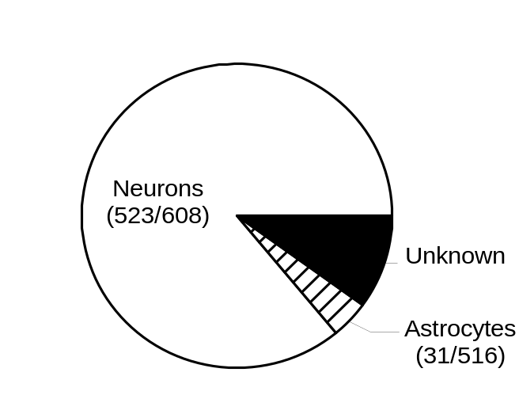

Figure 14: The average proportion of neurons and glia among MitoSOX positive, ROS producing cells

MitoSOX positive ROS producing, cellular profiles in the deep layer (La III-IV) of the dorsal horn after i.d. capsaicin injection (n=7).

CHAPTER 5: THE LEVELS OF MITOCHONDRIAL SUPEROXIDE DISMUTASE PLAY AN IMPORTANT ROLE IN CAPSAICIN-INDUCED SECONDARY HYPERALGESIA

Introduction
There is an increasing amount of experimental evidence that while it has been documented extensively that elevated levels of ROS can cause tissue damage in pathological conditions (Jenner, 1994), physiological concentrations of ROS are important cellular signaling messengers (Stone and Yang, 2006). Thus, ROS can be both beneficial and harmful at the same time and their levels are tightly controlled by endogenous antioxidant mechanisms. The present study extends this concept to examine the role of antioxidant superoxide dismutase (SOD) in central sensitization in the animal model of capsaicin-induced hyperalgesia.
Superoxide dismutases (SODs) are abundant endogenous enzymes in nervous tissue that neutralize superoxide (O₂^{.-}) by transforming it into hydrogen peroxide (H₂O₂). Hydrogen peroxides are normally further metabolized to molecular oxygen and water by catalase or gluthathione peroxidase (Fridovich, 1995). Thus SODs are the first and most crucial enzymes of the antioxidant defense systems against superoxides. Three distinct forms of SOD have been identified: Cu/ZnSOD (SOD1) found mainly in the cytoplasm, MnSOD (SOD2) localized primarily in the mitochondrial matrix, and EC-SOD (SOD3) localized in the extracellular space.
The mitchondria play a central role in energy metabolism and it has been proposed that mitochondrially generated ROS are a major source of degenerative diseases (Jenner, 1994). In line with that, the mitochondria are highly enriched with antioxidants and tightly regulate the levels of free radicals (Oury et al., 1999). SOD2 is the antioxidant enzyme that controls mitochondrial superoxide levels (Weisiger and Fridovich, 1973) and therefore is very important for mitochondrial superoxide-regulated physiological and pathological events. Under physiological conditions, approximately 0.2% of oxygen consumed by mitochondria is converted to ROS (Zeevalk et al., 2005; Staniek and Nohl, 2000). During electron transfer, electrons can escape from the normal reaction sequence and generate ROS, i.e. superoxide anions (Brookes, 2004). The nervous system is particularly vulnerable to oxidative stress because it consumes large amounts of oxygen (10 times more than other systems) and depends entirely on oxidative phosphorlyayion for its energy source (Halliwell, 1992). Therefore, it is not surprising that the mitochondria are a major neuronal source of intracellular ROS production. The mitochondria also are potent buffers of intracellular calcium (Shishkin et al., 2002); however, calcium overload can lead to destabilization of mitochondrial membrane potential, thus efficiency of oxidative phosphorylation (Nicholls, 2005). We propose that a sudden surge of intracellular Ca²⁺ following intense NMDA receptor activation overloads mitochondrial Ca²⁺ uptake. This destabilization of mitochondrial membrane potentials will enhance the activities of the mitochondrial electron transport system resulting in increased mitochondrial ROS production, which in turn inactivates mitochondrial antioxidant SOD2, thus causing more ROS accumulation. This increased ROS may affect redox sensitive signaling pathways towards sensitization of dorsal horn neurons, resulting in hyperalgesia.
Increased ROS production, specifically superoxide, in response to peripheral carrageenan injection has been shown to play a major role in the development of inflammatory pain through direct peripheral sensitization by ROS (Wang et al., 2004). The involvement of increased spinal ROS also has been demonstrated both in spinal nerve ligated neuropathic pain (Kim et al., 2004; Park et al., 2006) and in capsaicin-induced secondary hyperalgesia (Schwartz et al., 2006; Lee et al., 2007). However, a clear understanding of ROS mechanisms underlying persistent pain is lacking at the present time. The present study examines the effects of mitochondrial SOD (SOD2, MnSOD) function as a critical factor for determining the ROS effect on hyperalgesia. Based on our results, we hypothesize that elevated levels of spinal ROS after intradermal capsaicin treatment is partially due to decreased SOD2 function in the dorsal horn neurons. The study suggests that elevated spinal levels of ROS, specifically superoxides, are critical for capsaicin-induced secondary hyperalgesia, and the levels of SOD2 activities are inversely correlated with levels of hyperalgesia.

Results

SOD is involved in capsaicin-induced secondary hyperalgesia

To test whether SOD is involved in the maintenance and induction of capsaicin-induced hyperalgesia, the effect of a SOD mimetic, Mn(III) tetrakis (4-benzoic acid) porphyrin (MnTBAP), and a SOD inhibitor, diethylthiocarbamate (DETC), on pain was examined and the data are shown in Figures 15 and 16. Systemic (i.p.) MnTBAP treatment, 1.5 hrs after capsaicin injection, had no effect on the primary hyperalgesia (Fig. 15A). The same treatment; however, caused a significant reduction in secondary hyperalgesia (Fig. 15B), which lasted approximately 6 hours. In capsaicin-treated mice, foot withdrawal frequencies in response to vF stimuli were 75.3 ± 9.4 % (VF #2.48, n=6) and 79.6 ± 10.4 % (vF #3.00, n=6) with saline treatment; however, with a systemic injection of MnTBAP these values decreased to 32.7 ± 8.3 % (VF #2.48, n=6) and 28.1 ± 9.9 % (vF #3.00, n=6). In a dose-response study, 5 and 10 mg/kg of MnTBAP produced a graded antihyperalgesic effect, whereas, 2 mg/kg had no effect as compared to the saline treated group. The fact that a SOD mimetic produced antihyperalgesia only on secondary hyperalgesia suggests that superoxides are involved in central sensitization.
Intrathecal (i.t.) injection of a SOD inhibitor DETC (0.05 mg in 5 μl saline) 1.5 hr after capsaicin treatment, on the other hand, significantly enhanced and prolonged the secondary hyperalgesia but not the primary hyperalgesia (Fig. 16A & 16B). In capsaicin-treated mice, foot withdrawal frequencies in response to vF stimuli were 80.3 ± 7.8 % (VF #2.48, n=6) and 83.4 ± 11.1 % (vF #3.00, n=6) with an i.t. saline treatment; however, with DETC these values increased to 96.7± 7.5 % (VF #2.48, n=6) and 99.8 ± 8.9 % (vF #3.00, n=6) for the 0.05 mg dose. The enhanced hyperalgesia lasted up to 24 hr with the highest dose tested (0.05 mg) but for 8 hrs with two lower doses (0.01 and 0.02 mg). In a dose-response study, all three doses resulted in graded enhanced hyperalgesia as compared to the saline treated group. Since DETC would block superoxide dismutase activity and lead to superoxide accumulation, the enhancement of capsaicin-induced secondary hyperalgesia by DETC also supports the idea of superoxide involvement in central sensitization.
While post-treatment with either MnTBAP or DETC suggest that superoxides are involved in the maintenance of secondary hyperalgesia, it is not known whether superoxides are also critical for the development of capsaicin-induced hyperalgesia. To test this question, mice were treated with either MnTBAP or DETC 0.5 hr prior to capsaicin treatment and mechanical hyperalgesia was measured. Pre-treatment with MnTBAP (10 mg/kg) significantly reduced the capsaicin-induced secondary hyperalgesia (Fig. 15D) while DETC increased both the duration and the magnitude of capsaicin-induced secondary hyperalgesia (Fig. 16D). Neither MnTBAP nor DETC had any effect on the development of capsaicin-induced primary hyperalgesia (Figs. 15C & 16C). The results suggest that superoxides are critical not only for the development but also for the maintenance of capsaicin-induced secondary hyperalgesia, thus suggesting their roles in central sensitization.

Spinal levels of SOD2 proteins were unchanged but activities were decreased after capsaicin treatment
Previous data indicated that the levels of superoxide in the spinal cord are increased in response to intradermal capsaicin. Two possibilities were speculated on for the spinal superoxide elevation: decrease in SOD2 protein levels and/or decrease in SOD2 activity levels without protein level change. First, the total amount of SOD2 protein in the spinal cord was measured using a western blotting method. As shown in Figure 17, the levels of SOD2 protein in the ipsilateral L4-5 spinal cord did not change significantly one hour after capsaicin treatment compared to vehicle treated mice. Thus the data indicate that changes in the total SOD protein levels can not be the cause of superoxide accumulation.
In another experiment, the levels of SOD2 activity in the spinal cord were examined by a microtiter plate assay for SOD using a water soluble tetrazolium (WST-1) salt (Winterbourn and Peskin, 2000). The levels of SOD2 activity in the spinal cord are shown in Figure 18 under various conditions in mice. One hour after intradermal capsaicin treatment (CAP-1hr), the SOD2 activity levels in the ipsilateral L4/5 spinal cord were greatly decreased compared to that of vehicle treated mice. The average endogenous SOD2 activity was 259 ± 20.9 mU/μg protein, whereas, in capsaicin-treated mice it was 129.8 ± 12.8 mU/μg protein (n=12/group). This significant decrease, however, was completely reversed when the mice were treated with ROS scavengers, PBN or TEMPOL, 15 minutes after capsaicin (CAP+PBN-1hr and CAP+TEMPOL-1hr), with an average endogenous SOD2 activity of 284.8 ± 24.9 mU/μg protein (n=12/group) for PBN and 278.3 ± 25.4 mU/μg protein (n=12/group) for TEMPOL. These results indicate that the spinal superoxide increase in response to intradermal capsaicin might be due to reduced SOD2 activity but not decreased protein levels. When spinal SOD2 activity levels were measured 5 hours after capsaicin treatment, the time when mechanical hyperalgesia had significantly recovered from the peak hyperalgesic response at 2hr post capsaicin treatment, SOD2 activity levels were also significantly recovered from the lowest value at one-hour post treatment, with an average endogenous SOD2 activity of 209.45 ± 33.5 mU/μg protein (n=12/group). The data show that SOD2 activity levels are low when severe mechanical hypersensitivity develops in the paw and SOD2 activity levels recover moderately when hyperalgesia of the paw recovers moderately. The data suggests that decreased SOD2 activity in the spinal cord, at least in part, induces superoxide elevation and thus hyperalgesia.
Nitrated SOD2 levels were increased in the spinal cord after capsaicin treatment. Since spinal SOD2 activity levels were decreased without protein level changes, it was speculated that some SOD2 enzyme might have been inactivated. Since it has been shown that SOD can be inactivated by nitrosylation by peroxinitrite under some oxidative stress conditions (Yamakura et al., 1998; MacMillan-Crow and Cruthirds , 2001; Salvemini et al., 2001), the levels of nitrated SOD2 (N-SOD2) were measured in the L4/5 spinal cord of mice after various manipulations. The results for N-SOD2 protein levels in the spinal cord are shown in Figure 19. As speculated above, the levels of N-SOD2 in the ipsilateral L4/5 spinal cord were significantly increased (about 3 fold) one hour after capsaicin treatment, compared to those in vehicle-treated mice. Five hours after capsaicin treatment (CAP-5hr), spinal N-SOD2 levels were slightly higher but not significantly different from the vehicle treated mice (VEH-5hr). In addition, PBN and TEMPOL treatment in combination with capsaicin (CAP+PBN-1hr and CAP+TEMPOL-1hr) did not result in any difference in the spinal N-SOD2 protein levels from those of vehicle treated mice (VEH-1hr). These results indicate that the decrease in SOD2 activity levels in the spinal cord after capsaicin treatment may be, in part, caused by inactivation of SOD2 protein by nitration. The significant reduction of N-SOD2 levels by ROS scavengers also support the notion that elevated levels of ROS are involved in the nitration of SOD2.

Capsaicin-induced hyperalgesia is correlated with endogenous SOD2 activity levels
Previous data indicate that spinal SOD activity levels are inversely correlated with the levels of the capsaicin-induced secondary hyperalgesia. To correlate mitochondrial SOD (SOD2) function with hyperalgesia, capsaicin-induced hyperalgesia was measured in mice whose SOD2 function was modified genetically. Two genetically manipulated mice were used: SOD2 overexpressing transgenic mice (SOD2Tg^{+/-}) and SOD2 underexpressing knock out mice (SOD2KO^{+/-}). The wild type littermates were used as controls. Capsaicin-induced mechanical hyepralgesia was determined by measuring foot withdrawal frequencies in response to vF filament stimuli. Mechanical sensitivity was measured before and at various times after capsaicin treatment and the results are shown in Figures 20 and 21.
In SOD2KO^{+/-} mice, capsaicin injection produced significantly enhanced and prolonged (up to 48 hr) secondary hyperalgesia compared to wild type mice (Fig. 20). Primary hyperalgesia was also increased slightly in SOD2KO^{+/-} mice (Fig. 20A) and was statistically different from wt mice at certain time points. Foot withdrawal frequencies in response to vF stimuli were 97.5 ± 15.2% (vF #3.00 n=12) and 99.4 ±10.9% (vF #3.61, n=12) 2 hrs after capsaicin treatement in SOD2KO^{+/-} mice, and these values were still significantly high 50.7 ± 9.7% (vF #3.00, n=12) and 53.9 ± 10.3% (vF #3.61, n=12) at 24 hrs after (Figs. 20B), compared to the saline treated group. The results suggest that reduced levels of endogenous SOD2 might have caused significant elevation of spinal superoxides for a long period of time, which in turn caused enhancement and prolongation of capsaicin-induced hyperalgesia. To verify that the enhanced hyperalgesia was due to excessive superoxides, the effect of TEMPOL was tested in the SOD2KO^{+/-} mice. When TEMPOL was administered systemically 1.5 hr after capsaicin treatment, secondary hyperalgesia quickly subsided from 30 minutes after TEMPOL treatment and then returned to normal levels within 5 hrs after capsaicin treatment (Fig. 20D). Foot withdrawal frequencies in response to vF stimuli were 21.4 ± 9.2% (vF #3.00 n=12) and 24.7 ± 8.9% (vF #3.61, n=12) 1.5 hrs following i.t. TEMPOL treatment. In saline treated mice, these values remained increased to 94.7 ± 10.1% (vF #3.00, n=12) and 99.4 ± 12.5% (vF #3.61, n=12) 3 hrs after capsaicin treatment (Fig. 20D). To determine whether the enhanced hyperalgesia is due to reduced SOD2 function in these mice, the levels of SOD2 activity in the spinal cord were also measured in normal and after capsaicin treatment in SOD2KO^{+/-} mice. As shown in Figure 22, the basal endogenous levels of SOD2 activity were significantly lower in SOD2KO^{+/-} mice (SOD2KO^{+/-} VEH) compared to wild type mice (Wt VEH). The average endogenous SOD2 activity in wildtype vehicle treated mice was 280.6 ± 22.6 mU/μg protein (n=12), whereas, in SOD2KO^{+/-} mice this value decreased to 130.9 ± 15.3 mU/μg protein (n=12). One hour after capsaicin treatment, SOD2 activity levels further decreased in SOD2KO^{+/-} mice (SOD2KO^{+/-} CAP) and thus were significantly lower than those of capsaicin treated wild type litter mates (Wt CAP) or of vehicle treated SOD2KO^{+/-} mice (SOD2KO^{+/-} VEH). The average endogenous SOD2 activity one hr post capsaicin injection decreased to 83.8 ± 9.8 mU/μg protein (n=12), where this value was significantly different from the vehicle SOD2KO treated mice (130.9 ± 15.3 mU/μg protein) and from wt capsaicin treated mice (144.7 ± 8.9 mU/μg protein).
In SOD2 over-expressing SOD2Tg^{+/-} mice, the levels of capsaicin induced primary and secondary hyperalgesia were significantly reduced, especially the secondary hyperalgesia, compared to that of wild type littermates (Fig. 22). The data suggest that overexpression of SOD2 in SOD2Tg^{+/-} mice does not allow ROS accumulation to exceed normal levels, especially superoxide. Foot withdrawal frequencies in response to vF stimuli were 16.3 ± 9.2% (vF #3.00 n=10) and 18.5 ± 8.8% (vF #3.61, n=10) 2 hrs after capsaicin treatement in SOD2Tg^{+/-} mice. In saline treated mice, these values remained increased to 80.7 ± 10.2% (vF #3.00, n=10) and 84.2 ± 11.2% (vF #3.61, n=10) 3 hrs after capsaicin treatment (Fig. 22). The basal levels of SOD2 activity and their changes following capsaicin treatment were also measured in SOD2Tg^{+/-} mice. As shown in Figure 22, the basal endogenous levels of SOD2 activity (SOD2Tg^{+/-} VEH) were about 2 times that of wild type littermates (Wt VEH). One hour after capsaicin treatment, the spinal SOD2 activity levels (SOD2Tg^{+/-} CAP) did not change from the basal levels. The results provide evidence that under/over expression of endogenous SOD2 enhance/reduce superoxide accumulation in the spinal cord, which in turn increases/decreases central sensitization, and thus influence the levels of hyperalgesia. The average endogenous SOD2 activity in SOD2Tg vehicle treated mice was 537.8 ± 52.3 mU/μg protein (n=12) and one hr after capsaicin treatment this value was reported to be 522.8 ± 39.7 mU/μg protein (n=12) clearly showing no change in SOD2 activity.

Mitochondrial superoxide accumulation in response to capsaicin treatment is correlated to the levels of SOD2 activity
Previous data indicate that superoxide accumulation in the spinal cord is correlated with the levels of endogenous SOD2 activity. To determine whether mitochondrial superoxide levels in the spinal dorsal horn is modified by SOD2 activity levels, the number of dorsal horn neurons showing increased superoxides were detected by using redox sensitive dye MitoSOX. The reduced colorless form MitoSOX was injected intrathecally approximately 24 hr before sacrificing the animals in order to allow dye penetration into the spinal cord and to sequester it in the mitochondria. One day later, mice were treated with either capsaicin or vehicle and then sacrificed by perfusion fixation one hour after capsaicin treatment. This study was done in SOD2Tg^{+/-} and SOD2KO^{+/-} mice and their wild type littermates with and without capsaicin treatment and the results were compared among the different groups.
When the spinal cord sections were examined under an epifluorescent microscope, oxidized MitoSOX labeling was detected as red fluorescent granules scattered in the cytoplasm of cells (Fig. 23) as shown in previous study (Schwartz et al., 2007). Since it was clear that the number of MitoSOX positive cells varied greatly among different group tissues, quantification was done for the number of MitoSOX positive cells in the superficial (laminae I-II) and deep (laminae III-V) layers of the spinal dorsal horn and results are shown in Figure 24. As shown before, intradermal capsaicin (CAP) induced a significant increase in the number of MitoSOX positive cells in the spinal dorsal horn compared to that of vehicle treatment (VEH). In SOD2 underexpressing SOD2KO^{+/-} mice, the number of MitoSOX positive cells is slightly higher, but not significantly different, than wild type mice with vehicle treatment. After capsaicin treatment; however, the number of MitoSOX positive cells was increased significantly (2-3 fold) compared to that of vehicle treatment. This increase in SOD2KO^{+/-} mice is significantly higher than that in wild type mice with capsaicin treatment. In SOD2Tg^{+/-} mice, on the other hand, there was no difference in the number of MitoSOX positive cells after capsaicin treatment as well as basal levels compared to that of vehicle treated wild type littermates. The results confirmed that the levels of endogenous SOD2 levels determine the superoxide accumulation in the mitochondria, which in turn induce central sensitization and leads to hyperalgesia.

Discussion
Our previous study demonstrated that increased levels of spinal ROS are critical for the maintenance of capsaicin-induced secondary hyperalgesia, suggesting ROS involvement in central sensitization. The present study provides further evidence that mitochondrial superoxides are the major source of elevated spinal ROS in capsaicin-induced secondary hyperalgesia. The increased level of spinal superoxides is in part due to reduced levels of SOD2 activity as a consequence of inactivation of SOD2 enzymes by nitration. The decreased or increased levels of capsaicin-induced hyperalgesia are in accordance with the artificially increased or decreased levels of SOD, respectively, further support the importance of SOD for determining levels of hyperalgesia. Increased and decreased numbers of MitoSOX positive dorsal horn neurons and hyperalgesia in SOD2KO and SOD2Tg mice in response to capsaicin treatment confirms that reduced/increased mitochondrial SOD2 levels is a major contributor to spinal superoxide increase and thus hyperalgesia.
The present study demonstrates that superoxide elevation centrally in response to peripheral capsaicin is a key event in the development and maintenance of capsaicin-induced secondary hyperalgesia. This notion is proved via two lines of evidence. First, a SOD mimetic and a SOD inhibitor exerted a significant effect on capsaicin-induced secondary hyperalgesia. A significant reduction of the capsaicin-induced secondary hyperalgesia by a non-specific SOD mimetic, MnTBAP, suggests that exogenously supplemented action of superoxide dismutation by SOD to hydrogen peroxides reduced central sensitization. It is important to note that there was a problem in using this mimetic at high concentrations due to its low solubility; for this reason the systemic route of administration was used rather than intrathecal injection. A significant enhancement of the capsaicin-induced secondary hyperalgesia by a non-specific SOD inhibitor, DETC, further supports the notion that SOD determines the levels of central sensitization and thus secondary hyperalgesia. In both conditions, however, since both MnTBAP and DETC are non-specific drugs, these drugs will modify levels of superoxides not only in the mitochondria but also in the cytoplasm and extracellular spaces. For this reason, the specific source of superoxides, mitochondria, cytoplasm, or extracellular space, can not be identified. This important question was partially solved by using SOD2KO and SOD2Tg mice. In these mice, mitochondrial SOD protein and activity levels were modified accordingly as shown in our data, thus clearly specifying that the superoxide changes in the mitochondria are correlated with the levels of secondary hyperalgesia. Furthermore, the increased or decreased numbers of MitoSOX positive dorsal horn neurons in response to intradermal capsaicin in these SOD2KO and SODTg mice, respectively, also confirms that the mitochondrial superoxide generation is the major culprit for ROS elevation in the spinal cord and central sensitization.
The results show that SOD activity levels are compromised in the spinal cord following intradermal capsaicin injection without a reduction of total SOD protein levels. Thus, inactivation of SOD enzyme was speculated as a possible cause. Previous studies demonstrated that nitration of SOD is one of the inactivation mechanisms of SOD under oxidative stress conditions (Yamakura et al., 1998; Millan-Crow and Cruthirds, 2001; Echtay et al., 2002; Demicheli et al., 2007). Thus our data agrees with other studies showing that SOD inactivation by nitration can be reversed by removal of superoxide or nitric oxide, which inhibits the formation of peroxynitrite and peroxynitrite-mediated protein nitration (Akizuki et al., 2000; Salvemini et al., 2001). Our results show that increased inactivation of SOD2 by nitration coincides with the reduction of spinal SOD2 activity levels in the spinal cord after capsaicin treatment. The data suggest that superoxide elevation may be caused by SOD2 inactivation and this process is reversed by removing superoxides using the SOD mimetic MnTBAP (Fries et al., 2003). The present data are also in agreement with previous studies in which the SOD mimetic M40403 produced an antihyperalgesic effect in carrageenan-induced hyperalgesia (Salvemini et al., 1999; Salvemini et al., 2001) and the SOD mimetic MnTBAP protected against carrageenan-induced-pleurisy (Cuzzocrea et al., 1999). The data further suggest that nitric oxide generation may also be an important factor for central sensitization and hyperalgesia. In support of this, an increased nitric oxide production in the spinal dorsal horn in response to intradermal capsaicin (Wu et al., 2001) and inhibition of capsaicin-induced hyperalgesia by a NO synthase inhibitor (Lin et al., 1999) have been documented. Based on all these findings, we propose that mitochondrial superoxide elevation in combination with nitric oxide generation in the spinal dorsal horn, in response to intradermal capsaicin, lead to SOD2 inactivation by nitration (Figure 25). The elevated N-SOD2 in turn maintains the elevated mitochondrial superoxides, thus maintaining capsaicin-induced secondary hyperalgesia.
The data suggest that elevated mitochondrial superoxide levels in the dorsal horn neurons in response to intradermal capsaicin lead to enhanced excitability of these neurons and thus hyperalgesia. While it becomes clear that inactivation of SOD2 by nitration causes maintained elevation of mitochondrial superoxide levels, it is not fully understood what drives the initial SOD2 inactivation. One speculation is that the intense nociceptive input caused by capsaicin injection is driving an initial increase of mitochondrial superoxide generation by extensive activation of glutamate receptors, NMDA receptors in particular. Two possible mechanisms of increased mitochondrial superoxide generation can be considered. One is the increased energy demands due to a sudden increase in the activity of dorsal horn neurons that were bombarded by an overwhelming amount of excitatory amino acids released from nociceptive afferent fibers (Dougherty et al., 1993; Seybold et al., 1995; Jaffrey et al., 2001). This increased energy demand will facilitate the mitochondrial oxidative phosphorylation process for ATP production and thus increase superoxide generation. The other possibility is that an intense NMDA receptor activation will lead to a sudden massive Ca²⁺ influx, thus increasing intracellular Ca²⁺ levels. It is speculated that high levels of intracellular Ca²⁺ will overload mitochondria with Ca²⁺, destabilize mitochondrial membrane potentials, and thus speed up the mitochondrial electron transport system (Galeazza et al., 1995; Nicholls, 2005). Whether it is due to energy demand increase, destabilization of membrane potential, or both, the result will be an increase in mitochondrial superoxide generation, which in turn may inactivate SOD2 enzymes (Han et al., 2000). Thus we propose that the initial elevation of mitochondrial superoxide in combination with NO generation in the dorsal horn neurons will inactivate SOD2 enzymes by nitration, which will in turn maintain elevated superoxide levels and thus contribute to maintained secondary hyperalgesia. Although glutamate receptor activation leading to ROS generation has been shown in hippocampal CA1 neurons during LTP generation (Bindokas et al., 1996; Klann and Thiels, 1999), the initial ROS generation through glutamate receptor activation in dorsal horn neurons in response to intradermal capsaicin needs to be explored in future studies.
While it is evident that elevated superoxide levels in mitochondria in dorsal horn neurons are critical for secondary hyperalgesia, the exact mechanism of neuronal sensitization by mitochondrial superoxide is not known. The possibilities include deregulation of membrane potentials due to lipid peroxidation (Wang and Thayer, 2002; Choi et al., 2004) and modification of cellular signal transduction pathways due to changed redox status of cells toward oxidation (Sluka et al., 1997; Palecek et al., 2002). Since our study shows that hyperalgesia and SOD2 nitration are reversible within 0.5-1 hr after treatment with a SOD mimetic, it is most likely that superoxide is involved in modification of the reversible cellular signal transduction pathways between sensitization and desensitization of cells. Future studies are warranted to explore what signal transduction pathways are under control of the redox state of the dorsal horn cells in the capsaicin-induced central sensitization process.
The fact that an SOD mimetic or inhibitor affects only secondary hyperalgesia indicates that the primary site of ROS actions is the spinal cord. In SOD2Tg and SOD2KO mice, however, in addition to the large decrease and increase of the secondary hyperalgesia in response to capsaicin, respectively, the levels of primary hyperalgesia are also affected slightly but significantly compared to that of wild type animals. The results suggest that genetic manipulation of SOD2 might have deviated the physiological properties of primary afferent neurons from their normal characteristics.
Regarding the MitoSOX imaging data, a relatively small number of MitoSOX positive neurons are counted in the superficial dorsal horn (laminae I-II) compared to the deep dorsal horn (laminae III-V). The data seem to contradict the normal anatomy since the major nociceptive afferents project to the superficial dorsal horn. We believe this apparent discrepancy is due to technical limitations. As seen in Fig. 9A, MitoSOX labeling is seen as red granules, representing mitochondria, scattered in the cytoplasm. The cell counts are done when there is a definite nucleus surrounded by red granules. Thus when only a small number of red granules are present without an obvious nucleus, the cells are not included as positive neurons. This strict criterion might have eliminated many small dorsal horn neurons with very little cytoplasm, the typical of small neurons in lamina II. It will be desirable to repeat the experiments when a better labeling method is developed in the future to clarify this discrepancy. In conclusion, the present data suggest that elevated spinal levels of ROS, specifically superoxide, are critical for capsaicin-induced secondary hyperalgesia. They also suggest that SOD2 is a critical enzyme and most likely the mechanism that is maintaining the elevated superoxide levels in the spinal cord after capsaicin treatment. Futhermore, this study suggests the possible therapeutic potential for targeting SOD2 in persistent pain conditions.

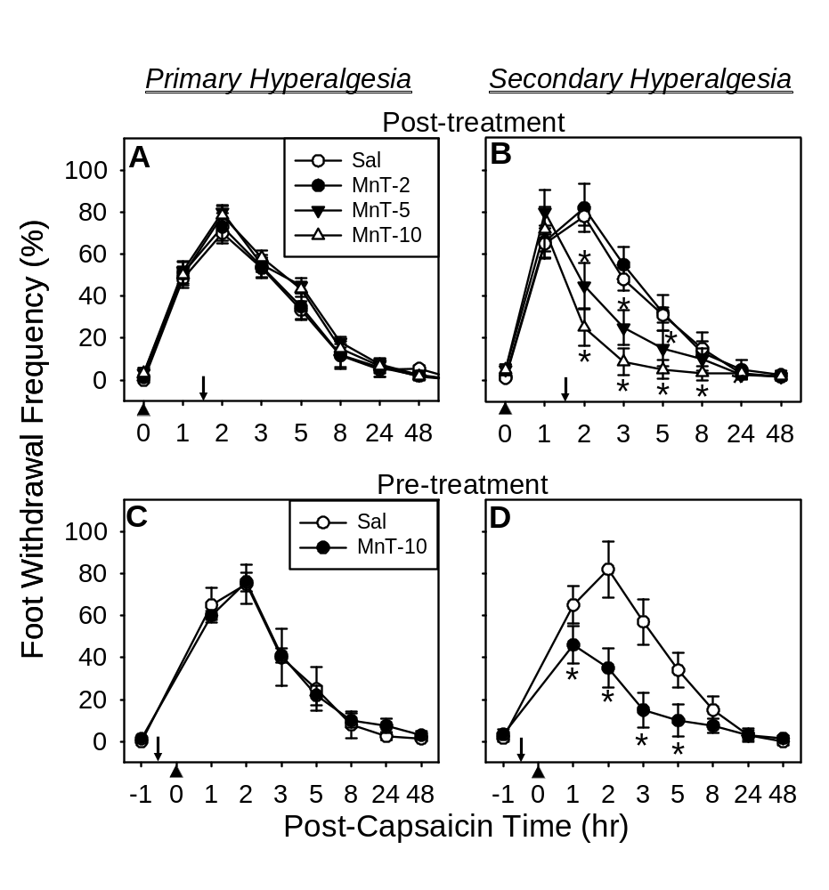

Figure 15: Effect of a SOD mimetic, MnTBAP, on capsaicin-induced hyperalgesia

A & B are post-treatment effect and C & D are pre-treatment effect. The mean ± SEM (n=6/ group) of primary (A&C) and secondary hyperalgesia (B&D) are plotted against the post capsaicin treatment time. MnTBAP (or vehicle saline) was injected systemically (i.p.) 1.5 hr after or 0.5 hr before (indicated by downward arrows) capsaicin injection (indicated by upward arrow heads) for post- or pre-treatments, respectively. MnTBAP reduced capsaicin-induced secondary hyperalgesia in a dose dependent manner but not primary hyperalgesia. *: values significantly different from corresponding values of the vehicle treated group at p ≤ 0.05, by Duncan’s post hoc test after two-way repeated ANOVA. The data indicate that removal of superoxides exogenously supplemented by a SOD mimetic, reduces capsaicin induced secondary hyperalgesia. MnTBAP(Mn-T) doses: 2, 5, or 10 mg/kg body weight.

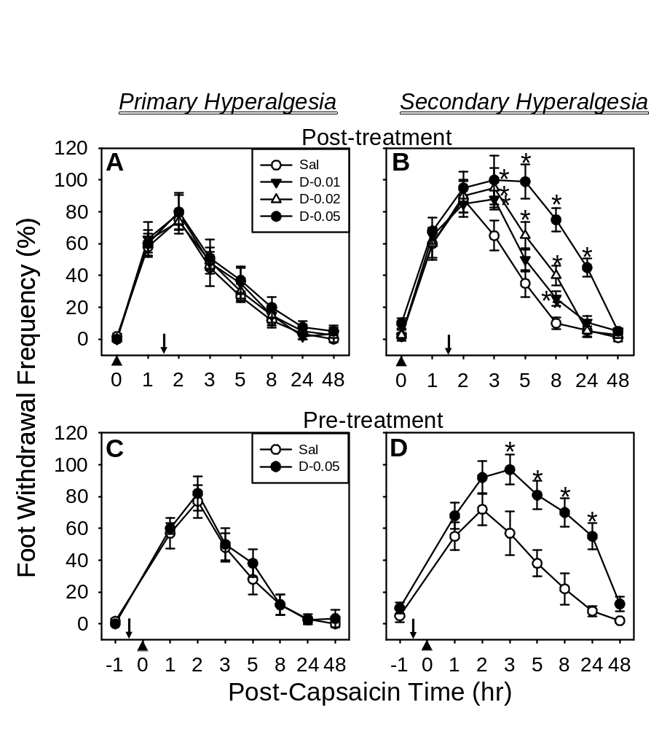

Figure 16: Effect of a SOD inhibitor, DETC, on capsaicin-induced hyperalgesia

A & B are post-treatment results and C & D are pre-treatment results. The mean ± SEM (n=6/ group) of primary (A&C) and secondary hyperalgesia (B&D) are plotted against the post capsaicin treatment time. DETC (or vehicle saline) was injected i.t. 1.5 hr after or 0.5 hr before (indicated by downward arrows) capsaicin injection (indicated by upward arrow heads) for post- or pre-treatments, respectively. DETC enhanced and prolonged capsaicin-induced secondary hyperalgesia in a dose dependent manner but not primary hyperalgesia. *: values significantly different from corresponding values of the vehicle treated group at p ≤ 0.05, by Duncan’s post hoc test after two-way repeated ANOVA. The data indicate that superoxide accumulation caused by inhibition of SOD enhances and prolongs the capsaicin induced secondary hyperalgesia. DETC(D) doses: 0.01, 0.02, or 0.05 mg in 5 μl saline.

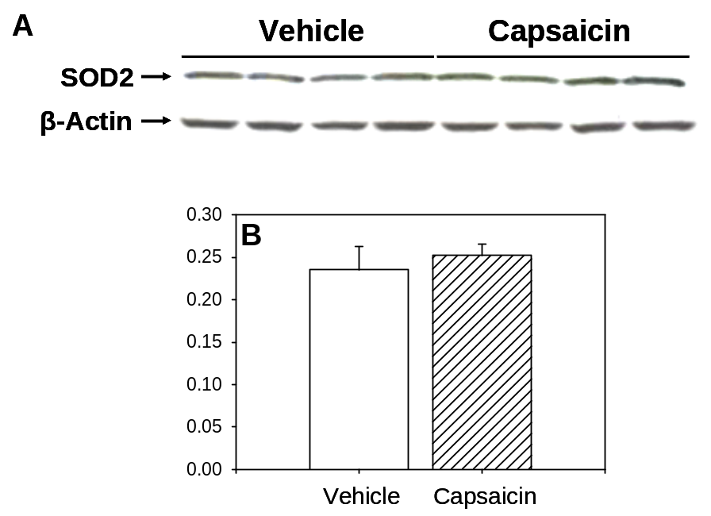

Figure 17: Total SOD2 protein levels in the L4/5 spinal cord

Examples of western blot gels for SOD2 proteins are show in (A) and the averaged relative density of SOD2 protein to β-actin are shown in (B). There is no change in the total amount of SOD2 proteins in the spinal cord one hr after i.d. capsaicin injection into the paw compared to that of vehicle injection. Data are expressed as mean ± SEM (n=8) and statistical analysis was done by non-paired t-test.

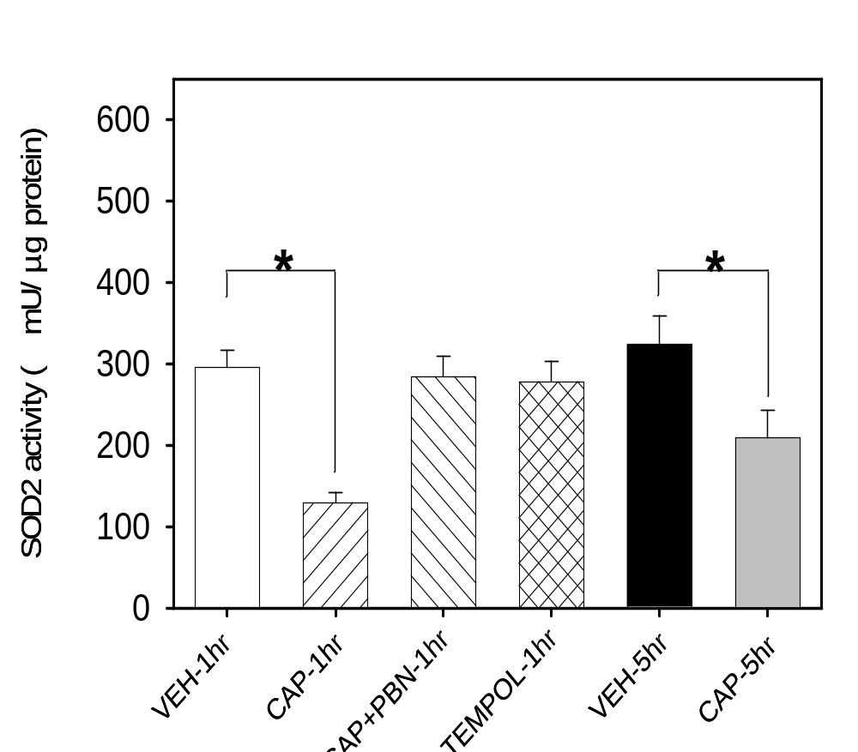

Figure 18: Total SOD2 activity levels in the L4/5 spinal cord

The SOD2 activity levels were measured in the following 6 groups of mice (n=12 per group) and the averaged values (± SEM) are shown in the above figure. CAP-1hr & CAP-5hr: 1hr and 5 hr after i.d. capsaicin injection, VEH-1hr & VEH-5hr: 1hr and 5hr after i.d. vehicle injection, CAP+PBN-1hr & CAP+TEMPOL-1hr: 1 hr after capsaicin plus PBN (100 mg/kg) or TEMPOL (300 mg/kg) treatment; PBN or TEMPOL was injected systemically (i.p.) 15 min after i.d. capsaicin injection. SOD activity levels were significantly reduced 1 hr after capsaicin then moderately recovered at 5 hr compared to that of vehicle treatment. Capsaicin-induced reduction on SOD2 activity was completely recovered by treatment with ROS scavengers, PBN and TEMPOL. *: values significantly different from corresponding values in the vehicle treated group at p ≤ 0.05 (n=12), by Duncan’s post hoc test after one-way repeated ANOVA. The data indicate that i.d. capsaicin induce the reduction in SOD2 activity in the spinal cord due to ROS elevation.

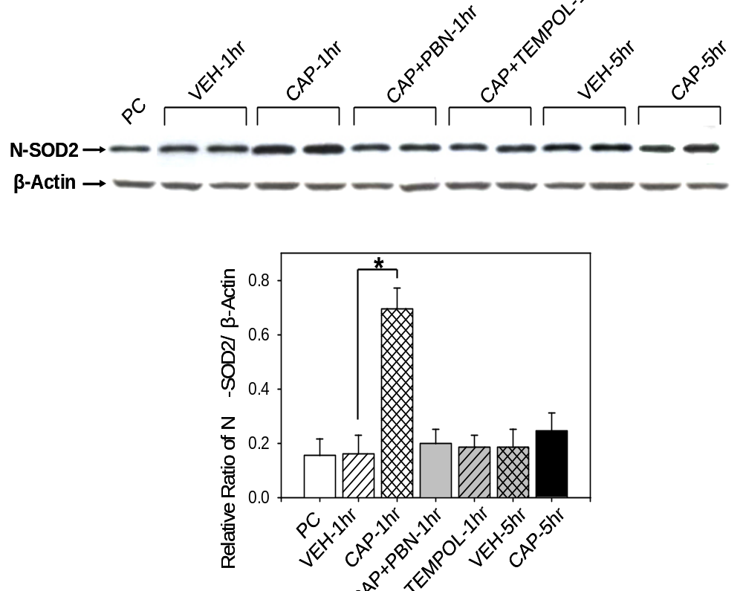

Figure 19: Nitrated SOD2 (N-SOD2) protein levels in the L4/5 spinal cord

An example of western blot gel for N-SOD2 is shown in the top panel and the averaged relative densities (± SEM) of N-SOD2 to β-actin are shown in the bottom graph. One hour after i.d. capsaicin treatment (CAP-1hr), the inactivated N-SOD2 levels increase approximately 3 times compared to vehicle treatment (VEH-1hr). Treatment with ROS scavengers (PBN: 100mg/kg; TEMPOL: 300 mg/kg) 15 minutes after capsaicin injection (CAP+PBN-1hr & CAP+TEMPOL-1hr), completely reversed N-SOD2 levels to normal levels. Five hours after capsaicin treatment (CAP-5hr), N-SOD2 levels were slightly higher than vehicle treated (VEH-5hr) control mice but not significantly different. The data indicate that ROS accumulation in the spinal cord might be caused, in part, by inactivation of SOD2 by nitration. *: value is significantly different between two linked groups at p ≤ 0.05 (n=8) by Bonferroni post hoc test after one-way ANOVA.

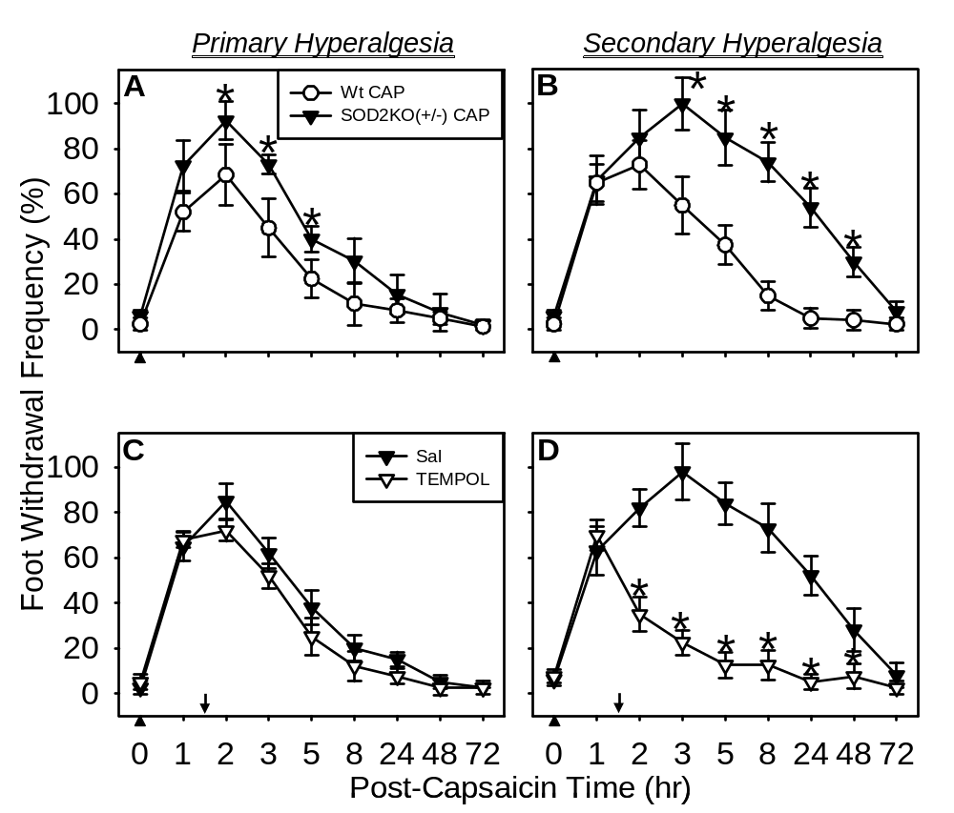

Figure 20: Capsaicin-induced primary (A) and secondary (B) hyperalgesia in SOD2 underexpressing SOD2KO+/- mice and ROS scavenger effect on primary (C) and secondary (D) hyperalgesia

The average foot withdrawal frequencies (± SEM, n=10 per group) in response to vF (#3.61) stimuli are plotted against the post capsaicin treatment (indicated by upward arrow heads) time. The capsaicin-induced hyperalgesia, both primary and secondary, was significantly enhanced and prolonged in SOD2KO^{+/-} mice compared to that of wild type littermates. Post-treatment with a ROS scavenger, TEMPOL (500 μg in 5 μl saline; indicated by downward arrow), 1.5 hr after capsaicin, significantly reduced secondary hyperalgesia but not primary hyperalgesia. Asterisks (*): values are significantly different from corresponding values in the control groups (wild type mice in A&B, saline group in C&D) at p ≤ 0.05 by Duncan’s post hoc test after two-way repeated ANOVA.

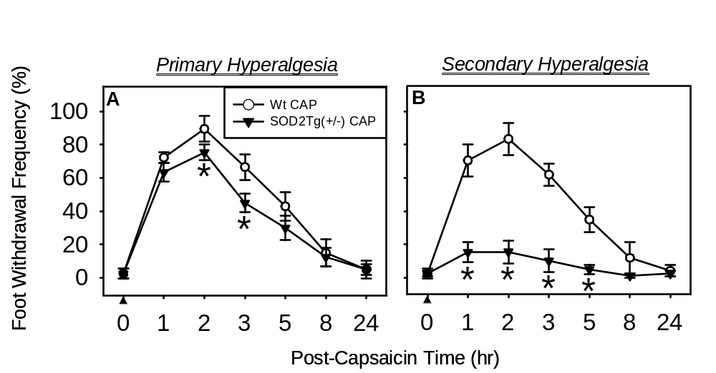

Figure 21: Capsaicin-induced primary (A) and secondary (B) hyperalgesia in SOD2 overexpressing SOD2Tg+/- mice

The capsaicin-induced hyperalgesia, both primary and secondary, were significantly reduced in SOD2Tg^{+/-} mice compared to wild type littermates. The effect is severer for secondary hyperalgesia than primary hyperalgesia, thus secondary hyperalgesia is almost non-existent. Asterisks (*): values are significantly different from corresponding values in the wild type littermates (Wt CAP) at p ≤ 0.05 (n=10) by Duncan’s post hoc test after two-way repeated ANOVA.

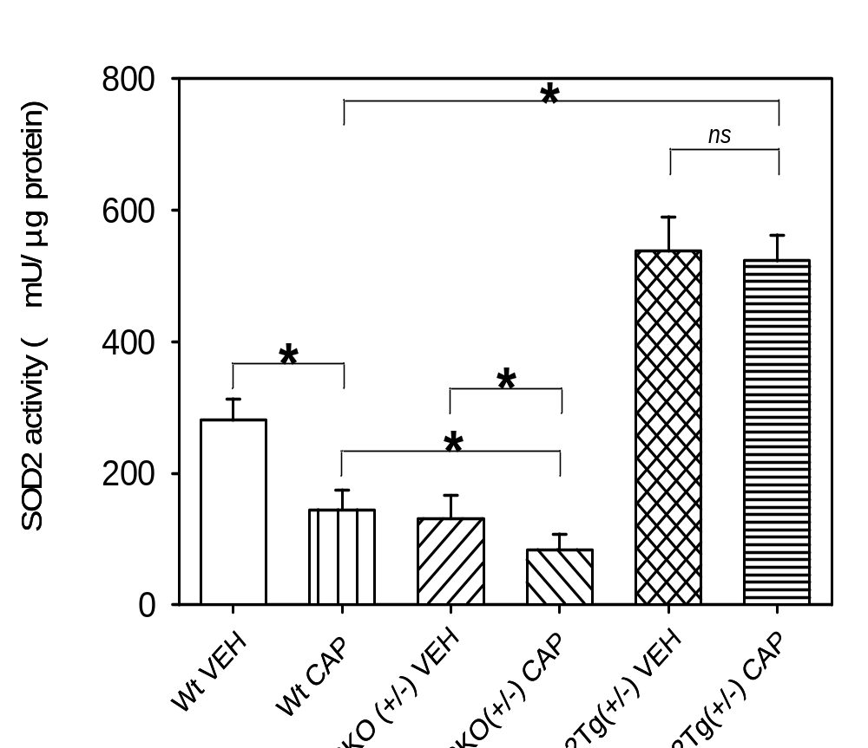

Figure 22: SOD2 activity levels in the L4/5 spinal cord in SOD2KO+/- and SOD2Tg^{+/-} mice with and without i.d. capsaicin treatment
The endogenous SOD2 activity levels are significantly lower in SOD2KO^{+/-} mice (SOD2KO^{+/-} VEH) and significantly higher in SOD2Tg^{+/-} mice (SOD2Tg^{+/-} VEH) compared to wild type (Wt-VEH). One hour after capsaicin treatment (CAP-1hr), SOD2 activity levels significantly decreased in Wt and SOD2KO^{+/-} mice but not in SOD2Tg^{+/-} mice. *: values are significantly different between two linked groups at p ≤ 0.05 (n=12) by Bonferroni post hoc test after one-way repeated ANOVA.

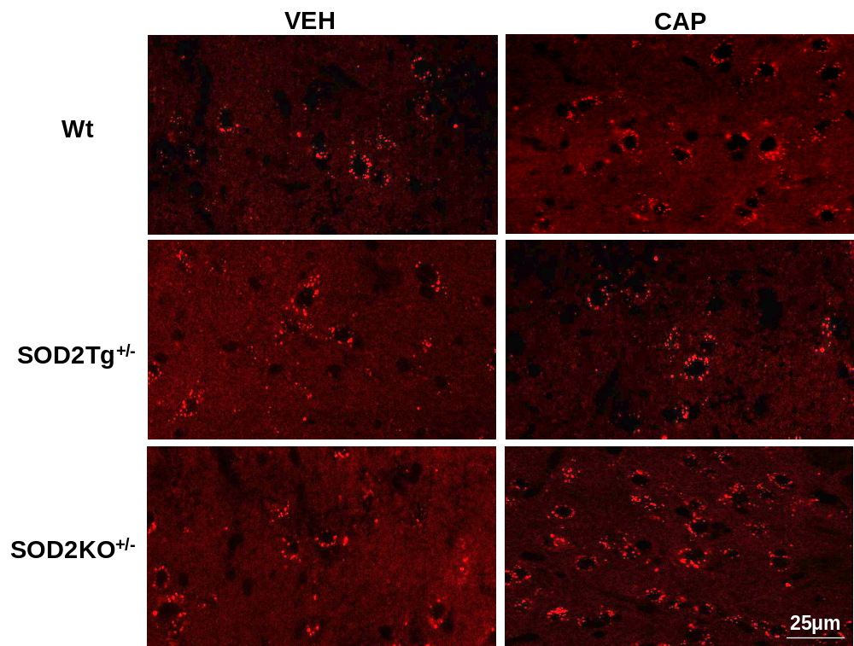

Figure 23: Examples of the MitoSOX labeled L5 spinal dorsal horn (lamina V) sections in various groups of mice

The MitoSOX labeling is identified as red fluorescent granules in the cytoplasm of cellular profiles. The round to oval shaped black space, which is enclosed by red granules, represents the nucleus. The numbers of MitoSOX positive cells are increased after capsaicin treatment in both Wt and SOD2KO^{+/-} mice but not in SOD2Tg^{+/-} mice compared to that of vehicle treated mice. In addition, the numbers of MitoSOX labeled cells are more numerous in capsaicin treated SOD2KO^{+/-} mice compared to capsaicin treated wt mice.

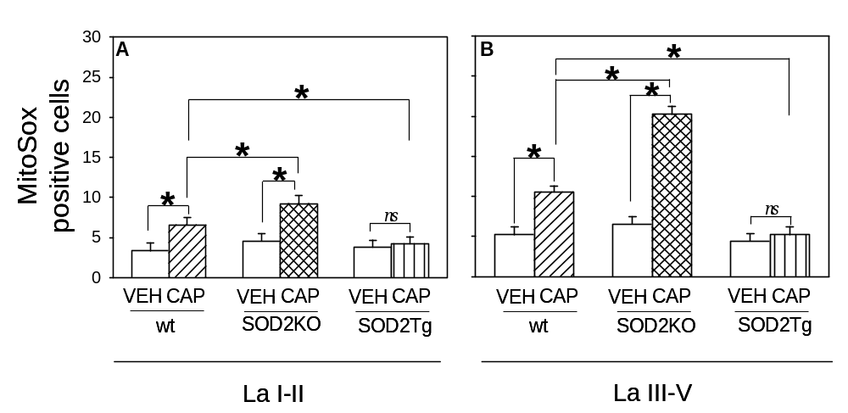

Figure 24: The number of MitoSOX positive cells in the superficial (laminae I-II) and deep (laminae III-V) dorsal horn of various groups

The numbers of MitoSOX positive cells are very small in vehicle treated (VEH) mice in all 3 groups (Wt, SOD2KO^{+/-}, and SODTg^{+/-}). After capsaicin treatment (CAP), however, the number of MitoSOX positive cells increases significantly in Wt and SODKO^{+/-} mice but not in SODTg^{+/-} mice. This increase is far greater in SODKO^{+/-} mice compared to Wt mice. *: values are significantly different between 2 linked groups at p ≤ 0.05 by Bonferroni post hoc test after one-way repeated ANOVA. The data indicate that endogenous levels of SOD2 determine the number of cells that show enhanced mitochondrial superoxide accumulation (n=7 per group).

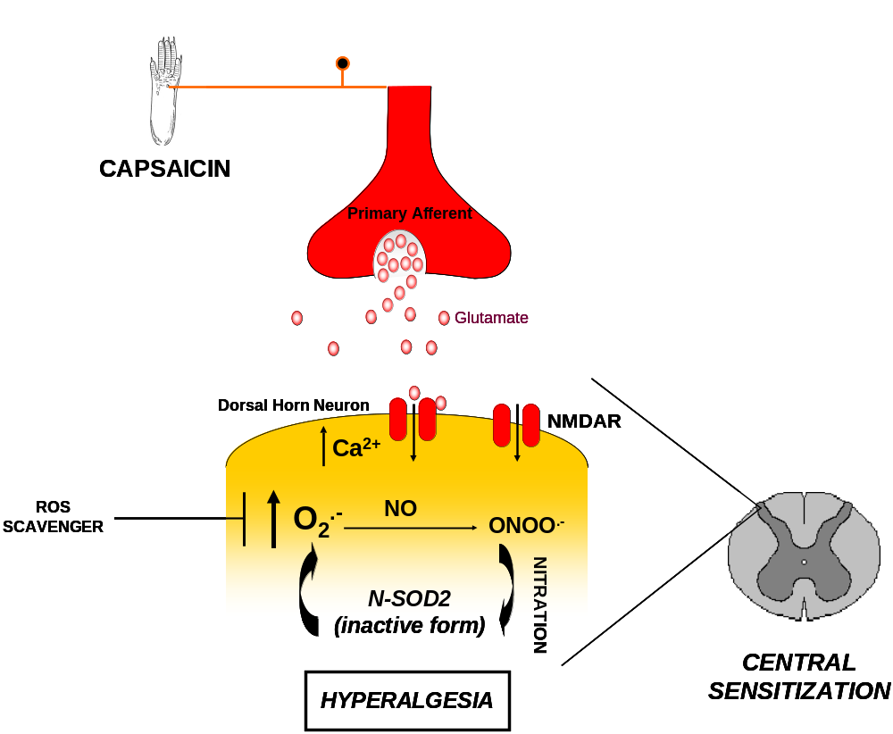

Figure 25: Proposed role of superoxide in capsaicin-induced hyperalgesia

When released at the level of the spinal cord, most likely in response to glutamate, superoxide interacts with nitric oxide to form peroxynitrite. When this occurs, peroxynitrite nitrates SOD2, thereby deactivating the enzyme and causing it to lose function. As a consequence, levels of superoxide remain elevated, favoring the hyperalgesic response. However, removal of superoxides by ROS scavengers allows SOD2 to remain in its active form favoring an anti-hyperalgesic response.

CHAPTER 6: GENERAL DISCUSSION
Pain is highly prevalent and is the primary reason for seeking medical attention when either persistent or chronic. Evaluation of the cause of pain is difficult since pain is complicated by the fact that the clinical diagnosis of pain is often imprecise, reflecting the emotional state of the sufferer, the disease state, individual differences and gender bias. Pain must thus be examined in term of its severity, temporality, and etiology because the detailed mechanisms of persistent pain are not completely understood. A critical phenomenon that contributes to persistent pain states is central sensitization, a form of hyperexcitability of sensory processing in the dorsal horn of the spinal cord. Furthermore, an emerging concept in the field of persistent pain is that elevated levels of spinal ROS play a critical role in central sensitization. The main evidence is the behavioral signs of pain and responses of spinal dorsal horn neurons can be greatly reduced by antioxidants in animal models of pain. However, a clear understanding of ROS mechanisms underlying persistent pain is lacking at the present time.
There is an increasing amount of experimental evidence suggesting that oxidative stress, the cytotoxic effects of ROS, is a causal factor in the neuropathology of neurodegenerative diseases, stroke, and the normal aging process. The current project extends this concept to the study of the role of ROS in central sensitization and pain. High intensity nociceptive inputs lead to central sensitization through NMDA receptor activation and calcium influx into dorsal horn neurons. Exposure of neurons to excessive glutamate can trigger excitotoxicity. Glutamate can activate NMDA and AMPA/kainate receptors, and is followed by calcium influx, which in turn may cause excessive production of ROS. In this study we propose that central sensitization and excitotoxicity share similar mechanisms. Thus, high levels of intracellular calcium overload mitochondria and cause superoxide generation and may activate various enzymes that also cause further cellular ROS production. Therefore, central sensitization can be viewed as a mild form of excitotoxicity.
Following this concept, this study was designed to explore the possible role of mitochondrial SOD (SOD2, MnSOD) function as a critical factor for determining the ROS effect on hyperalgesia. As mentioned, we propose that spinal ROS are important intermediate signaling molecules between high intensity nociceptive inputs and central sensitization and that the antioxidant SOD2 plays a critical role in reducing central sensitization. The projects in this dissertation examined the hypothesis that oxidative stress in the spinal cord plays an important role in the development of central sensitization, and thus capsaicin-induced hyperalgesia. To address this hypothesis, the experiments were designed to evaluate the following: (1) that ROS in the spinal cord plays an important role in capsaicin-induced mechanical hyperalgesia; (2) that elevation of spinal ROS is due to increased production of superoxides in dorsal horn neurons in response to nociceptive afferent inputs; and (3) that elevated levels of spinal ROS are partially due to alterations of mitochondrial SOD2 enzymes in spinal dorsal horn neurons; it is concluded that SOD2 is a critical mechanism for reducing spinal ROS effects.
While different studies suggest that ROS are important not only for central but also peripheral sensitization in pain, the exact site of ROS action in pain has not been clearly identified. Pain induced by intradermal capsaicin has well defined peripheral and central components (Willis, 2001). Intradermal injection of capsaicin into the hind paw produces both primary hyperalgesia (in the area injured by capsaicin injection) and secondary hyperalgesia (in the adjacent undamaged area). The former is due to nociceptive afferent sensitization, whereas the latter is due to central sensitization. Thus the capsaicin-induced pain model is useful to study the role of ROS in these two different components of pain hypersensitivity. The present study uses this well established model to investigate the differential role of ROS in primary and secondary hyperalgesia.
In the beginning of this study, to investigate the role of ROS in capsaicin-induced hyperalgesia, two free radical scavengers, PBN and TEMPOL, were used in the experiments. PBN and TEMPOL are both blood brain barrier (BBB) and cell membrane permeant. PBN scavenges all types of free radicals without specificity, whereas TEMPOL preferentially removes superoxides. Systemic and intrathecal administration of free radical scavengers, post capsaicin injection, showed strong analgesic effects, so ROS accumulation is presumably an important factor underlying hyperalgesia in the capsaicin-induced pain model. It was shown that this effect is strong on secondary hyperalgesia only, is mediated by spinal mechanisms, thus indicating that central sensitization is affected by ROS. In addition, a significant reduction in intensity and duration of secondary hyperalgesia after PBN or TEMPOL pretreatments indicates that ROS are critically involved not only in the maintenance but also in the development of secondary hyperalgesia in capsaicin-induced hyperalgesia. Furthermore, when levels of hyperalgesia were examined after spinal ROS levels were artificially increased by intrathecal injection of the ROS donor, t-BOOH they produced a transient hyperalgesia in a dose dependent manner. The significant antihyperalgesic effect of intrathecal ROS scavengers and the induction of hyperalgesia with an intrathecal ROS generator indicate that ROS act primarily through a spinal mechanism to induce pain.
Even though data suggest that elevated spinal ROS seem to be involved in capsaicin-induced central sensitization, the sources and critical types of ROS are not clear. The brain receives its energy almost exclusively from oxidative metabolism in the mitochondrial respiratory chain. Thus it is not surprising that mitochondria are the major neuronal source of intracellular ROS, which are mostly superoxides and cause excitotoxicity and LTP (Halliwell and Gutteridge, 1989; Schapira and Cooper, 1992). Due to this, and since behavioral studies have demonstrated that the free radical scavenger TEMPOL was effective in reducing capsaicin-induced secondary hyperlagesia, we hypothesize that the major source of ROS elevation in the cord is from increased superoxide production in dorsal horn neurons. To prove that intradermal injection of capsaicin increases spinal ROS and that elevated spinal ROS, in turn is caused, at least in part, by enhanced production of superoxides in neurons, the production of mitochondrial superoxides was determined by a histological method using a mitochondrial superoxide specific redox sensitive dye, MitoSOX, in combination with immunostaining for neurons and glia. This study showed that many more cells are labeled by MitoSOX after capsaicin treatment as compared to vehicle-treated mice, and the majority of MitoSOX positive cells were also identified as neurons. Therefore, these results suggest that mitochondrial ROS production in dorsal horn neurons may be a major contributor to the spinal cord ROS increase. The data indicate that neuronal production of mitochondrial superoxides is an important factor in capsaicin-induced hyperalgesia.
Our previous study demonstrated that increased levels of spinal cord ROS are critical for maintenance of capsaicin-induced secondary hyperalgesia, suggesting ROS involvement in central sensitization. Our present study further indicates that mitochondrial superoxides are a major source of elevated spinal ROS in capsaicin-induced secondary hyperalgesia. Since increasing antioxidant activity seems to benefit pain treatment, the data suggest that overproduction of superoxide is responsible for central sensitization. We hypothesize that endogenous SOD2 is critical for modifying the cellular signaling pathways of central sensitization. Using western blot analysis and enzyme assays, we showed that the increase of spinal superoxides is partially due to reduced levels of SOD2 activity as a consequence of inactivation of SOD2 proteins, by nitration, in dorsal horn neurons. Inactivation of SOD2 proteins may alter the properties of key regulatory proteins (i.e. MAPK, PKA, PKC) involved in several specific signaling pathways that affect central sensitization. Current research has reached a consensus that several signal transduction cascades that depend on excitatory amino acids and their receptors are involved in pain mechanisms, particularly central sensitization, and that their activation leads to persistent pain. Furthermore, decreased or increased levels of capsaicin-induced hyperalgesia in accordance with the artificially increased or decreased levels of SOD, respectively, further indicated that endogenous SOD2 is a critical factor for determining levels of hyperalgesia. It was also shown that increased numbers of MitoSOX positive dorsal horn neurons in SOD2KO mice with capsaicin treatment confirms that reduced mitochondrial SOD2 levels is a major contributor to the spinal superoxide increase. These findings suggest that SOD2 is in fact playing a critical role in capsaicin-induced hyperalgesia and that superoxide release centrally in response to capsaicin is a key event in the development and maintenance of persistent pain. These results further support the notion that inactivation of SOD2 is a critical event in central sensitization, due to the fact that the levels of superoxide can remain elevated. Therefore, the results emphasized the importance of SOD2 and mitochondrially generated ROS by demonstrating the potential pathologies due to mitochondrial oxidative stress and its importance in central sensitization.
Taken together, we conclude that that (1) elevated spinal levels of ROS, specifically superoxide, are critical for capsaicin-induced secondary hyperalgesia, and that (2) SOD2 is a critical enzyme and most likely the mechanism that maintains the elevated superoxide levels in the spinal cord after capsaicin treatment. Since ROS, specifically superoxide, are important in the development of hyperalgesia, this study suggests the possible therapeutic potential for targeting SOD2, using SOD mimetics, in persistent pain conditions.

REFERENCES

Abe, K. and Saito, H. (1998). Characterization of t-butyl hydroperoxide toxicity in cultured rat cortical neurones and astrocytes. Pharmacol. Toxicol. 83, 40-46.
Afonso, V., Champy, R., Mitrovic, D., Collin, P., and Lomri, A. (2007). Reactive oxygen species and superoxide dismutases: role in joint diseases. Joint Bone Spine 74, 324-329.
Akizuki, E., Akaike, T., Okamoto, S., Fuji, S., Yamaguchi, Y., Ogawa, M., and Maeda, H. (2000). Role of nitric oxide and superoxide in acute cardiac allograft rejection in rats. Proc. Soc. Exp. Biol. Med. 225, 151-159.
Battaglia,G. and Rustioni,A. (1988). Coexistence of glutamate and substance P in dorsal root ganglion neurons of the rat and monkey. J. Comp. Neurol. 277, 302-312.
Baumann, T. K., Simone, D. A., Shain, C. N., and LaMotte, R. H. (1991). Neurogenic hyperalgesia: The search for the primary cutaneous afferent fibers that contribute to capsaicin-induced pain and hyperalgesia. J. Neurophysiol. 66, 212-227.
Bessou, P. and Perl, E. R. (1969). Response of cutaneous sensory units with unmyelinated fibers to noxious stimuli. J. Neurophysiol. 32, 1025-1043.
Bevan, S. and Szolcsanyi, J. (1990). Sensory neuron-specific actions of capsaicin: mechanisms and applications. Trends Pharmacol. Sci. 11, 330-333.
Bileviciute, I., Lundeberg, T., Ekblom, A., and Theodorsson, E. (1993). Bilateral changes of substance P-, neurokinin A-, calcitonin gene-related peptide- and neuropeptide Y-like immunoreactivity in rat knee joint synovial fluid during acute monoarthritis. Neurosci. Lett. 153, 37-40.
Bindokas, V. P., Jordán, J., Lee, C. C., and Miller, R. J. (1996). Superoxide production in rat hippocampal neurons: selective imaging with hydroethidine. J. Neurosci. 16(4), 1324-1336.
Bonica, J. J. (1990). Causalgia and other reflex sympathetic dystrophies. In The Management of Pain, J.J.Bonica, ed. (Philadelphia: Lea & Febiger), 220-243.
Brookes, P. S. (2004). Mitochondrial nitric oxide synthase. Mitochondrion 3, 187-204.

Burgess, S. E., Gardell, L. R., Ossipov,M.H., Malan,T.P., Jr., Vanderah,T.W., Lai,J., and Porreca,F. (2002). Time-dependent descending facilitation from the rostral ventromedial medulla maintains, but does not initiate, neuropathic pain. J. Neurosci. 22, 5129-5136.
Carlton, S. M., Chung, J. M., Leonard, R. B., and Willis, W. D. (1985). Funicular trajectories of brainstem neurons projecting to the lumbar spinal cord in the monkey (Macaca fascicularis): a retrograde labeling study. J. Comp Neurol. 241, 382-404.
Carlton, S. M., McNeil, D. L., Chung, K., and Coggeshall, R. E. (1987). A light and electron microscopic level analysis of calcitonin gene-related peptide (CGRP) in the spinal cord of the primate: an immunohistochemical study. Neurosci. Lett. 82, 145-151.
Carlton, S. M., Zhou, S., and Coggeshall, R. E. (1998). Evidence for the interaction of glutamate and NK1 receptors in the periphery. Brain Res. 790, 160-169.
Caterina, M. J., Schumacher, M. A., Tominaga, M., Rosen, T. A., Levine, J. D., and Julius, D. (1997). The capsaicin receptor: a heat-activated ion channel in the pain pathway. Nature 389, 816-824.
Caterina, M. J., Leffler, A., Malmberg, A. B., Martin, W. J., Trafton, J., Petersen-Zeitz, K. R., Koltzenburg, M., Basbaum, A. I., and Julius, D. (2000). Impaired nociception and pain sensation in mice lacking the capsaicin receptor. Science 288, 306-313.
Chan, S. F. and Sucher, N. J. (2001). An NMDA receptor signaling complex with protein phosphatase 2A. J. Neurosci. 21, 7985-7992.
Chen, C. C., England,S., Akopian,A.N., and Wood,J.N. (1998). A sensory neuron-specific, proton-gated ion channel. Proc. Natl. Acad. Sci. U. S. A. 95, 10240-10245.
Chen, L. and Huang, L. M. (1992). Protein kinase C reduces Mg²⁺ block of NMDA-receptor channels as a mechanism of modulation. Nature 356, 521-523.
Choi, J., Forster, M. J., McDonald, S. R., Weintraub, S. T., Carroll, C. A., and Gracy, R. W. (2004). Proteomic identification of specific oxidized proteins in ApoE-knockout mice: Relevance to Alzheimer's disease. Free Radical Biol. Med. 36, 1155-1162.
Chuang, H. H., Prescott, E. D., Kong, H., Shields, S., Jordt, S. E., Basbaum, A. I., Chao, M. V., and Julius, D. (2001). Bradykinin and nerve growth factor release the capsaicin receptor from PtdIns(4,5)P2-mediated inhibition. Nature 411, 957-962.
Coderre, T. J. and Melzack, R. (1991). Central neural mediators of secondary hyperalgesia following heat injury in rats: neuropeptides and excitatory amino acids. Neurosci. Lett. 131, 71-74.
Coderre, T. J. and Melzack, R. (1992). The contribution of excitatory amino acids to central sensitization and persistent nociception after formalin-induced tissue injury. J. Neurosci. 12, 3665-3670.
Coderre, T. J., Xanthos, D. N., Francis, L., and Bennett, G. J. (2004). Chronic post-ischemia pain (CPIP): a novel animal model of complex regional pain syndrome-Type I (CRPS-I; reflex sympathetic dystrophy) produced by prolonged hind paw ischemia and reperfusion in the rat. Pain 112, 94-105.
Coggeshall, R. E. and Carlton, S. M. (1997). Receptor localization in the mammalian dorsal horn and primary afferent neurons. Brain Res. Brain Res. Rev. 24, 28-66.
Contestabile, A. (2001). Antioxidant strategies for neurodegenerative diseases
6. Expert Opinion on Therapeutic Patents 11, 573-585.
Cook, A. J., Woolf, C. J., Wall, P. D., and McMahon, S. B. (1987). Dynamic receptive field plasticity in rat spinal cord dorsal horn following C primary afferent input. Nature 325, 151-153.
Costigan, M. and Woolf, C. J. (2000). Pain: molecular mechanisms. J. Pain 1, 35-44.
Coyle,J.T. and Puttfarcken,P. (1993). Oxidative stress, glutamate, and neurodegenerative disorders. Science 262, 689-695.
Cuzzocrea, S., Zingarelli, B., Costantino, G., and Caputi, A. P. (1999). Beneficial effects of Mn(III)tetrakis (4-benzoic acid) porphyrin (MnTBAP), a superoxide dismutase mimetic, in carrageenan-induced pleurisy. Free Radic. Biol. Med. 26, 25-33.
dam-Vizi, V. (2005). Production of reactive oxygen species in brain mitochondria: contribution by electron transport chain and non-electron transport chain sources. Antioxid. Redox. Signal. 7, 1140-1149.
Davies, K. J., Lin, S. W., and Pacifici, R. E. (1987). Protein damage and degradation by oxygen radicals. IV. Degradation of denatured protein. J. Biol. Chem. 262, 9914-9920.
De, B. S. and Rustioni, A. (1988). Glutamate and substance P coexist in primary afferent terminals in the superficial laminae of spinal cord. Proc. Natl. Acad. Sci. U. S. A. 85, 7820-7824.
Demicheli, V., Quijano, C., Alvarez, B., and Radi, R. (2007). Inactivation and nitration of human superoxide dismutase (SOD) by fluxes of nitric oxide and superoxide. Free Radic. Biol. Med. 42, 1359-1368.
Dougherty, P. M., Palecek, J., Paleckova, V., and Willis, W. D. (1994). Neurokinin 1 and 2 antagonists prevent the sensitization of primate spinothalamic tract neurons following intradermal capsaicin. J. Neurophysiol. 72, 1464-1475.
Dougherty, P. M., Palecek, J., Paleckova, V., and Willis, W. D. (1995). Infusion of substance P or neurokinin A by microdialysis alters responses of primate spinothalamic tract neurons to cutaneous stimuli and to iontophoretically released excitatory amino acids. Pain 61, 411-425.
Dougherty, P. M., Palecek, J., Zorn, S., and Willis, W. D. (1993). Combined application of excitatory amino acids and substance P produces long-lasting changes in responses of primate spinothalamic tract neurons. Brain Res. Rev. 18, 227-246.
Dougherty, P. M. and Willis, W. D. (1991). Enhancement of spinothalamic neuron responses to chemical and mechanical stimuli following combined micro-iontophoretic application of N-methyl-D-aspartic acid and substance P. Pain 47, 85-93.
Dougherty, P. M. and Willis, W. D. (1992). Enhanced responses of spinothalamic tract neurons to excitatory amino acids accompany capsaicin-induced sensitization in the monkey. J. Neurosci. 12, 883-894.
Dougherty, P. M., Willis, W. D., and Lenz, F. A. (1998). Transient inhibition of responses to thermal stimuli of spinal sensory tract neurons in monkeys during sensitization by intradermal capsaicin. Pain 77, 129-136.
Dray, A. (1995). Inflammatory mediators of pain. Br. J. Anaesth. 75, 125-131.
Dubner, R. and Ruda, M. A. (1992). Activity-dependent neuronal plasticity following tissue injury and inflammation. Trends in Neurosci. 15, 96-103.
Echtay, K. S., Roussel, D., St-Pierre, J., Jekabsons, M. B., Cadenas, S., Stuart, J. A., Harper, J. A., Roebuck, S. J., Morrison, A., Pickering, S., Clapham, J. C., and Brand, M. D. (2002). Superoxide activates mitochondrial uncoupling proteins. Nature 415, 96-99.
Folz, R. J., Abushamaa, A. M., and Suliman, H. B. (1999). Extracellular superoxide dismutase in the airways of transgenic mice reduces inflammation and attenuates lung toxicity following hyperoxia. J. Clin. Invest 103, 1055-1066.
Fridovich, I. (1995). Superoxide radical and superoxide dismutases. Annu. Rev. Biochem. 64, 97-112.
Fries, D. M., Paxinou, E., Themistocleous, M., Swanberg, E., Griendling, K. K., Salvemini, D., Slot, J. W., Heijnen, H. F., Hazen, S. L., and Ischiropoulos, H. (2003). Expression of inducible nitric-oxide synthase and intracellular protein tyrosine nitration in vascular smooth muscle cells: role of reactive oxygen species. J. Biol. Chem. 278, 22901-22907.
Galeazza, M. T., Garry, M. G., Yost, H. J., Strait, K. A., Hargreaves, K. M., and Seybold, V. S. (1995). Plasticity in the synthesis and storage of substance P and calcitonin gene-related peptide in primary afferent neurons during peripheral inflammation. Neuroscience 66, 443-458.
Gamse, R., Holzer, P., and Lembeck, F. (1980). Decrease of substance P in primary afferent neurones and impairment of neurogenic plasma extravasation by capsaicin. Br. J. Pharm. 68, 207-213.
Garry, M. G., Jackson, D. L., Geier, H. E., Southam, M., and Hargreaves, K. M. (1999). Evaluation of the efficacy of a bioerodible bupivacaine polymer system on antinociception and inflammatory mediator release. Pain 82, 49-55.
Gerlach, M., Ben Shachar, D., Riederer, P., and Youdim, M. B. (1994). Altered brain metabolism of iron as a cause of neurodegenerative diseases? J. Neurochem. 63, 793-807.
Guedes, R. P., Bosco, L. D., Teixeira, C. M., Araujo, A. S., Llesuy, S., Bello-Klein, A., Ribeiro, M. F., and Partata, W. A. (2006). Neuropathic pain modifies antioxidant activity in rat spinal cord. Neurochem. Res. 31, 603-609.
Guo, W., Zou, S., Guan, Y., Ikeda, T., Tal, M., Dubner, R., and Ren, K. (2002). Tyrosine phosphorylation of the NR2B subunit of the NMDA receptor in the spinal cord during the development and maintenance of inflammatory hyperalgesia. J. Neurosci. 22, 6208-6217.
Hacimuftuoglu, A., Handy, C. R., Goettl, V. M., Lin, C. G., Dane, S., and Stephens, R. L. (2006). Antioxidants attenuate multiple phases of formalin-induced nociceptive response in mice. Behav.Brain Res. 173, 211-216.
Haddad, J. J. (2002). Antioxidant and prooxidant mechanisms in the regulation of redox(y)-sensitive transcription factors. Cell Signal. 14, 879-897.
Haley, J. E., Sullivan, A. F., and Dickenson, A. H. (1990). Evidence for spinal N-methyl-D-aspartate receptor involvement in prolonged chemical nociception in the rat. Brain Research 518, 218-226.
Halliwell, B. and Gutteridge, J. M. (1989). Free Radicals in Biology and Medicine. (Oxford: Clarendon Press).
Han, D. S., Cadenas, E., Kobayashi, M. S., and Packer, L. (2000). Oxidative stress in glutamate neurotoxicity. In Free radicals in brain pathophysiology, G.Poli, E.Cadenas, and L.Packer, eds. (New York: Dekker),127-157.
Hardy, J. D. (1953). Thresholds of pain and reflex contraction as related to noxious stimulation. J. Appl. Physiol. 5, 725-739.
Hardy, J. D. (1956). The nature of pain. J. Chron. Dis. 4, 22-51.
Hargreaves, K., Dubner, R., Brown, F., Flores, C., and Joris, J. (1988). A new and sensitive method for measuring thermal nociception in cutaneous hyperalgesia. Pain 32, 77-88.
Hensley, K., Pye, Q. N., Tabatabaie, T., Stewart, C. A., and Floyd, R. A. (1997). Reactive oxygen involvement in neurodegenerative pathways. In Neuroinflammation: Mechanisms and Management, P.L.Wood, ed. (Totowa, NJ: Humana Press), 265-281.
Hu, J. W., Sessle, B. J., Raboisson, P., Dallel, R., and Woda, A. (1992). Stimulation of craniofacial muscle afferents induces prolonged facilitatory effects in trigeminal nociceptive brain-stem neurones. Pain 48, 53-60.
Hylden, J., Nahin, R., Traub, R., and Dubner, R. (1989). Expansion of receptive fields of spinal laminae I projection neurons in rats with unilateral adjuvant-induced inflammation: the contribution of dorsal horn mechanisms. Pain 27, 229-243.
Jaffrey, S. R., Erdjument-Bromage, H., Ferris, C. D., Tempst, P., and Snyder, S. H. (2001). Protein S-nitrosylation: a physiological signal for neuronal nitric oxide. Nat. Cell Biol. 3, 193-197.
Jansco, G. and Kiraly, E. (1981). Sensory neurotoxins: chemically induced selective destruction of primary sensory neurons. Brain Research 210, 83-89.
Jenner, P. (1994). Oxidative damage in neurodegenerative disease. Lancet 344, 796-798.
Ji, R. R., Kohno, T., Moore, K. A., and Woolf, C. J. (2003). Central sensitization and LTP: do pain and memory share similar mechanisms? Trends Neurosci. 26, 696-705.
Julius, D. and Basbaum, A. I. (2001). Molecular mechanisms of nociception. Nature 413, 203-210.
Kahlert, S., Zündorf, G., and Reiser, G. (2005). Glutamate-mediated influx of extracellular Ca²⁺ is coupled with reactive oxygen species genertion in cultured hippocampal neurons but not in astrocytes. J. Neurosci. Res. 79, 262-271.
Kamata, H. and Hirata, H. (1999). Redox regulation of cellular signalling. Cell. Signal. 11(1), 1-14.
Kandel, E., Schwartz, J., Jessell, T. "The Perception of Pain." Principles of Neural Science. Ed. Kandell, E. New York, 2000, McGraw-Hill, 472-491.
Khalil, Z. and Khodr, B. (2001). A role for free radicals and nitric oxide in delayed recovery in aged rats with chronic constriction nerve injury. Free Radic. Biol. Med. 31, 430-439.
Khalil, Z., Liu, T., and Helme, R. D. (1999). Free radicals contribute to the reduction in peripheral vascular responses and the maintenance of thermal hyperalgesia in rats with chronic constriction injury. Pain 79, 31-37.
Khasar, S. G., Gold, M. S., and Levine, J. D. (1998). A tetrodotoxin-resistant sodium current mediates inflammatory pain in the rat. Neurosci. Lett. 256, 17-20.
Kim, H. K., Kim, J. H., Gao, X., Zhou, J. L., Lee, I., Chung, K., and Chung, J. M. (2006). Analgesic effect of vitamin E is mediated by reducing central sensitization in neuropathic pain. Pain 122, 53-62.
Kim, H. K., Park, S. K., Zhou, J. L., Taglialatela, G., Chung, K., Coggeshall, R. E., and Chung, J. M. (2004). Reactive oxygen species (ROS) play an important role in a rat model of neuropathic pain. Pain 111, 116-124.
Klann, E. (1998). Cell-permeable scavengers of superoxide prevent long-term potentiation in hippocampal area CA1. J. Neurophysiol. 80, 452-457.
Klann, E. and Thiels, E. (1999). Modulation of protein kinases and protein phosphatases by reactive oxygen species: Implications for hippocampal synaptic plasticity. Prog. Neuro-Psychopharmacol. & Biol Psychiat. 23, 359-376.
Koul, B., Vesterqvist, O., Egberg, N., and Steen, S. (1992). Twenty-four-hour heparin-free veno-right ventricular ECMO: an experimental study. Ann. Thorac. Surg. 53, 1046-1051.
Kress, M., Reeh, P. W., and Vyklicky, L. (1997). An interaction of inflammatory mediators and protons in small diameter dorsal root ganglion neurons of the rat. Neurosci. Lett. 224, 37-40.
Kress, M. and Zeilhofer, H. U. (1999). Capsaicin, protons and heat: new excitement about nociceptors. Trends Pharmacol. Sci. 20, 112-118.
LaMotte, R. H., Lundberg, L. E., and Torebjork, H. E. (1992). Pain, hyperalgesia and activity in nociceptive C units in humans after intradermal injection of capsaicin. J. Physiol 448, 749-764.
LaMotte, R. H., Shain, C. N., Simone, D. A., and Tsai, E. F. P. (1991). Neurogenic hyperalgesia: Psychophysical studies of underlying mechanisms. J. Neurophysiol. 66, 190-211.
LaMotte, R. H., Thalhammer, J. G., and Robinson, C. J. (1983). Peripheral neural correlates of magnitude of cutaneous pain and hyperalgesia: a comparison of neural events in monkey with sensory judgments in human. J. Neurophysiol. 50, 1-26.
Lawand, N. B., Willis, W. D., and Westlund, K. N. (1997). Blockade of joint inflammation and secondary hyperalgesia by L-NAME, a nitric oxide synthase inhibitor. NeuroReport 8, 895-899.
Lebovitz, R. M., Zhang, H., Vogel, H., Cartwright, J., Jr., Dionne, L., Lu, N., Huang, S., and Matzuk, M. M. (1996). Neurodegeneration, myocardial injury, and perinatal death in mitochondrial superoxide dismutase-deficient mice. Proc. Natl. Acad. Sci. U. S. A. 93, 9782-9787.
Lee, I., Kim, H. K., Kim, J. H., Chung, K., and Chung, J. M. (2007). The role of reactive oxygen species in capsaicin-induced mechanical hyperalgesia and in the activities of dorsal horn neurons. Pain 133, 9-17.
Lee I, Park, E. S., Kim, H. K., Wang, J. G., Chung, K, Chung, J. M. A modified direct lumbar puncture method in rats. Neurosci. Abst. 2006. 832.20.
Lewen, A., Matz, P., and Chan, P. H. (2000). Free radical pathways in CNS injury. J. Neurotrauma 17, 871-890.
Lin, Q., Peng, Y. B., Willis, W. D. (1996). Inhibition of primate spinothalamic tract neurons by spinal glycine and GABA is reduced during central sensitization. J Neurophysiol. 76, 1005-14.
Lin, Q., Palecek, J., Paleckova, V., Peng, Y. B., Wu, J., Cui, M., and Willis,W. D. (1999). Nitric oxide mediates the central sensitization of primate spinothalamic tract neurons. J. Neurophysiol. 81, 1075-1085.
Liu, X., Bee, D., and Barer, G. R. (1999). Role of nitric oxide synthase and cyclooxygenase in pulmonary vascular control in isolated perfused lungs of ferrets, rats and rabbits. Exp. Physiol 84, 907-916.
Maher, P. and Schubert, D. (2000). Signaling by reactive oxygen species in the nervous system. Cell. Mol. Life. Sci. 57, 1287-1305.
Malick, A., Strassman, R. M., and Burstein, R. (2000). Trigeminohypothalamic and reticulohypothalamic tract neurons in the upper cervical spinal cord and caudal medulla of the rat. J. Neurophysiol. 84, 2078-2112.
Mark, M. D. and Herlitze, S. (2000). G-protein mediated gating of inward-rectifier K+ channels. Eur. J. Biochem. 267, 5830-5836.
Marsh, S. J., Stansfeld, C. E., Brown, D. A., Davey, R., and McCarthy, D. (1987). The mechanism of action of capsaicin on sensory C-type neurons and their axons in vitro. Neuroscience 23, 275-289.
Martin, T. J. and Eisenach, J. C. (2001). Pharmacology of opioid and nonopioid analgesics in chronic pain states. J. Pharmacol. Exp. Ther. 299, 811-817.
Melov, S. (2000). Mitochondrial oxidative stress. Physiologic consequences and potential for a role in aging. Ann. N. Y. Acad. Sci. 908, 219-225.
Melov, S., Coskun, P. E., and Wallace, D. C. (1999). Mouse models of mitochondrial disease, oxidative stress, and senescence. Mutat. Res. 434, 233-242.
Melov, S., Schneider, J. A., Day, B. J., Hinerfeld, D., Coskun, P., Mirra, S. S., Crapo,J.D., and Wallace,D.C. (1998). A novel neurological phenotype in mice lacking mitochondrial manganese superoxide dismutase. Nat. Genet. 18, 159-163.
Merighi, A., Polak, J. M., and Theodosis, D. T. (1991). Ultrastructural visualization of glutamate and aspartate immunoreactivities in the rat dorsal horn, with special reference to the co-localization of glutamate, substance P and calcitonin-gene related peptide. Neuroscience 40, 67-80.
Merskey, H and Bogduk, N. Classification of Chronic Pain: Descriptions of Chronic Pain Syndromes and Definitions of Pain Terms. 2nd ed., Seattle, 1994, IASP Press.
Meyer, R. A. and Campbell, J. N. (1981). Myelinated nociceptive afferents account for the hyperalgesia that follows a burn to the hand. Science 213, 1527-1529.
Millan-Crow, L. A. and Cruthirds, D. L. (2001). Invited review: manganese superoxide dismutase in disease. Free Radic. Res. 34, 325-336.
Miller, M. J., Sadowska-Krowicka, H., Jeng, A.Y., Chotinaruemol, S., Wong, M., Clark, D. A., Ho, W., and Sharkey, K. A. (1993). Substance P levels in experimental ileitis in guinea pigs: effects of misoprostol. Am. J. Physiol 265, G321-G330.
Nanayama, T., Kuraishi,Y., Ohno, H., and Satoh, M. (1989). Capsaicin-induced release of calcitonin gene-related peptide from dorsal horn slices is enhanced in adjuvant arthritic rats. Neurosci. Res. 6, 569-572.
Neugebauer, V. and Li, W. (2003). Differential sensitization of amygdala neurons to afferent inputs in a model of arthritic pain. J. Neurophysiol. 89, 716-727.
Nicholls, D. G. (2005). Mitochondria and calcium signaling. Cell Calcium 38, 311-317.
O'Dell, T. J., Huang, P. L., Dawson, T. M., Dinerman, J. L., Snyder, S. H., Kandel, E. R., and Fishman, M.C. (1994). Endothelial NOS and the blockade of LTP by NOS inhibitors in mice lacking neuronal NOS. Science 265, 542-546.
Ohtori, S., Chiba, T., Takahashi, K., Ino, H., Yamagata, M., Sameda, H., Murata, Y., and Moriya, H. (2000). Neonatal capsaicin treatment decreased substance P receptor immunoreactivity in lamina III neurons of the dorsal horn. Neurosci. Res. 38, 147-154.
Oury, T. D., Card, J. P., and Klann, E. (1999). Localization of extracellular superoxide dismutase in adult mouse brain. Brain Res. 850, 96-103.
Owens, C. M., Zhang, D., and Willis, W. D. (1992). Changes in the response states of primate spinothalamic tract cells caused by mechanical damage of the skin or activation of descending controls. J. Neurophysiol. 67, 1509-1527.
Palecek, J., Dougherty, P. M., Kim, S. H., Paleckova, V., Lekan, H., Chung, J. M., Carlton, S. M., and Willis, W. D. (1992). Responses of spinothalamic tract neurons to mechanical and thermal stimuli are increased in an experimental model of peripheral neuropathy in primates. Neurosci. Abstr. 18, 287.
Palecek, J., Paleckova, V., and Willis, W. D. (2002). The roles of pathways in the spinal cord lateral and dorsal funiculi in signaling nociceptive somatic and visceral stimuli in rats. Pain 96, 297-307.
Park, E. S., Gao, X., Chung, J. M., and Chung, K. (2006). Levels of mitochondrial reactive oxygen species increase in rat neuropathic spinal dorsal horn neurons. Neurosci. Lett. 391, 108-111.
Raymond, L. A., Blackstone, C. D., and Huganir, R. L. (1993). Phosphorylation of amino acid neurotransmitter receptors in synaptic plasticity. Trends in Neurosci. 16(4), 147-153.
Reaume, A. G., Elliott, J. L., Hoffman, E. K., Kowall, N. W., Ferrante, R. J., Siwek, D. F., Wilcox, H. M., Flood, D. G., Beal, M. F., Brown, R. H., Jr., Scott, R. W., and Snider, W. D. (1996). Motor neurons in Cu/Zn superoxide dismutase-deficient mice develop normally but exhibit enhanced cell death after axonal injury. Nat. Genet. 13, 43-47.
Ren, K., Iadarola, M. J., and Dubner, R. (1996). An isobolographic analysis of the effects of N-methyl-D-aspartate and NK1 tachykinin receptor antagonists on inflammatory hyperalgesia in the rat. Br. J. Pharmacol. 117, 196-202.
Ren, K. and Dubner, R. (1999). Inflammatory Models of Pain and Hyperalgesia. ILAR. J. 40, 111-118.
Reynolds, I. J. and Hastings, T. G. (1995). Glutamate induces the production of reactive oxygen species in cultured forebrain neurons following NMDA receptor activation. J. Neurosci. 15(5), 3318-3327.
Rhee, S. G., Bae, Y. S., Lee, S. R., and Kwon, J. (2000). Hydrogen peroxide: a key messenger that modulates protein phosphorylation through cysteine oxidation. Sci. STKE. 2000, 1-5.
Sah, P. and Faber, E. S. (2002). Channels underlying neuronal calcium-activated potassium currents. Prog. Neurobiol. 66, 345-353.
Salvemini, D., Mazzon, E., Dugo, L., Riley, D. P., Serraino, I., Caputi, A. P., and Cuzzocrea, S. (2001). Pharmacological manipulation of the inflammatory cascade by the superoxide dismutase mimetic, M40403. Br. J. Pharmacol. 132, 815-827.
Salvemini, D., Wang, Z. Q., Zweier, J. L., Samouilov, A., Macarthur, H., Misko, T. P., Currie, M. G., Cuzzocrea, S., Sikorski, J. A., and Riley, D. P. (1999). A nonpeptidyl mimic of superoxide dismutase with therapeutic activity in rats. Science 286, 304-306.
Schaible, H., Grubb, B., Neugebauer, V., and Oppman, M. (1991). The effects of NMDA antagonists on neuronal activity in cat spinal cord evoked by acute inflammation in the knee joint. Eur. J. Neuroscience. 3, 981-991.
Schapira, A. H. and Cooper, J. M. (1992). Mitochondrial function in neurodegeneration and aging. Mutat. Res. 275, 1133-1143.
Schepelmann, K., Messlinger, K., Schaible, H. G., and Schmidt, R. F. (1992). Inflammatory mediators and nociception in the joint: excitation and sensitization of slowly conducting afferent fibers of cat's knee by prostaglandin I2. Neuroscience 50, 237-247.
Schuligoi, R., Donnerer,J., and Amann,R. (1994). Bradykinin-induced sensitization of afferent neurons in the rat paw. Neuroscience 59, 211-215.
Schwartz, E., Lee, I., Chung, K., Chung, J. M. Oxidative stress in the spinal cord plays an important role in capsaicin-induced hyperalgesia. Neurosci Abst 2006; 551.21.
Schwartz, E., Lee, I., Kim,H. Y., Chung, K., Chung, J..M. The role of free radicals in capsaicin-induced pain. American Pain Society Abst 2007.
Schwartz, E., Lee, I., Kim, H.Y., Chung, K., Chung, J. M. Increased ROS production reduces SOD2 function in the spinal cord in capsaicin-induced hyperalgesia Neurosci Abst 2007; 821.20.
Servitja, J. M., Masgrau, R., Pardo, R., Sarri, E., and Picatoste, F. (2000). Effects of oxidative stress on phospholipid signaling in rat cultured astrocytes and brain slices. J. Neurochem. 75, 788-794.
Seybold, V. S., Galeazza, M. T., Garry, M.G., and Hargreaves, K. M. (1995). Plasticity of Calcitonin-Gene-Related Peptide Neurotransmission in the Spinal-Cord During Peripheral Inflammation. Can. Phys. Pharm. 73, 1007-1014.
Sherrington, C. S. (1906). The Integrative Action of the Nervous System. (New Haven: Yale University Press).
Shishkin,V., Potapenko,E., Kostyuk,E., Girnyk,O., Voitenko,N., and Kostyuk,P. (2002). Role of mitochondria in intracellular calcium signaling in primary and secondary sensory neurones of rats. Cell calcium 32, 121-130.
Simone, D. A., Baumann, T. K., and LaMotte, R. H. (1989). Dose-dependent pain and mechanical hyperalgesia in humans after intradermal injection of capsaicin. Pain 38, 99-107.
Simone, D. A., Sorkin, L. S., Oh, U. T., Chung, J. M., Owens, C., LaMotte, R. H., and Willis, W. D. (1991). Neurogenic hyperalgesia: Central neural correlates in responses of spinothalamic tract neurons. J. Neurophysiol. 66, 228-246.
Sluka, K. A., Milton, M. A., Willis, W. D., and Westlund, K. N. (1997). Differential roles of neurokinin 1 and neurokinin 2 receptors in the development and maintenance of heat hyperalgesia induced by acute inflammation. Br. J. Pharmacol. 120, 1263-1273.
Sluka, K. A., Rees, H., Chen, P. S., Tsuruoka, M., and Willis, W. D. (1997). Inhibitors of G-proteins and protein kinases reduce the sensitization to mechanical stimulation and the desensitization to heat of spinothalamic tract neurons induced by intradermal injection of capsaicin in the primate. Exp. Brain Res. 115, 15-24.
Sorkin, L. S. and McAdoo, D. J. (1993). Amino acids and serotonin are released into the lumbar spinal cord of the anesthetized cat following intradermal capsaicin injections. Brain Res. 607, 89-98.
Staniek, K. and Nohl, H. (2000). Are mitochondria a permanent source of reactive oxygen species? Biochim. Biophys. Acta 1460, 268-275.
Steen, K. H., Reeh, P. W., Anton, F., and Handwerker, H. O. (1992). Protons Selectively Induce Lasting Excitation and Sensitization to Mechanical Stimulation of Nociceptors in Rat Skin, Invitro 73. J. of Neur. 12, 86-95.
Stone, J. R. and Yang, S. (2006). Hydrogen peroxide: a signaling messenger. Antioxid. Redox. Signal. 8, 243-270.
Sun, R. Q., Lawand, N. B., Lin, Q., and Willis, W. D. (2004). Role of calcitonin gene-related peptide in the sensitization of dorsal horn neurons to mechanical stimulation after intradermal injection of capsaicin. J. Neurophysiol. 92, 320-326.
Sun, X. F. and Larson, A. A. (1991). Behavioral sensitization to kainic acid and quisqualic acid in mice: comparison to NMDA and substance P responses. J. Neurosci. 11, 3111-3123.
Supowit, S. C., Gururaj, A., Ramana, C. V., Westlund,K.N., and DiPette,D.J. (1995). Enhanced neuronal expression of calcitonin gene-related peptide in renalcorticoid-salt hypertension. Hypertension 25, 1333-1338.
Thiemermann, C. (2003). Membrane-permeable radical scavengers (tempol) for shock, ischemia-reperfusion injury, and inflammation. Crit. Care Med. 31, 76-84.
Torebjörk, H. E., Lundberg, L. E., and LaMotte, R. H. (1992). Central changes in processing of mechanoreceptive input in capsaicin-induced secondary hyperalgesia in humans. J. Physiol 448, 765-780.
Valko, M., Leibfritz, D., Moncol, J., Cronin, M. T., Mazur, M., and Telser, J. (2007). Free radicals and antioxidants in normal physiological functions and human disease. Int. J. Biochem. Cell Biol. 39, 44-84.
Vanderah, T. W., Ossipov, M. H., Lai, J., Malan, T. P., Jr., and Porreca, F. (2001). Mechanisms of opioid-induced pain and antinociceptive tolerance: descending facilitation and spinal dynorphin. Pain 92, 5-9.
Viggiano, A., Monda, M., Viggiano, A., Viggiano, D., Viggiano, E., Chiefari, M., Aurilio, C., and De Luca, B. (2005). Trigeminal pain transmission requires reactive oxygen species production. Brain Research 1050, 72-78.
Votyakova, T. V. and Reynolds, I. J. (2004). Detection of hydrogen peroxide with Amplex Red: interference by NADH and reduced glutathione auto-oxidation. Arch. Biochem. Biophys. 431, 138-144.
Wang, G. J. and Thayer, S. A. (2002). NMDA-induced calcium loads recycle across the mitochondrial inner membrane of hippocampal neurons in culture. J. Neurophysiol. 87, 740-749.
Wang, Z. Q., Porreca, F., Cuzzocrea, S., Galen, K., Lightfoot, R., Masini, E., Muscoli, C., Mollace, V., Ndengele, M., Ischiropoulos, H., and Salvemini, D. (2004). A newly identified role for superoxide in inflammatory pain. J. Pharmacol. Exp. Ther. 309, 869-878.
Waxman, S. G., Dib-Hajj, S., Cummins, T. R., and Black, J. A. (1999). Sodium channels and pain. Proc. Natl. Acad. Sci. U. S. A. 96, 7635-7639.
Wei, F. and Zhuo, M. (2001). Potentiation of sensory responses in the anterior cingulate cortex following digit amputation in the anaesthetised rat. J. Physiol 532, 823-833.
Weisiger, R. A. and Fridovich, I. (1973). Mitochondrial superoxide simutase. Site of synthesis and intramitochondrial localization. J. Biol. Chem. 248, 4793-4796.
Willis, W. D. (1982). Control of nociceptive transmission in the spinal cord. In Progress in Sensory Physiology, H.Autrum, D.Ottoson, E.R.Perl, and R.F.Schmidt, eds. (Berlin: Springer-Verlag), 24-39.
Willis, W. D., Jr. (1988). Anatomy and physiology of descending control of nociceptive responses of dorsal horn neurons: comprehensive review. Prog. Brain Res. 77, 1-29.
Willis, W. D. (1994). Central plastic responses to pain. In Proceedings of the 7th World Congress on Pain, Progress in Pain Research and Management, Eds. G.F.Gebhart, D.L.Hammond, and T.S.Jensen, Seattle, IASP Press, 301-321.
Willis, W. D. (2001). Role of neurotransmitters in sensitization of pain responses. Ann. N. Y. Acad. Sci., 933, 142-156.
Willis, W. D. and Coggeshall, R. E. Sensory mechanisms of the spinal cord. New York, Plenum Pres, 1991.
Wood, J. N., Winter, J., James, I. F., Rang, H. P., Yeats, J., and Bevan, S. (1988). Capsaicin-induced ion fluxes in dorsal root ganglion cells in culture. J. Neurosci. 8, 3208-3220.
Woolf, C. J. and Costigan, M. (1999). Transcriptional and posttranslational plasticity and the generation of inflammatory pain. Proc. Natl. Acad. Sci. U. S. A 96, 7723-7730.
Woolf, C.J . and Salter, M. W. (2000). Neuronal plasticity: increasing the gain in pain. Science 288, 1765-1768.

Woolf, C. J. and Thompson, S. W. N. (1991). The induction and maintenance of central sensitization is dependent on N-methyl-D-aspartic acid receptor activation; implication for the treatment of post-injury pain hypersensitivity states. Pain 44, 293-299.
Wu, J., Fang, L., Lin, Q., and Willis, W. D. (2001). Nitric oxide synthase in spinal cord central sensitization following intradermal injection of capsaicin. Pain 94, 47-58.
Yamakura, F., Taka, H., Fujimura, T., and Murayama, K. (1998). Inactivation of human manganese-superoxide dismutase by peroxynitrite is caused by exclusive nitration of tyrosine 34 to 3-nitrotyrosine. J. Biol. Chem. 273, 14085-14089.
Zeevalk, G. D., Bernard, L. P., Song, C., Gluck, M., and Ehrhart, J. (2005). Mitochondrial inhibition and oxidative stress: reciprocating players in neurodegeneration. Antioxid. Redox. Signal. 7, 1117-1139.
Zhang, X., Wu, J., Fan, L., and Willis, W. D. (2003). The effects of protein phosphatase inhibitions on nociceptive behavioral responses of rats following intradermal injection of capsaicin. Pain 106, 443-451.
Zhang, X., Wu, J., Lei,Y., Fang, L., and Willis, W. D. (2005). Protein phosphatase modulates the phosphorylation of spinal cord NMDA receptors in rats following intradermal injection of capsaicin. Pain 138, 264-272.
Zimmermann, M. (2001). Pathobiology of neuropathic pain. Eur. J. Pharmacol. 429, 23-37.
Zou, X., Lin, Q., and Willis, W. D. (2000). Enhanced phosphorylation of NMDA receptor 1 subunits in spinal cord dorsal horn and spinothalamic tract neurons after intradermal injection of capsaicin in rats. J. Neurosci. 20, 6989-6997.

