Identifying limiting nutrients in a Galveston Bay seagrass community

Mikaela J. Weisse
TAMUG REU final report
July 29, 2011

Mentor: Carolyn A. Weaver
Advisor: Dr. Anna R. Armitage

Abstract
Seagrasses, an ecologically important group of marine plants, have declined in worldwide areal extent by 29% since 1879, in part due to nutrient enrichment. To reduce this decline, it is important to identify the limiting nutrient of a system and regulate its input. We examined the effects of nutrient addition on Galveston Bay seagrass communities by fertilizing with nitrogen (N) and phosphorus (P). We utilized 12 - 1 m² plots, which we monitored for 20 days after fertilization. Benthic microalgal biomass was significantly higher in plots that had both N and P addition, suggesting co-limitation. P fertilization increased P levels of Halodule wrightii only on Day 11, while N levels were unaltered by any treatment. Neither seagrass nor macroalgae cover changed in response to nutrients. Given the changes observed in this study, it is possible that the seagrass and microalgae in the bay system are limited by different nutrients. We believe there were stronger nutrient responses in microalgae relative to seagrass because algae are faster growing plants that could quickly adjust to the new nutrient levels. Alternatively, the seagrass community may be nitrogen and phosphorus saturated, but limited instead by another factor, such as space or light availability.

Introduction
Seagrass are submerged flowering plants found in marine environments worldwide (Orth et al., 2006). Seagrass provide many ecosystem services including high primary productivity, nutrient retention, and faunal habitat (Orth et al., 2006). However, since 1879 there has been a 29% decrease in seagrass coverage across the globe (Waycott et al., 2009). Nutrient addition is the most common cause of seagrass decline (Orth et al., 2006) often leading to eutrophication, defined by Nixon (1995) as “an increase in the rate of supply of organic matter to an ecosystem.”
Eutrophication can occur from natural causes (e.g., dead biomass, animal waste, etc.), but over the past 50 years, eutrophication has been linked to anthropogenic sources, such as agricultural fertilizers and human waste (Nixon, 1995). In marine and coastal environments, eutrophication often leads to blooms of opportunistic algae, which can block light from seagrass (Hauxwell et al., 2003), subsequently changing seagrass biomass and abundance (Smith et al., 1999).
Plant growth responses to nutrient addition are closely related to Liebig’s Law of the Minimum, which states that plant growth is limited by the least abundant nutrient relative to plant demands (Smith et al., 1999). If the limiting nutrient is added to an ecosystem, algal growth will often increase in response to nutrient addition. Other plants respond positively to the addition of a limiting nutrient as well, but algae’s fast growing nature allows it to respond first. This quick response gives algae a competitive advantage over other plants in obtaining light and nutrients, and makes algae a good indicator of nutrient enrichment (Tomasko and Lapointe, 1991).
Anthropogenic eutrophication can be ameliorated by preventing the addition of the limiting nutrient to the ecosystem (Smith et al., 1999). By identifying the limiting nutrient of a system and the community response to nutrient addition, management strategies can be created to control anthropogenic eutrophication.
The central objective of this study was to determine a seagrass community’s response to nitrogen (N) and phosphorus (P) addition in order to identify the limiting nutrient. We monitored percent cover of various seagrass species, nutrient levels of Halodule wrightii, nutrient levels of the sediment, and biomass of benthic microalgae. The study was conducted in Christmas Bay, on the Gulf coast of Texas, over a period of 20 days.

Methods
Site Description
The Galveston Bay system in southern Texas, consisting of Galveston, Trinity, East, West, and Christmas Bays, is the 7th largest estuary in the United States (Fig. 1; Pulich and White, 1991). While seagrass beds were abundant in the bay system in the 1950s, seagrass is now almost exclusively found in Christmas Bay, with Halodule wrightii (the dominant species), Ruppia maritima, Halophila engelmannii, and Thalassia testudinum present (Pulich and White, 1991). Seagrass decline in the area can be attributed to subsidence, erosion, Hurricane Carla (1961), and waterfront development (Pulich and White, 1991). Wastewater discharge and runoff from development also appear to correlate with the disappearance of seagrass, as both often contain substantial amounts of nutrients which can promote algal blooms, subsequently reducing light availability (Pulich and White, 1991). The Galveston Bay system receives most of its anthropogenic nutrients from the Trinity and San Jacinto Rivers, at estimated levels of 2 - 9 g P m⁻² yr⁻¹ and 16 - 45 g N m⁻² yr⁻¹ (Santschi, 1995). Both nutrient input estimates are high compared to other Texan estuaries, but phytoplankton studies indicate that N is the limiting nutrient in the Galveston Bay system (Örnólfsdóttir et al., 2004). Christmas Bay was chosen as the site for this experiment because it contains abundant seagrass beds and also has a low level of development and wastewater discharge sites, making it an ideal location for determining the effects of nutrient addition in undisturbed areas. This study was conducted in an existing H. wrightii bed (N 29°02’15.2”, W 095°11’18.9”) at a depth of around one meter (Fig. 2).
Experimental Design
To determine the seagrass community’s response to fertilizers, we utilized 12 1-m² plots in Christmas Bay, TX (Fig. 3), which were part of a larger, 24-plot design. Plots, marked with PVC pipe and flags, were placed in a randomized grid pattern with two meter intervals between plots. There were a total of four treatments: control with no nutrient addition, N addition (+N), P addition (+P), and N and P addition (+N+P); each treatment was replicated 3 times. Plots were N fertilized with slow release commercial grade polymer coated urea and P fertilized with orthophosphate rock. Loading rates of 0.123 g N m⁻² day⁻¹ and 0.025 g P m⁻² day⁻¹ were determined using Santschi’s (1995) estimates of anthropogenic nutrient input to Galveston Bay. Plots were fertilized once on Day 0 of the study by gently massaging fertilizer into the sediment. Control plots were similarly massaged, but no fertilizer was added.
Sample Collection
Plots were monitored over a three week period, with four sampling events total (Day 0, 11, 15, and 20). Changes in macrophyte species abundance were measured by visually and tactually estimating percent cover within a 0.25 m² PVC frame placed in each plot. One person estimated the percent cover at all times in order to maintain consistency. Then 15 to 20 H. wrightii leaves were collected from each plot in gallon plastic bags and stored at -20°C. A sediment core of 2.5 cm diameter and 5 cm depth was taken from the same location to determine nutrient levels. Another core of 1 cm diameter and 2 cm depth was also taken for estimates of benthic microalgal biomass. Sediment cores were collected in 50 mL Falcon tubes and stored at -20°C prior to processing.
Sample Analysis
To determine nutrient levels, 2.5 cm cores and seagrass samples were dried at 70°C and then ground to a fine powder using a mortar and pestle. A CHNSO Analyzer 2400 was used to determine total %N levels. Total P percentages were determined using colorimetric analysis of phosphate concentration of sample extract after a dry-oxidation acid hydrolysis extraction of leaf and sediment samples (Fourqurean et al., 1992). The 1 cm cores were freeze dried for 24 hours, and then extracted using 100% acetone for 12 hours. Biomass was calculated using Equation 1, with absorbance readings of clean extract at 665 nm corrected for turbidity at 750 nm (Lorenzen, 1967). Significant differences in H. wrightii leaf %N and %P, sediment %N and %P, H. wrightii and R. maritima percent cover, and biomass of benthic microalgae were determined using separate single factor repeated measures ANOVAs with time and treatment were independent factors, as well as Bernoulli post-hoc tests. Sediment %P data and benthic microalgal biomass data were log transformed prior to analysis. Benthic microalgal biomass was not analyzed for Day 0 sampling due to contamination of samples. In addition, one outlier was removed from Day 11 because of a processing error that resulted in a negative number.

Results
H. wrightii and R. maritima were the only macrophytic species identified in the study plots; H. wrightii was the dominant species. The percent cover of R. maritima was not affected by time or by treatment (Fig. 4). H. wrightii percent cover did vary with time, with a significant decrease in cover between Day 0 and Day 20 (p = 0.002). However, percent cover of H. wrightii did not change due to treatment (Fig 5).
P levels of H. wrightii leaf tissue did exhibit a time*treatment effect (p = 0.023). P levels on Day 11 were higher for leaves collected from +P and +N+P treated plots than those from control plots. However, these fell to near-control levels for subsequent sampling events (Fig. 6). N levels in leaf tissue did not vary across treatments, although there was a significant decrease in N levels from Day 11 to Day 20 (p = 0.041) (Fig. 7).
Sediment P levels also did not show any treatment effects (Table 1). P levels were statistically lower on Day 20 than on Days 0, 11, and 15 (p = 0.002, 0.005, and 0.003, respectively). Treatment did not affect N levels, but Day 15 N levels were statistically higher than those from Day 0 (p = 0.011) and Day 20 (p = 0.004) (Table 2).
Benthic microalgal biomass did not significantly change over time. Biomass was significantly higher in +N+P plots than in control plots (p = 0.017). Another trend, although not significant, was consistently higher biomass in +N plots compared to control plots (Fig. 8).

Discussion
Percent cover of R. maritima and H. wrightii seemed to be more dependent on plot location than on nutrient treatment. Plots with more R. maritima were generally found on the west end of the set-up, corresponding to slightly deeper water (1m rather than 0.5m). We did not observe much turnover between the two species during the course of this study. Other studies have indicated changes in seagrass percent cover due to competition between seagrass species (Fourqurean et al., 1995; Armitage et al., 2005). Fourqurean et al. (1995) observed a shift in Florida Bay from Thalassia testudinum to H. wrightii, as H. wrightii is a better competitor for light in areas with sufficient nutrients. The lack of turnover between these two species suggests that nutrient addition did not create a competitive advantage for either species, or at least not enough to be visible in 20 days. While there was a significant decrease in H. wrightii percent cover from Day 0 to Day 20, the most likely cause is not treatment effect, but rather natural factors or variability in sampling accuracy due to differences in visibility.
Many studies attribute seagrass loss from nutrient enrichment to increases in macroalgae. Hauxwell et al. (2003) determined that nutrient enrichment can lead to macroalgal blooms, which can impose light limitations on seagrass. We did not encounter any macroalgae growing in the plots during the study, indicating that nutrient addition did not promote the growth of macroalgae, at least on this time scale. However, the microalgal species present in Christmas Bay generally grow on hard substrates (personal observation), so a response to nutrient addition would first require colonization of the area.
As leaf tissue %N did not change across treatments, H. wrightii is most likely not N limited, as seagrass do not take up nutrients they have in abundance (Touchette et al., 2000). However, changes in nutrient levels found in other studies were not observed until several months after fertilization (e.g., Anton et al., 2011; Armitage et al., 2011). The Day 11 response of H. wrightii tissue %P to P fertilization may suggest slight P limitation. Perhaps the seagrass took up the pulse of P provided by the fertilizer and turned it into new biomass. This could explain why the P effect evident in Day 11 was no longer present on subsequent days, as the extra phosphorus would have been transferred to new plant material. Although the measured coverage of seagrass did not change in accordance with this hypothesis, percent cover is a somewhat coarse way of measuring the amount of seagrass present that could easily miss small changes. To fully test this idea, it would be necessary to measure the change in biomass more accurately.
The lack of change in sediment nutrient levels is somewhat surprising, given that nutrients were added directly to the sediment. Other studies saw significant changes in sediment nutrient levels after fertilization (e.g., Armitage et al., 2005). Perhaps the nutrient additions were too small to be statistically significant, particularly with the amount of error present due to using only 3 replicates. Another possible concern is that fertilizers were washed away or spread among plots between sampling events. However, since treatment effects were found in other lines of evidence, the spread or loss of fertilizer is unlikely. Alternatively, nutrients may have entered the ecosystem through algae or other organisms before the second sampling event on Day 11, thus giving the illusion of constant nutrient levels.
Benthic microalgal biomass increased in plots with N addition, suggesting N limitation. However, +N+P plots generally had higher biomass levels than +N plots, with +N+P treatment as the only treatment with biomass levels significantly higher than those of the control treatment. Since plots with N addition did even better when coupled with P addition, the benthic microalgae are most likely co-limited by both N and P. Studies with phytoplankton in the Galveston Bay system found similar results; phytoplankton biomass increased with the addition of nitrogen, but increased even more with the addition of both nitrogen and phosphorus (personal communication, A. Quigg, Texas A&M University at Galveston). Co-limitation is an exception to Liebig’s Law of the Minimum that occurs in simple organisms, where multiple nutrients added together increase growth more than any single nutrient (Arrigo, 2005). While changes due to treatment were apparent in algal biomass, we did not observe any changes due to time. However, since samples from Day 0 were excluded from this study, algal biomass may have increased significantly between fertilization and the first sampling event, at least in plots with +N and +N+P treatments.
Benthic microalgae responded primarily to N addition, while H. wrightii responded only to P addition. One possibility for these opposing responses is that the different groups of organisms have different limiting nutrients. Seagrass and algae have different nutrient needs, and thus may respond differently to addition of nutrients. Armitage et al. (2005) encountered a similar situation in Florida Bay. Seagrass were severely limited by P, whereas macroalgae showed a slight response only to N addition.
While slight changes in nutrient levels and algal biomass were observed over the course of this study, we believe that the brevity of the study period prevented us from seeing more significant alterations to the community. Other studies on seagrass communities did not observe major changes until at least two months after fertilization (e.g., Anton et al., 2011; Armitage et al., 2011). Armitage et al. (2011) did not see changes in seagrass tissue nutrient levels after one month, and began to see only minor alterations four months after fertilization. A longer study period may have produced more significant changes in the community due to treatment effects.
Alternatively, the lack of major alterations to H. wrightii nutrient levels could imply that H. wrightii is neither N nor P limited. Instead, light or space availability may be the limiting factor of H. wrightii growth in Galveston Bay. To reach seagrass, light must penetrate the water column and pass through a layer of epiphytic algae. If not enough light reaches the seagrass, photosynthesis may be impaired and growth limited (Ralph et al., 2007). Seagrass could also be limited by micronutrients rather than nitrogen or phosphorus.
In the future, it will be necessary to monitor the plots over a longer period of time. While changes to the community were modest during this study period, a study conducted during an entire growing season may further differentiate between treatments and allow for more conclusive determination of the limiting nutrient of the system. Other future directions could involve monitoring the growth of epiphytic algae. These algae would most likely increase quickly with the addition of nutrients, and could potentially show co-limitation as well. Epiphytic algae can also block light from seagrass and limit its growth. Researching the light budget of the community could indicate if light is the primary factor that limits seagrass growth.
The co-limitation of benthic microalgae implicates that any input of nitrogen or phosphorus to the Bay system will have an effect on floral communities. While more research is necessary to conclusively determine the response of seagrass to nutrient addition in Christmas Bay, phosphorus and light are the most likely limiting factors in seagrass growth. In either case, since algal blooms are a major component of seagrass decline, it is crucial to reduce the flow of nitrogen and phosphorus runoff into Christmas Bay in order to maintain current levels of algae, and protect the health of the seagrass community.

References
Anton, A., J. Cebrian, K. L. Heck, C. M. Duarte, K. L. Sheehan, M.-E. C. Miller, & C. D. Foster, 2011. Decoupled effects (positive to negative) of nutrient enrichment on ecosystem services. Ecological Applications 21: 991-1009.
Armitage, A. R., T. A. Frankovich, K. L. Heck Jr., & J. W. Fourqurean, 2005. Experimental nutrient enrichment causes complex changes in seagrass, microalgae, and macroalgae community structure in Florida Bay. Estuaries 28: 422-434.
Armitage, A. R., T. A. Frankovich, & J. W. Fourqurean, 2011. Long-term effects of adding nutrients to an oligotrophic coastal environment. Ecosystems 14: 430-444.
Arrigo, K. R., 2005. Marine microorganisms and global nutrient cycles. Nature 437: 349-355.
Fourqurean, J. W., J. C. Zieman, & G. N. V. Powell, 1992. Phosphorus limitation of primary production in Florida Bay - Evidence from C-N-P ratios of the dominant seagrass Thalassia testudinum. Limnology and Oceanography 37:162-171.
Fourqurean, J. W., J. V. N. Powell, W. J. Kenworthy, & J. C. Zieman, 1995. The effects of long-term manipulation of nutrient supply on competition between the seagrasses Thalassia testudinum and Halodule wrightii in Florida Bay. Oikos 72: 349-358.
Hauxwell, J., J. Cebrián, & I. Valiela, 2003. Eelgrass Zostera marina loss in temperate estuaries: relationship to land-derived nitrogen loads and effect of light limitation imposed by algae. Marine Ecology Progress Series 247: 59-73.
Lester, J. & L. Gonzalez, 2009. Galveston Bay status and trends project: seagrass. Houston Advanced Research Center, The Woodlands, Texas.
Lorenzen, C. J., 1967. Determination of chlorophyll and pheo-pigments: spectrophotometric equations. Limnology and Oceanography 12: 343-346.
Nixon, S. W., 1995. Coastal marine eutrophication: a definition, social causes, and future concerns. Ophelia 41: 199-219.
Örnólfsdóttir, E. B., S. E. Lumsden, & J. L. Pinckey, 2004. Nutrient pulsing as a regulator of phytoplankton abundance and community composition in Galveston Bay, Texas. Journal of Experimental and Marine Biology and Ecology 303: 197-220.
Orth, R. J., T. J. B. Carruthers, W. C. Dennison, C. M. Duarte, J. W. Fourqurean, K. L. Heck Jr., A. R. Hughes, G. A. Kendrick, W. J. Kenworthy, S. Olyarnik, F. T. Short, M. Waycott, & S. M. Williams, 2006. A global crisis for seagrass ecosystems. Bioscience 56: 987-996.
Pulich, W. M. & W. A. White, 1991. Decline of submerged vegetation in the Galveston Bay system: chronology and relationships to physical processes. Journal of Coastal Research 7: 1125-1138.
Ralph, P. J., M. J. Durako, S. Enríquez, C. J. Collier, and M. A. Doblin, 2007. Impact of light limitation on seagrasses. Journal of Experimental Marine Biology and Ecology 350: 176-193.
Santschi, P. H., 1995. Seasonality in nutrient concentrations in Galveston Bay. Marine Environmental Research 40: 337-362.
Smith, V. H., G. D. Tilman, & J. C. Nekola, 1999. Eutrophication: impacts of excess nutrient inputs on freshwater, marine, and terrestrial ecosystems. Environmental Pollution 100: 179-196.
Tomasko, D. A. & B. E. Lapointe, 1991. Productivity and biomass of Thalassia testudinum as related to water column nutrient availability and epiphyte levels: field observations and experimental studies. Marine Ecology Progress Series 75: 9-17.
Touchette, B. W. & J. M. Burkholder, 2000. Review of nitrogen and phosphorus metabolism in seagrass. Journal of Experimental Marine Biology and Ecology 250: 133-167.
Waycott, M., C. M. Duarte, T. J. B. Carruthers, R. J. Orth, W. C. Dennison, S. Olyarnik, A. Calladine, J. W. Fourqurean, K. L. Heck Jr., A. R. Hughes, G. A. Kendrick, W. J. Kenworthy, F. T. Short, & S. M. Williams, 2009. Accelerating loss of seagrass across the globe threatens coastal ecosystems. PNAS 106: 12377-12381.

References follow Hydrobiologia format.

Figures and Tables
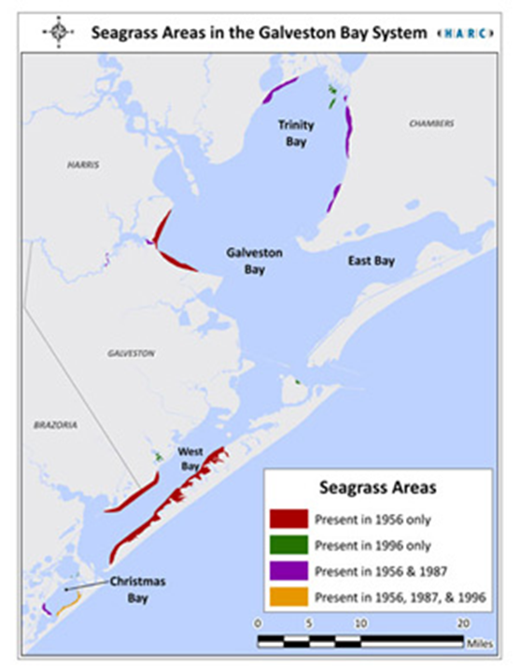
Figure 1: The Galveston Bay system. This study was conducted in Christmas Bay, the area of the highest remaining seagrass abundance (figure from Lester & Gonzales, 2009).

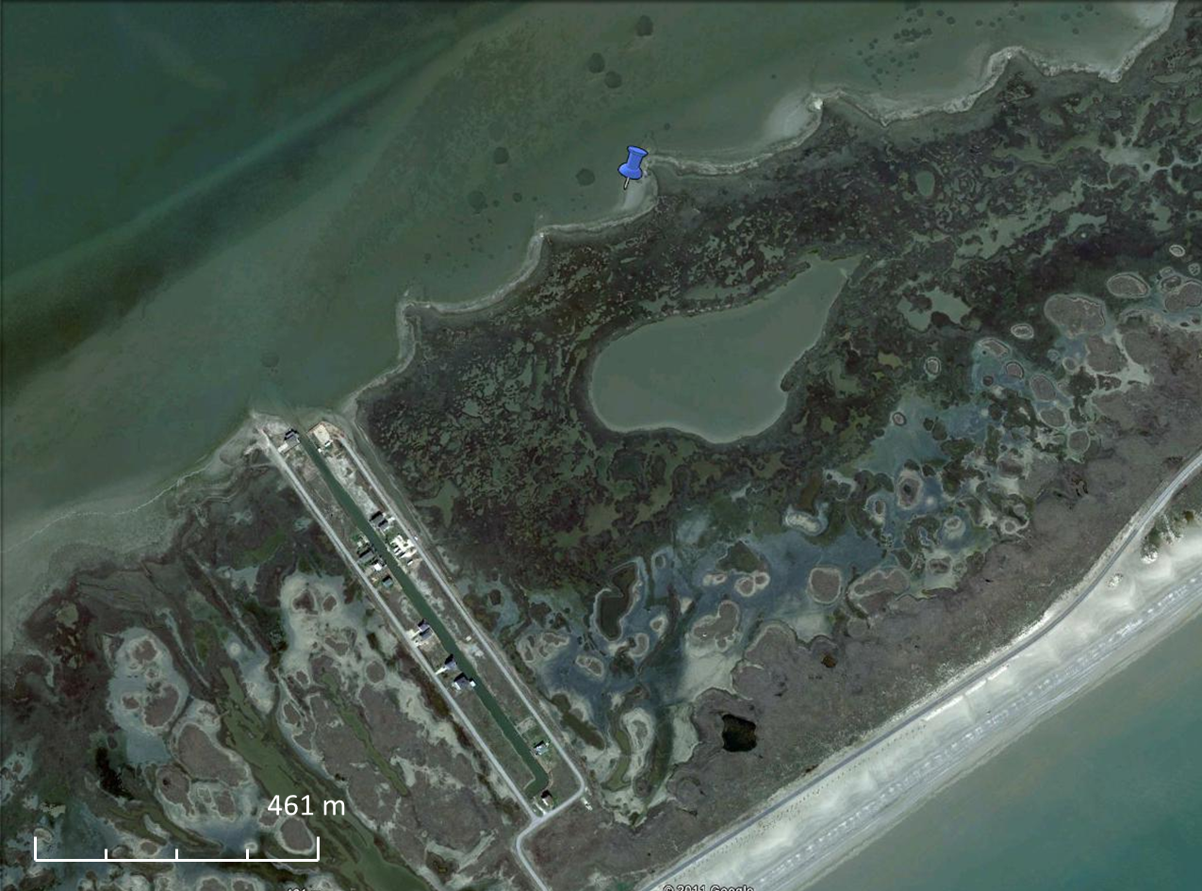
Figure 2: Study site location in Christmas Bay. The study site is marked with a blue push-pin. The photo is oriented with the top facing north, and the strip of water on the bottom of the picture is the Gulf of Mexico.

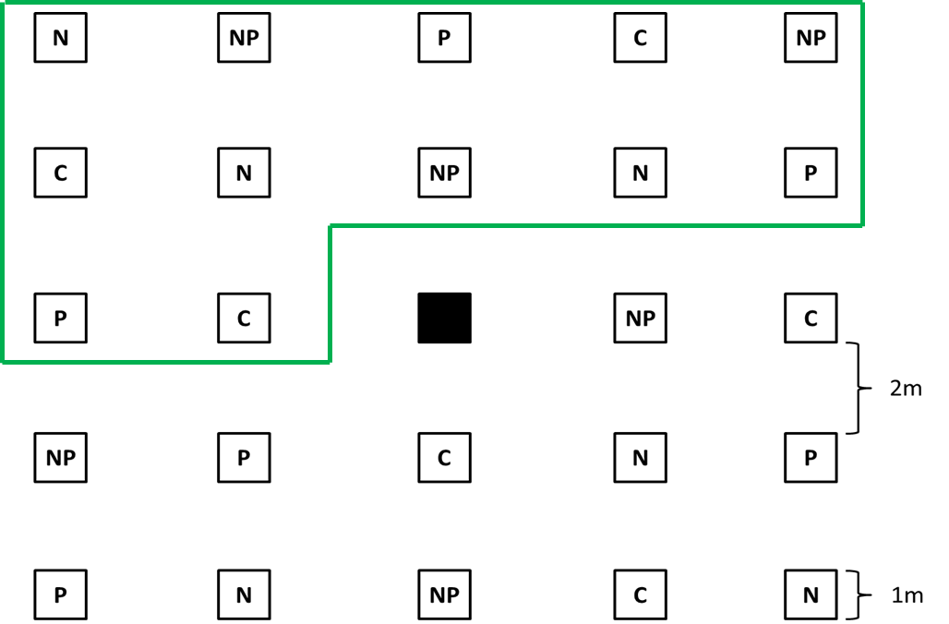

Figure 3: Treatments were randomly assigned for each plot. Each plot is 1m² with 2m intervals between plots. This study made use of the first 12 plots (boxed in green) of a larger, 24 plot experimental set-up. C denotes control, N denotes nitrogen addition, P denotes phosphorus addition, and NP denotes both nitrogen and phosphorus addition. The plots were monitored over a period of 20 days.

$$\frac{A×K×\left({665}_{o}-{665}_{a}\right)×v}{V_{f}×l}$$
Equation 1: Calculation for estimated benthic microalgal biomass. A represents the absorption coefficient of chlorophyll (11.0), K is the reduction factor (2.43), 665_{o} is the absorbance before adding two drops of 1N HCl, 665_{a} is the absorbance after, v is the volume of acetone used in extraction, V_{f} is the total volume of sample, and l is the path length of the cuvette.
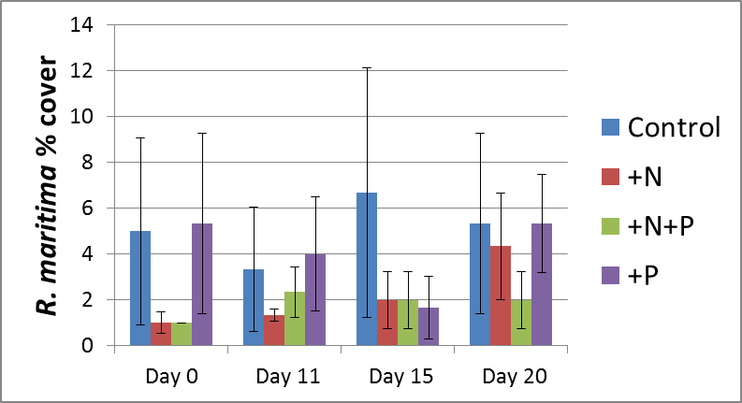
Figure 4: Percent cover of R. maritima did not have any statistical differences due to time or nutrient treatment.
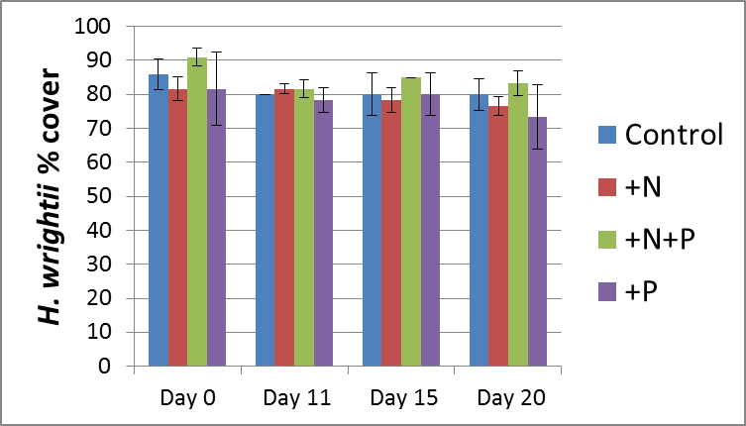
Figure 5: Percent cover of H. wrightii was significantly higher on Day 0 than on Day 20, but there were no changes due to nutrient treatments.
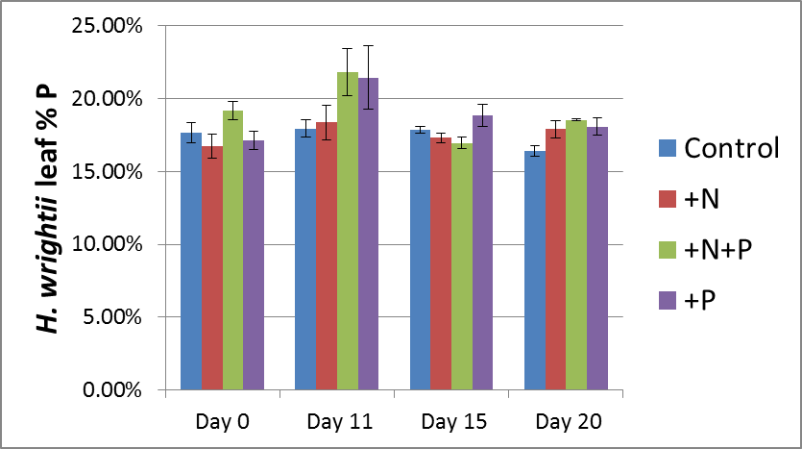
Figure 6: Phosphorus effect observed on Day 11. H. wrightii leaf tissue %P had a significant time*nutrient treatment effect (p = 0.023). Phosphorus levels increased on Day 11 in plots with P addition, but returned to near-control levels for subsequent sampling events.

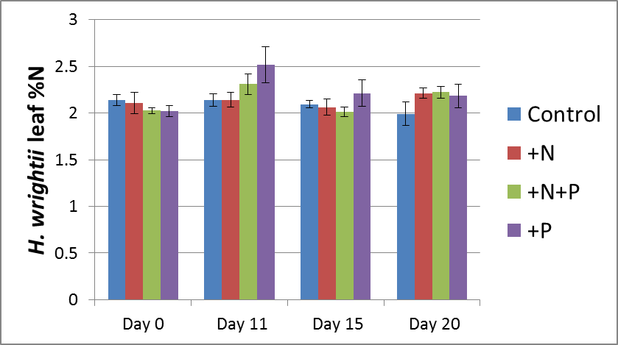
Figure 7: Leaf tissue %N not affected by treatment. While H. wrightii N levels were significantly higher on Day 11 than Day 15 (p = 0.041), no significant differences occurred due to nutrient treatment.

 | Day 0 | Day 11 | Day 15 | Day 20
Control | 1.06 ± 0.01% | 1.28 ± 0.29% | 1.09 ± 0.12% | 0.67 ± 0.04%
+N | 0.98 ± 0.09% | 1.07 ± 0.11% | 0.78 ± 0.05% | 0.78 ± 0.03%
+N+P | 1.01 ± 0.11% | 0.96 ±0.03% | 0.93 ± 0.11% | 0.61 ± 0.04%
+P | 0.73 ± 0.12% | 0.87 ± 0.12% | 0.90 ± 0.03% | 0.66 ± 0.03%
Table 1: Sediment %P over time and nutrient treatments. Phosphorus levels in the sediment did not significantly change due to treatment. Levels on Day 20 were significantly lower than levels at all other times.

 | Day 0 | Day 11 | Day 15 | Day 20
Control | 0.047 ± 0.003% | 0.043 ± 0.005% | 0.050 ± 0.005% | 0.047 ± 0.003%
+N | 0.040 ± 0.000% | 0.043 ± 0.003% | 0.050 ± 0.000% | 0.047 ± 0.003%
+N+P | 0.043 ± 0.003% | 0.043 ± 0.003% | 0.050 ± 0.000% | 0.043 ± 0.003%
+P | 0.047 ± 0.003% | 0.040 ± 0.005% | 0.053 ± 0.003% | 0.040 ± 0.000%
Table 2: Sediment %N across time and nutrient treatment. There was no statistically significant effect of nutrient addition on sediment nitrogen levels. Day 15 sediment %N was significantly higher than sediment %N on Days 0 and 20.

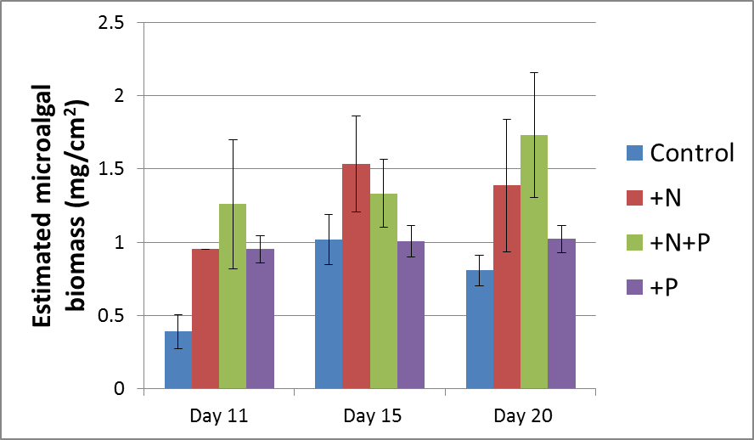
Figure 8: Benthic microalgal biomass greatest in NP plots. There was a trend of higher biomass in N plots compared to the control, but this difference was not significant. Biomass in NP plots was significantly higher than that in control plots (p = 0.017). No significant changes in biomass were observed due to time.

